UNITED STATES
SECURITIES AND EXCHANGE COMMISSION
Washington, DC 20549
FORM 8-K
CURRENT REPORT
Pursuant to Section 13 OR 15(d) of the
Securities Exchange Act of 1934
Date of Report (Date of earliest event reported): August 5, 2026

The Carlyle Group Inc.
(Exact name of registrant as specified in its charter)
Delaware |  | 001-35538 |  |  | 45-2832612
(State or Other Jurisdiction  of Incorporation) |  | (Commission  File Number) |  |  | (IRS Employer  Identification No.)
1001 Pennsylvania Avenue, NW
Washington, DC 20004-2505
(Address of Principal Executive Offices, Including Zip Code)
(202) 729-5626
(Registrant’s Telephone Number, Including Area Code)
Not Applicable
(Former Name or Former Address, if Changed Since Last Report)
Check the appropriate box below if the Form 8-K filing is intended to simultaneously satisfy the filing obligation of the registrant under any
of the following provisions (see General Instruction A.2. below):
☐ | Written communications pursuant to Rule 425 under the Securities Act (17 CFR 230.425)
☐ | Soliciting material pursuant to Rule 14a-12 under the Exchange Act (17 CFR 240.14a-12)
☐ | Pre-commencement communications pursuant to Rule 14d-2(b) under the Exchange Act (17 CFR 240.14d-2(b))
☐ | Pre-commencement communications pursuant to Rule 13e-4(c) under the Exchange Act (17 CFR 240.13e-4(c))
Securities registered pursuant to Section 12(b) of the Act:
Title of each class | Trading Symbol(s) | Name of each exchange on which registered
Common Stock | CG | The Nasdaq Global Select Market
4.625% Subordinated Notes due 2061 of Carlyle Finance  L.L.C. | CGABL | The Nasdaq Global Select Market
Indicate by check mark whether the registrant is an emerging growth company as defined in Rule 405 of the Securities Act of 1933 (§230.405
of this chapter) or Rule 12b-2 of the Securities Exchange Act of 1934 (§240.12b-2 of this chapter).
Emerging growth company ☐
If an emerging growth company, indicate by check mark if the registrant has elected not to use the extended transition period for complying
with any new or revised financial accounting standards provided pursuant to Section 13(a) of the Exchange Act. ☐
Item 2.02 | Results of Operations and Financial Condition.
On August 5, 2026, The Carlyle Group Inc. issued a summary press release and a detailed earnings presentation announcing
financial results for its second quarter ended June 30, 2026. The summary press release and the earnings presentation are
furnished as Exhibit 99.1 and Exhibit 99.2, respectively, to this Current Report on Form 8-K (this “Report”).
The information in this Report, including the exhibits hereto, shall not be deemed “filed” for purposes of Section 18 of the
Securities Exchange Act of 1934, as amended, or otherwise subject to the liabilities of that section, nor shall it be deemed
incorporated by reference in any filing under the Securities Act of 1933, as amended, except as shall be expressly set forth by
specific reference in such a filing.
Item 9.01 | Financial Statements and Exhibits.
(d)Exhibits.
Exhibit No. |  | Description
99.1 |  | Summary earnings press release of The Carlyle Group Inc., dated August 5, 2026.
99.2 |  | Earnings presentation of The Carlyle Group Inc., dated August 5, 2026.
104 |  | Cover Page Interactive Data File (embedded within the Inline XBRL document).
SIGNATURES
Pursuant to the requirements of the Securities Exchange Act of 1934, the registrant has duly caused this report to be signed on
its behalf by the undersigned hereunto duly authorized.

 |  | The Carlyle Group Inc.
Date: August 4, 2026 |  |  |  | By: |  | /s/ Justin V. Plouffe
 |  |  |  | Name: |  | Justin V. Plouffe
 |  |  |  | Title: |  | Chief Financial Officer
Page | 1

Exhibit 99.1
Carlyle Reports Second Quarter 2026 Financial Results
Washington, D.C. and New York, NY – August 5, 2026 – The Carlyle Group Inc. (NASDAQ: CG) today
reported its unaudited results for the second quarter ended June 30, 2026. The full detailed presentation of Carlyle’s
second quarter 2026 results can be viewed at ir.carlyle.com.
U.S. GAAP results for Q2 2026 included income before provision for income taxes of $274 million and a margin on
income before provision for income taxes of 24.4%.
Carlyle Chief Executive Officer Harvey M. Schwartz said, “The second quarter was one of Carlyle’s strongest
quarters in recent years, underscoring the power of our diversified platform. We delivered record Fee Related
Earnings, our highest Distributable Earnings in nearly four years, alongside strong fundraising, and exceptional
realization activity. Carlyle continues to distinguish itself as an industry leader and an outlier in returning capital to
our clients, distributing nearly $7 billion during the quarter and $37 billion over the past year. This performance
reflects the disciplined execution of our strategy and the momentum we continue to build across the firm.”
Dividend
The Board of Directors has declared a quarterly dividend of $0.35 per common share to holders of record at the
close of business on August 17, 2026, payable on August 26, 2026.
Conference Call
Carlyle will host a conference call at 8:30 a.m. EDT on Wednesday, August 5, 2026, to announce its second quarter
2026 financial results. The conference call will be available via public webcast from the Events & Presentations
section of ir.carlyle.com and a replay will also be available on our website soon after the call’s completion.
About Carlyle
Carlyle (NASDAQ: CG) is a global investment firm with deep industry expertise that deploys private capital across
three business segments: Global Private Equity, Global Credit, and Carlyle AlpInvest. With $485 billion of assets
under management as of June 30, 2026, Carlyle’s purpose is to connect people, ideas, and capital to fuel growth for
companies and performance for investors. Carlyle employs more than 2,500 people in 28 offices across four
continents. Further information is available at www.carlyle.com. Follow Carlyle on X @OneCarlyle and LinkedIn
at The Carlyle Group.
Page | 2
Forward-Looking Statements
This press release may contain forward-looking statements within the meaning of Section 27A of the Securities Act
of 1933, as amended, and Section 21E of the Securities Exchange Act of 1934, as amended. These statements
include, but are not limited to, statements related to our expectations, estimates, beliefs, projections, future plans and
strategies, anticipated events or trends, and similar expressions and statements that are not historical facts, including
our expectations regarding the performance of our business, our financial results, our liquidity and capital resources,
contingencies, and our dividend policy. You can identify these forward-looking statements by the use of words such
as “outlook,” “believes,” “expects,” “potential,” “continues,” “may,” “will,” “should,” “seeks,” “approximately,”
“predicts,” “intends,” “plans,” “estimates,” “anticipates,” or the negative version of these words or other comparable
words. Such forward-looking statements are subject to various risks, uncertainties, and assumptions. Accordingly,
there are or will be important factors that could cause actual outcomes or results to differ materially from those
indicated in these statements including, but not limited to, those described in this press release and under the section
entitled “Risk Factors” in our Annual Report on Form 10-K for the year ended December 31, 2025, filed with the
U.S. Securities and Exchange Commission (“SEC”) on February 27, 2026, as such factors may be updated from
time to time in our periodic filings with the SEC, which are accessible on the SEC’s website at www.sec.gov. These
factors should not be construed as exhaustive and should be read in conjunction with the other cautionary statements
that are included in this press release and in our other periodic filings with the SEC. We undertake no obligation to
publicly update or review any forward-looking statements, whether as a result of new information, future
developments, or otherwise, except as required by applicable law.
This press release does not constitute an offer for any Carlyle fund.
Contacts:
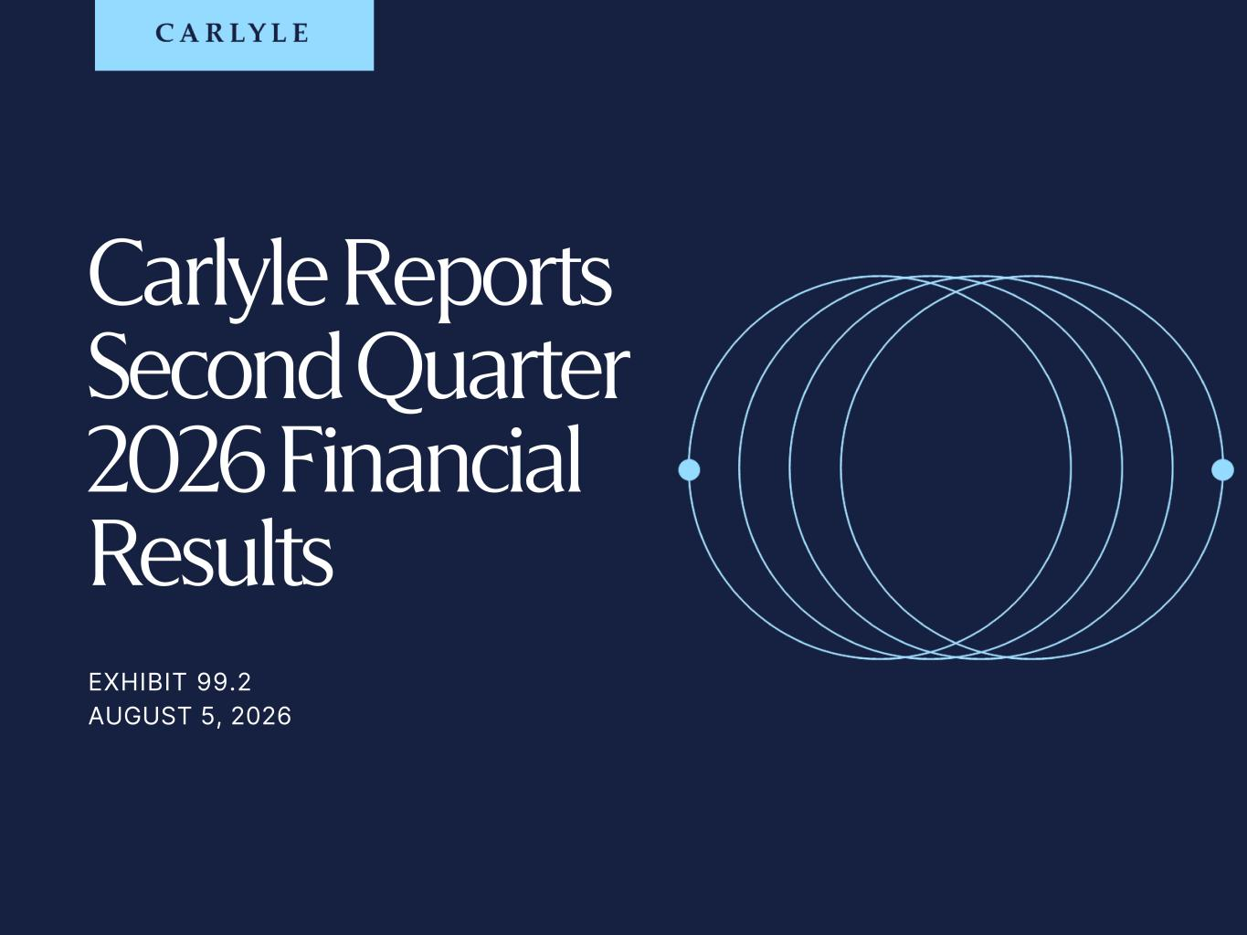
Daniel Harris
Phone: +1 (212) 813-4527
daniel.harris@carlyle.com

Investor Relations

Media
TRADE SECRET & STRICTLY CONFIDENTIAL EXHIBIT 99.2 AUGUST 5, 2026 Carlyle Reports Second Quarter 2026 Financial Results

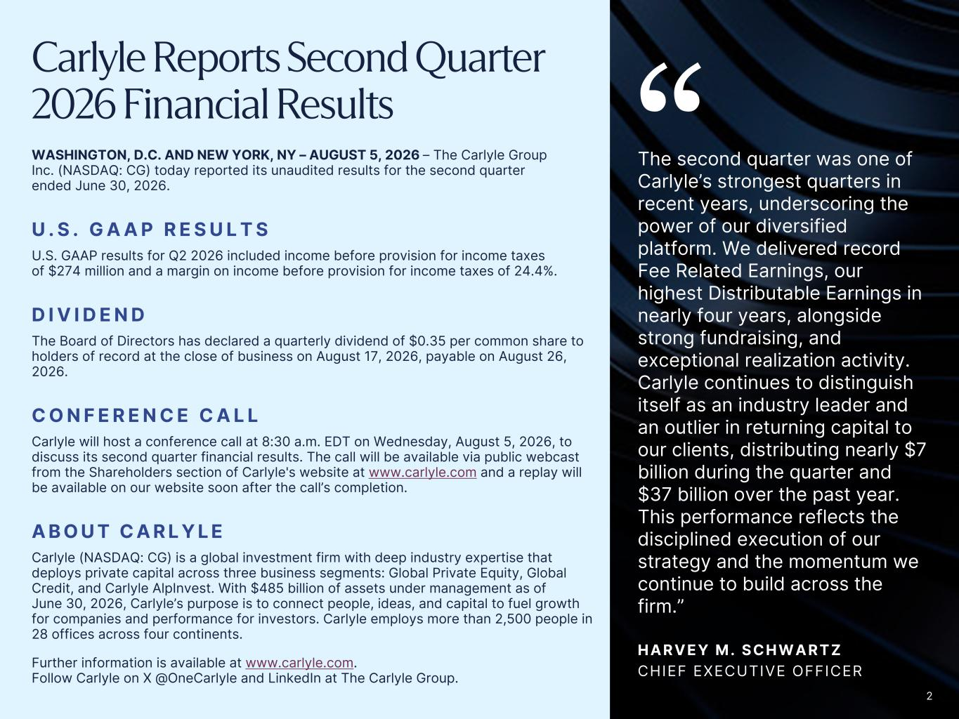
2 Carlyle Reports Second Quarter 2026 Financial Results WASHINGTON, D.C. AND NEW YORK, NY – AUGUST 5, 2026 – The Carlyle Group Inc. (NASDAQ: CG) today reported its unaudited results for the second quarter ended June 30, 2026. U . S . G A A P R E S U L T S U.S. GAAP results for Q2 2026 included income before provision for income taxes of $274 million and a margin on income before provision for income taxes of 24.4%. D I V I D E N D The Board of Directors has declared a quarterly dividend of $0.35 per common share to holders of record at the close of business on August 17, 2026, payable on August 26, 2026. C O N F E R E N C E C A L L Carlyle will host a conference call at 8:30 a.m. EDT on Wednesday, August 5, 2026, to discuss its second quarter financial results. The call will be available via public webcast from the Shareholders section of Carlyle's website at www.carlyle.com and a replay will be available on our website soon after the call’s completion. A B O U T C A R L Y L E Carlyle (NASDAQ: CG) is a global investment firm with deep industry expertise that deploys private capital across three business segments: Global Private Equity, Global Credit, and Carlyle AlpInvest. With $485 billion of assets under management as of June 30, 2026, Carlyle’s purpose is to connect people, ideas, and capital to fuel growth for companies and performance for investors. Carlyle employs more than 2,500 people in 28 offices across four continents. Further information is available at www.carlyle.com. Follow Carlyle on X @OneCarlyle and LinkedIn at The Carlyle Group. The second quarter was one of Carlyle’s strongest quarters in recent years, underscoring the power of our diversified platform. We delivered record Fee Related Earnings, our highest Distributable Earnings in nearly four years, alongside strong fundraising, and exceptional realization activity. Carlyle continues to distinguish itself as an industry leader and an outlier in returning capital to our clients, distributing nearly $7 billion during the quarter and $37 billion over the past year. This performance reflects the disciplined execution of our strategy and the momentum we continue to build across the firm.” H A R V E Y M . S C H W A R T Z CHIEF EXECUTIVE OFFICER “ 2


Forward-Looking Statements This presentation may contain forward-looking statements within the meaning of Section 27A of the Securities Act of 1933, as amended, and Section 21E of the Securities Exchange Act of 1934, as amended. These statements include, but are not limited to, statements related to our expectations, estimates, beliefs, projections, future plans and strategies, anticipated events or trends, and similar expressions and statements that are not historical facts, including our expectations regarding the performance of our business, our financial results, our liquidity and capital resources, contingencies, and our dividend policy. You can identify these forward-looking statements by the use of words such as “outlook,” “believes,” “expects,” “potential,” “continues,” “may,” “will,” “should,” “seeks,” “approximately,” “predicts,” “intends,” “plans,” “estimates,” “anticipates,” or the negative version of these words or other comparable words. Such forward-looking statements are subject to various risks, uncertainties, and assumptions. Accordingly, there are or will be important factors that could cause actual outcomes or results to differ materially from those indicated in these statements including, but not limited to, those described in this presentation and under the section entitled “Risk Factors” in our Annual Report on Form 10-K for the year ended December 31, 2025, filed with the U.S. Securities and Exchange Commission (“SEC”) on February 27, 2026, as such factors may be updated from time to time in our periodic filings with the SEC, which are accessible on the SEC’s website at www.sec.gov. These factors should not be construed as exhaustive and should be read in conjunction with the other cautionary statements that are included in this presentation and in our other periodic filings with the SEC. We undertake no obligation to publicly update or review any forward-looking statements, whether as a result of new information, future developments, or otherwise, except as required by applicable law. This presentation does not constitute an offer for any Carlyle fund. Contacts INVESTOR RELATIONS MEDIA Daniel Harris Phone: +1 (212) 813-4527 daniel.harris@carlyle.com Brittany Bensaull Phone: +1 (212) 813-4839 brittany.bensaull@carlyle.com 3

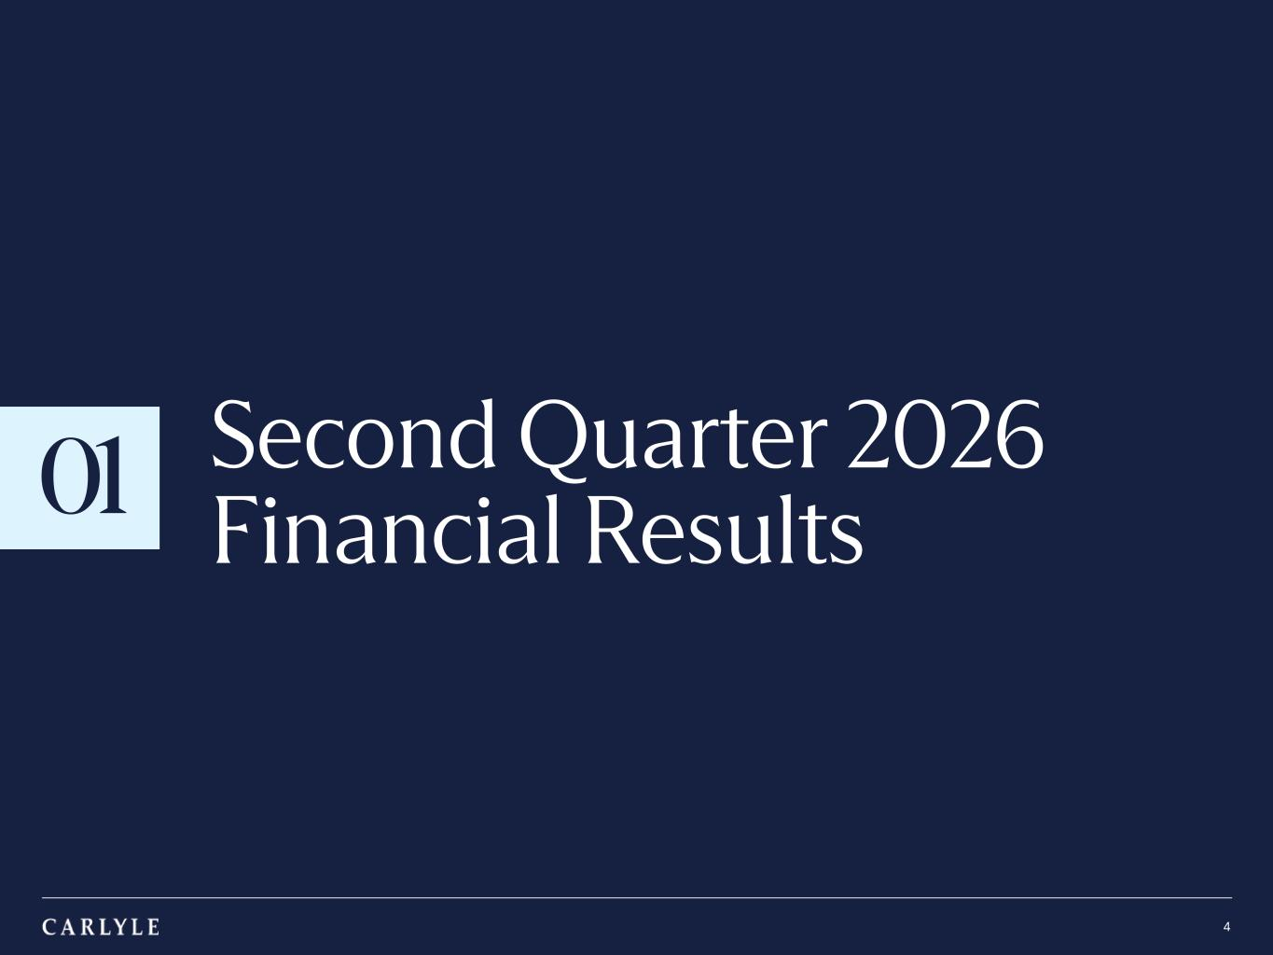
TRADE SECRET & STRICTLY CONFIDENTIAL 01 4 Second Quarter 2026 Financial Results

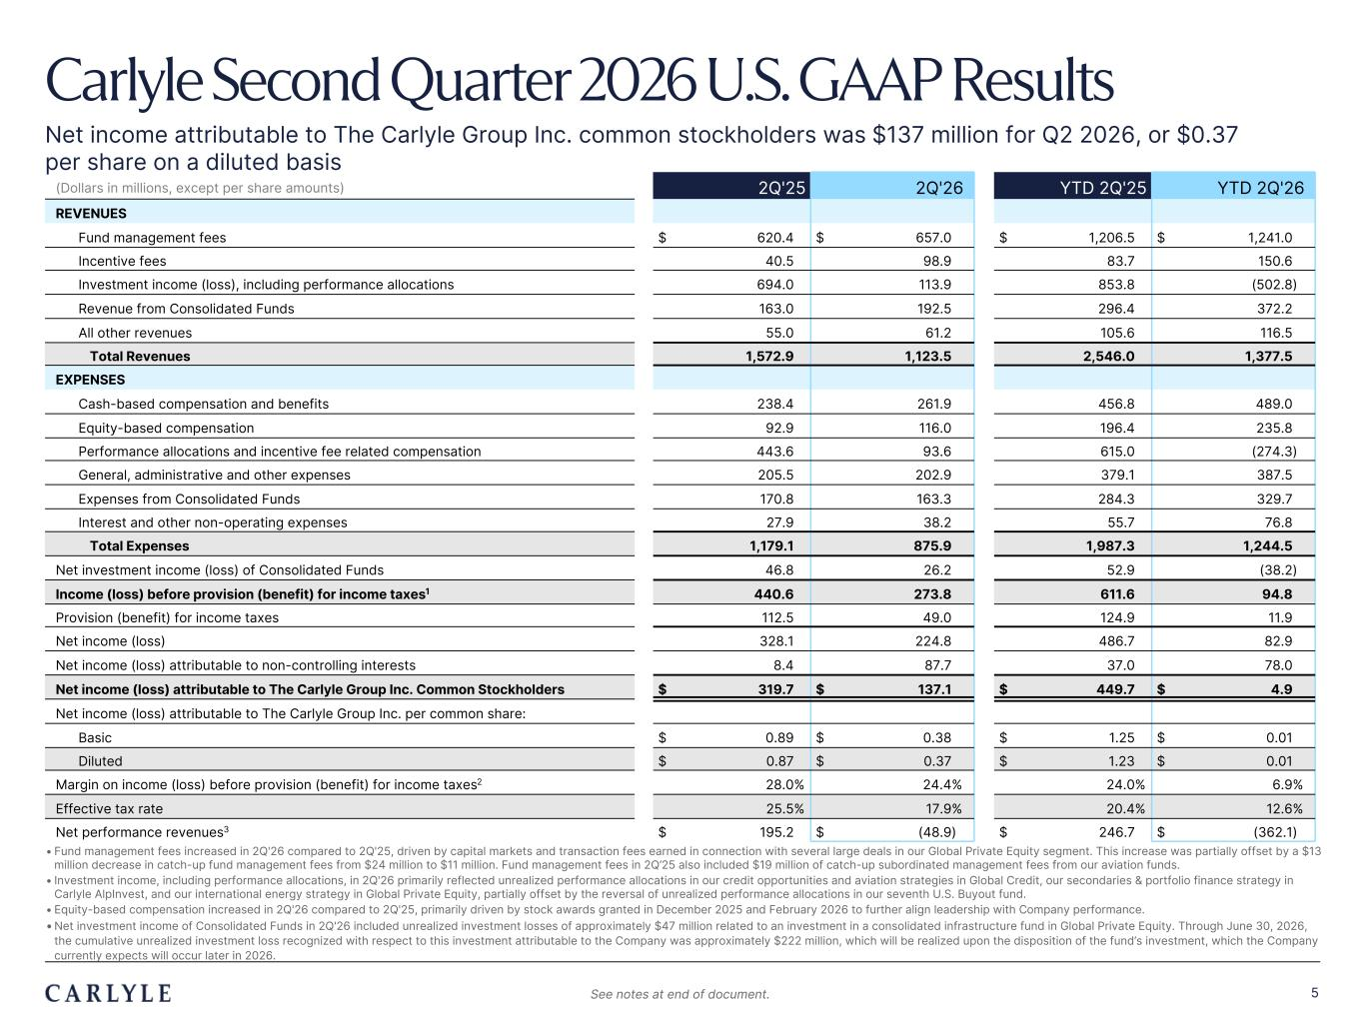
Plum R117 G45 B79 Dark Gray R101 G101 B101 Light Green R216 G240 B221 Pale Blue R221 G244 B255 Light Indigo R176 G188 B228 Indigo R49 G71 B143 Brown R96 G70 B60 Taupe R209 G199 B189 Light Gray R230 G230 B230 Dark Blue R22 G32 B64 Green R57 G108 B101 Champagne R251 G246 B237 Sky Blue R149 G218 B255 Salmon R240 G196 B188 5 • Fund management fees increased in 2Q'26 compared to 2Q'25, driven by capital markets and transaction fees earned in connection with several large deals in our Global Private Equity segment. This increase was partially offset by a $13 million decrease in catch-up fund management fees from $24 million to $11 million. Fund management fees in 2Q’25 also included $19 million of catch-up subordinated management fees from our aviation funds. • Investment income, including performance allocations, in 2Q'26 primarily reflected unrealized performance allocations in our credit opportunities and aviation strategies in Global Credit, our secondaries & portfolio finance strategy in Carlyle AlpInvest, and our international energy strategy in Global Private Equity, partially offset by the reversal of unrealized performance allocations in our seventh U.S. Buyout fund. • Equity-based compensation increased in 2Q'26 compared to 2Q'25, primarily driven by stock awards granted in December 2025 and February 2026 to further align leadership with Company performance. •Net investment income of Consolidated Funds in 2Q'26 included unrealized investment losses of approximately $47 million related to an investment in a consolidated infrastructure fund in Global Private Equity. Through June 30, 2026, the cumulative unrealized investment loss recognized with respect to this investment attributable to the Company was approximately $222 million, which will be realized upon the disposition of the fund’s investment, which the Company currently expects will occur later in 2026. (Dollars in millions, except per share amounts) 2Q'25 2Q'26 YTD 2Q'25 YTD 2Q'26 REVENUES Fund management fees $ 620.4 $ 657.0 $ 1,206.5 $ 1,241.0 Incentive fees 40.5 98.9 83.7 150.6 Investment income (loss), including performance allocations 694.0 113.9 853.8 (502.8) Revenue from Consolidated Funds 163.0 192.5 296.4 372.2 All other revenues 55.0 61.2 105.6 116.5 Total Revenues 1,572.9 1,123.5 2,546.0 1,377.5 EXPENSES Cash-based compensation and benefits 238.4 261.9 456.8 489.0 Equity-based compensation 92.9 116.0 196.4 235.8 Performance allocations and incentive fee related compensation 443.6 93.6 615.0 (274.3) General, administrative and other expenses 205.5 202.9 379.1 387.5 Expenses from Consolidated Funds 170.8 163.3 284.3 329.7 Interest and other non-operating expenses 27.9 38.2 55.7 76.8 Total Expenses 1,179.1 875.9 1,987.3 1,244.5 Net investment income (loss) of Consolidated Funds 46.8 26.2 52.9 (38.2) Income (loss) before provision (benefit) for income taxes1 440.6 273.8 611.6 94.8 Provision (benefit) for income taxes 112.5 49.0 124.9 11.9 Net income (loss) 328.1 224.8 486.7 82.9 Net income (loss) attributable to non-controlling interests 8.4 87.7 37.0 78.0 Net income (loss) attributable to The Carlyle Group Inc. Common Stockholders $ 319.7 $ 137.1 $ 449.7 $ 4.9 Net income (loss) attributable to The Carlyle Group Inc. per common share: Basic $ 0.89 $ 0.38 $ 1.25 $ 0.01 Diluted $ 0.87 $ 0.37 $ 1.23 $ 0.01 Margin on income (loss) before provision (benefit) for income taxes2 28.0% 24.4% 24.0% 6.9% Effective tax rate 25.5% 17.9% 20.4% 12.6% Net performance revenues3 $ 195.2 $ (48.9) $ 246.7 $ (362.1) Carlyle Second Quarter 2026 U.S. GAAP Results Net income attributable to The Carlyle Group Inc. common stockholders was $137 million for Q2 2026, or $0.37 per share on a diluted basis See notes at end of document.

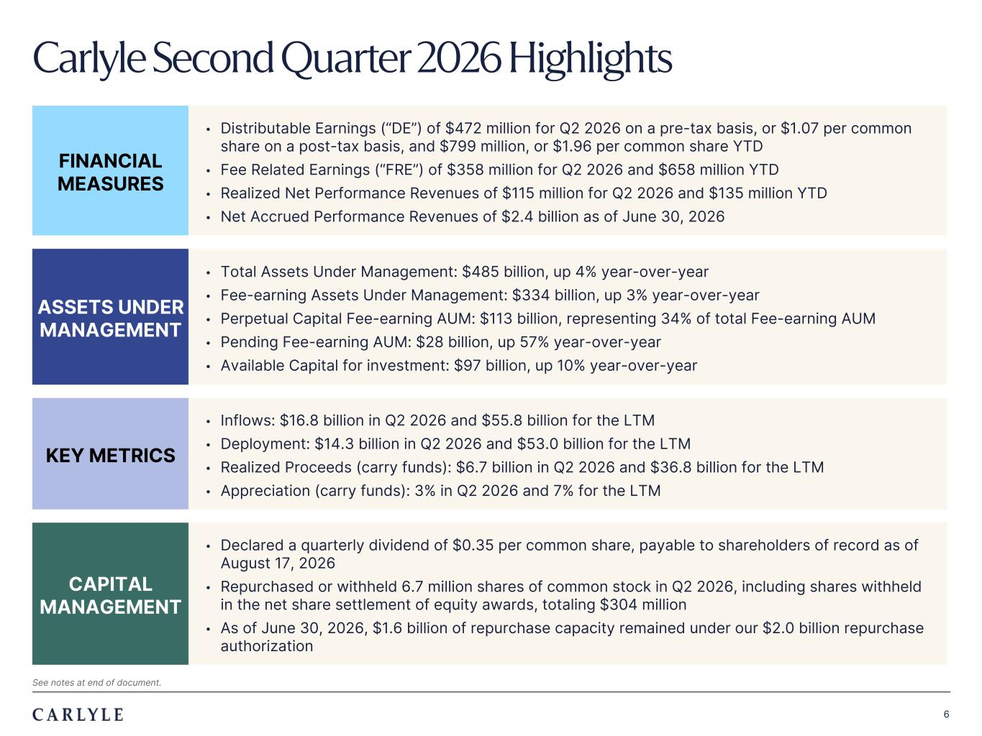
Plum R117 G45 B79 Dark Gray R101 G101 B101 Light Green R216 G240 B221 Pale Blue R221 G244 B255 Light Indigo R176 G188 B228 Indigo R49 G71 B143 Brown R96 G70 B60 Taupe R209 G199 B189 Light Gray R230 G230 B230 Dark Blue R22 G32 B64 Green R57 G108 B101 Champagne R251 G246 B237 Sky Blue R149 G218 B255 Salmon R240 G196 B188 6 FINANCIAL MEASURES • Distributable Earnings (“DE”) of $472 million for Q2 2026 on a pre-tax basis, or $1.07 per common share on a post-tax basis, and $799 million, or $1.96 per common share YTD • Fee Related Earnings (“FRE”) of $358 million for Q2 2026 and $658 million YTD • Realized Net Performance Revenues of $115 million for Q2 2026 and $135 million YTD • Net Accrued Performance Revenues of $2.4 billion as of June 30, 2026 ASSETS UNDER MANAGEMENT • Total Assets Under Management: $485 billion, up 4% year-over-year • Fee-earning Assets Under Management: $334 billion, up 3% year-over-year • Perpetual Capital Fee-earning AUM: $113 billion, representing 34% of total Fee-earning AUM • Pending Fee-earning AUM: $28 billion, up 57% year-over-year • Available Capital for investment: $97 billion, up 10% year-over-year KEY METRICS • Inflows: $16.8 billion in Q2 2026 and $55.8 billion for the LTM • Deployment: $14.3 billion in Q2 2026 and $53.0 billion for the LTM • Realized Proceeds (carry funds): $6.7 billion in Q2 2026 and $36.8 billion for the LTM • Appreciation (carry funds): 3% in Q2 2026 and 7% for the LTM CAPITAL MANAGEMENT • Declared a quarterly dividend of $0.35 per common share, payable to shareholders of record as of August 17, 2026 • Repurchased or withheld 6.7 million shares of common stock in Q2 2026, including shares withheld in the net share settlement of equity awards, totaling $304 million • As of June 30, 2026, $1.6 billion of repurchase capacity remained under our $2.0 billion repurchase authorization Carlyle Second Quarter 2026 Highlights See notes at end of document.

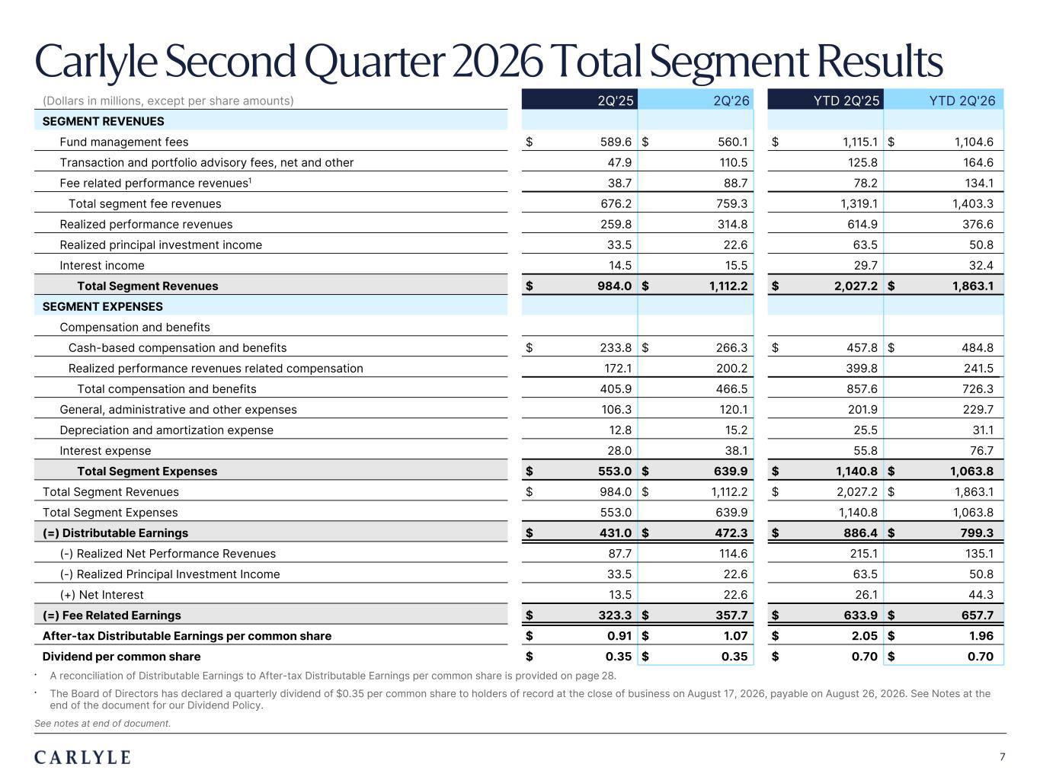
Plum R117 G45 B79 Dark Gray R101 G101 B101 Light Green R216 G240 B221 Pale Blue R221 G244 B255 Light Indigo R176 G188 B228 Indigo R49 G71 B143 Brown R96 G70 B60 Taupe R209 G199 B189 Light Gray R230 G230 B230 Dark Blue R22 G32 B64 Green R57 G108 B101 Champagne R251 G246 B237 Sky Blue R149 G218 B255 Salmon R240 G196 B188 7 Carlyle Second Quarter 2026 Total Segment Results (Dollars in millions, except per share amounts) 2Q'25 2Q'26 YTD 2Q'25 YTD 2Q'26 SEGMENT REVENUES Fund management fees $ 589.6 $ 560.1 $ 1,115.1 $ 1,104.6 Transaction and portfolio advisory fees, net and other 47.9 110.5 125.8 164.6 Fee related performance revenues1 38.7 88.7 78.2 134.1 Total segment fee revenues 676.2 759.3 1,319.1 1,403.3 Realized performance revenues 259.8 314.8 614.9 376.6 Realized principal investment income 33.5 22.6 63.5 50.8 Interest income 14.5 15.5 29.7 32.4 Total Segment Revenues $ 984.0 $ 1,112.2 $ 2,027.2 $ 1,863.1 SEGMENT EXPENSES Compensation and benefits Cash-based compensation and benefits $ 233.8 $ 266.3 $ 457.8 $ 484.8 Realized performance revenues related compensation 172.1 200.2 399.8 241.5 Total compensation and benefits 405.9 466.5 857.6 726.3 General, administrative and other expenses 106.3 120.1 201.9 229.7 Depreciation and amortization expense 12.8 15.2 25.5 31.1 Interest expense 28.0 38.1 55.8 76.7 Total Segment Expenses $ 553.0 $ 639.9 $ 1,140.8 $ 1,063.8 Total Segment Revenues $ 984.0 $ 1,112.2 $ 2,027.2 $ 1,863.1 Total Segment Expenses 553.0 639.9 1,140.8 1,063.8 (=) Distributable Earnings $ 431.0 $ 472.3 $ 886.4 $ 799.3 (-) Realized Net Performance Revenues 87.7 114.6 215.1 135.1 (-) Realized Principal Investment Income 33.5 22.6 63.5 50.8 (+) Net Interest 13.5 22.6 26.1 44.3 (=) Fee Related Earnings $ 323.3 $ 357.7 $ 633.9 $ 657.7 After-tax Distributable Earnings per common share $ 0.91 $ 1.07 $ 2.05 $ 1.96 Dividend per common share $ 0.35 $ 0.35 $ 0.70 $ 0.70 • A reconciliation of Distributable Earnings to After-tax Distributable Earnings per common share is provided on page 28. • The Board of Directors has declared a quarterly dividend of $0.35 per common share to holders of record at the close of business on August 17, 2026, payable on August 26, 2026. See Notes at the end of the document for our Dividend Policy. See notes at end of document.

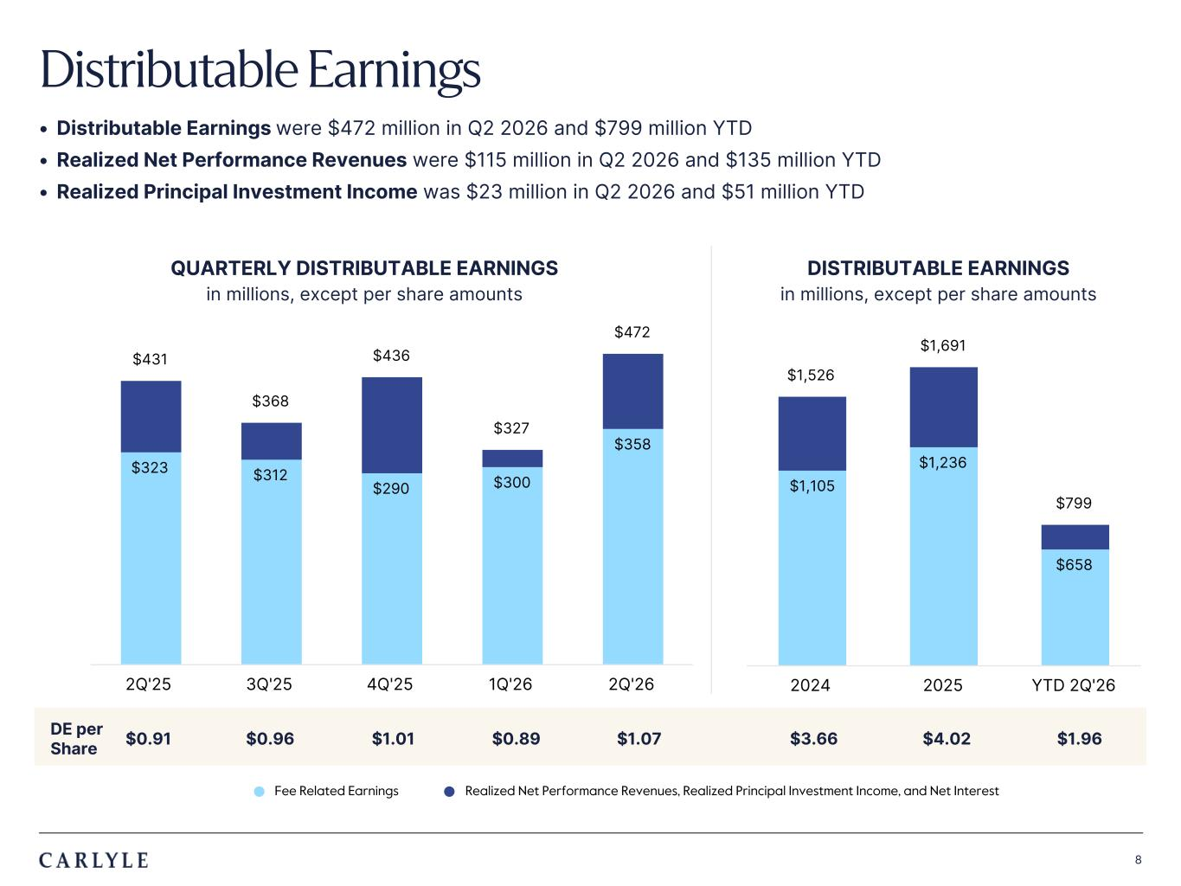
Plum R117 G45 B79 Dark Gray R101 G101 B101 Light Green R216 G240 B221 Pale Blue R221 G244 B255 Light Indigo R176 G188 B228 Indigo R49 G71 B143 Brown R96 G70 B60 Taupe R209 G199 B189 Light Gray R230 G230 B230 Dark Blue R22 G32 B64 Green R57 G108 B101 Champagne R251 G246 B237 Sky Blue R149 G218 B255 Salmon R240 G196 B188 8 • Distributable Earnings were $472 million in Q2 2026 and $799 million YTD • Realized Net Performance Revenues were $115 million in Q2 2026 and $135 million YTD • Realized Principal Investment Income was $23 million in Q2 2026 and $51 million YTD Distributable Earnings $1,105 $1,236 $658 $1,526 $1,691 $799 2024 2025 YTD 2Q'26 DISTRIBUTABLE EARNINGS in millions, except per share amounts l Fee Related Earnings l Realized Net Performance Revenues, Realized Principal Investment Income, and Net Interest DE per Share $0.91 $0.96 $1.01 $0.89 $1.07 $3.66 $4.02 $1.96 QUARTERLY DISTRIBUTABLE EARNINGS in millions, except per share amounts $323 $312 $290 $300 $358 $431 $368 $436 $327 $472 2Q'25 3Q'25 4Q'25 1Q'26 2Q'26

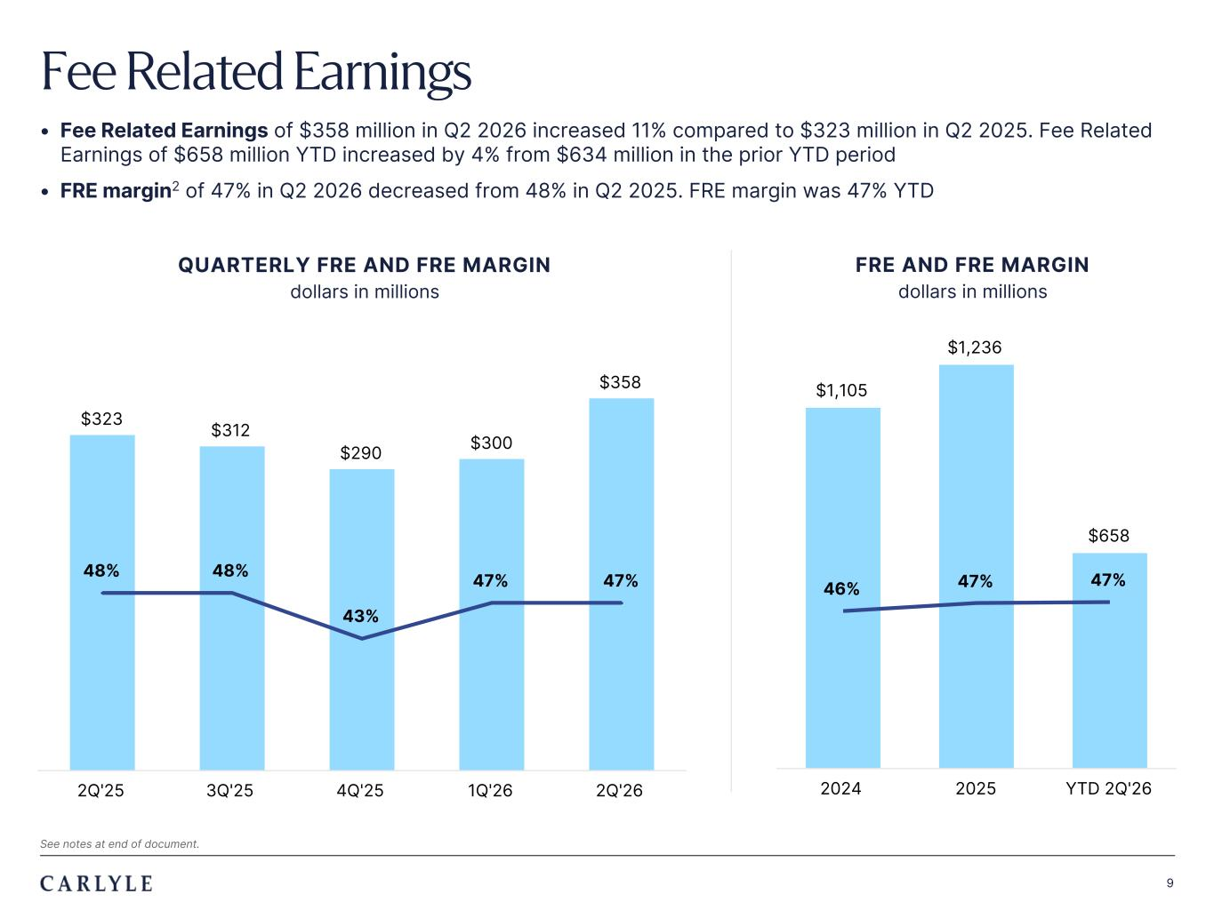
Plum R117 G45 B79 Dark Gray R101 G101 B101 Light Green R216 G240 B221 Pale Blue R221 G244 B255 Light Indigo R176 G188 B228 Indigo R49 G71 B143 Brown R96 G70 B60 Taupe R209 G199 B189 Light Gray R230 G230 B230 Dark Blue R22 G32 B64 Green R57 G108 B101 Champagne R251 G246 B237 Sky Blue R149 G218 B255 Salmon R240 G196 B188 9 • Fee Related Earnings of $358 million in Q2 2026 increased 11% compared to $323 million in Q2 2025. Fee Related Earnings of $658 million YTD increased by 4% from $634 million in the prior YTD period • FRE margin2 of 47% in Q2 2026 decreased from 48% in Q2 2025. FRE margin was 47% YTD Fee Related Earnings $323 $312 $290 $300 $358 48% 48% 43% 47% 47% 2Q'25 3Q'25 4Q'25 1Q'26 2Q'26 See notes at end of document. $1,105 $1,236 $658 46% 47% 47% 2024 2025 YTD 2Q'26 QUARTERLY FRE AND FRE MARGIN dollars in millions FRE AND FRE MARGIN dollars in millions

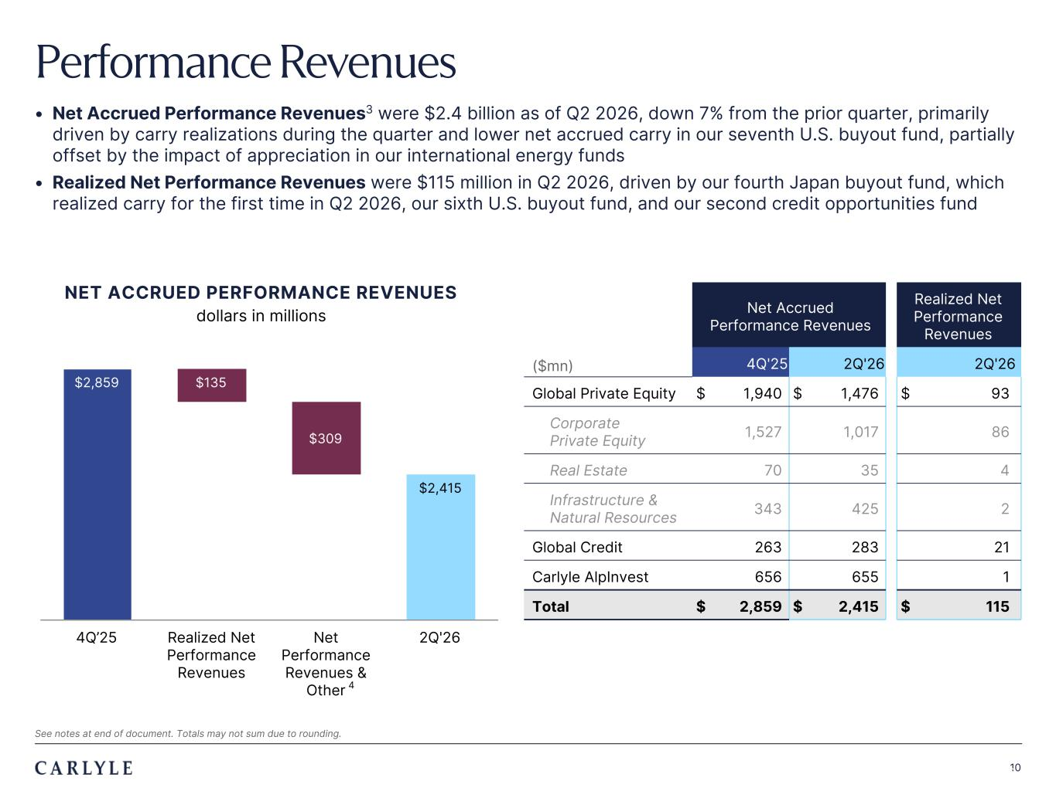
Plum R117 G45 B79 Dark Gray R101 G101 B101 Light Green R216 G240 B221 Pale Blue R221 G244 B255 Light Indigo R176 G188 B228 Indigo R49 G71 B143 Brown R96 G70 B60 Taupe R209 G199 B189 Light Gray R230 G230 B230 Dark Blue R22 G32 B64 Green R57 G108 B101 Champagne R251 G246 B237 Sky Blue R149 G218 B255 Salmon R240 G196 B188 10 $2,859 $2,415 $135 $309 4Q’25 Realized Net Performance Revenues Net Performance Revenues & Other 2Q'26 • Net Accrued Performance Revenues3 were $2.4 billion as of Q2 2026, down 7% from the prior quarter, primarily driven by carry realizations during the quarter and lower net accrued carry in our seventh U.S. buyout fund, partially offset by the impact of appreciation in our international energy funds • Realized Net Performance Revenues were $115 million in Q2 2026, driven by our fourth Japan buyout fund, which realized carry for the first time in Q2 2026, our sixth U.S. buyout fund, and our second credit opportunities fund Performance Revenues 10 Net Accrued Performance Revenues Realized Net Performance Revenues ($mn) 4Q'25 2Q'26 2Q'26 Global Private Equity $ 1,940 $ 1,476 $ 93 Corporate Private Equity 1,527 1,017 86 Real Estate 70 35 4 Infrastructure & Natural Resources 343 425 2 Global Credit 263 283 21 Carlyle AlpInvest 656 655 1 Total $ 2,859 $ 2,415 $ 115 NET ACCRUED PERFORMANCE REVENUES dollars in millions See notes at end of document. Totals may not sum due to rounding. 4

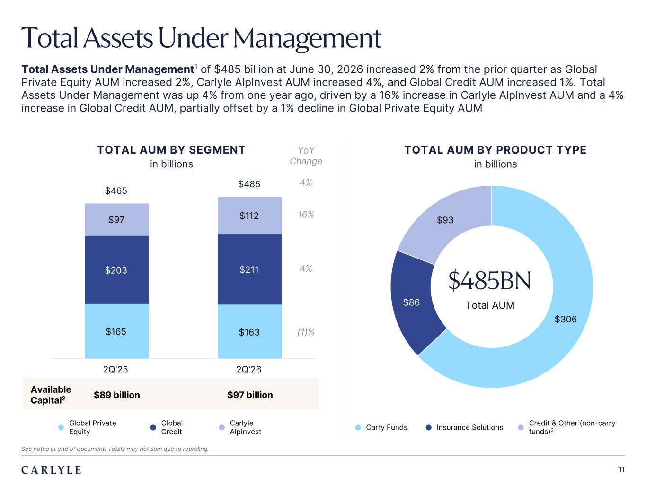
Plum R117 G45 B79 Dark Gray R101 G101 B101 Light Green R216 G240 B221 Pale Blue R221 G244 B255 Light Indigo R176 G188 B228 Indigo R49 G71 B143 Brown R96 G70 B60 Taupe R209 G199 B189 Light Gray R230 G230 B230 Dark Blue R22 G32 B64 Green R57 G108 B101 Champagne R251 G246 B237 Sky Blue R149 G218 B255 Salmon R240 G196 B188 11 $306 $86 $93 $165 $163 $203 $211 $97 $112 $465 $485 2Q'25 2Q'26 Total Assets Under Management Total Assets Under Management1 of $485 billion at June 30, 2026 increased 2% from the prior quarter as Global Private Equity AUM increased 2%, Carlyle AlpInvest AUM increased 4%, and Global Credit AUM increased 1%. Total Assets Under Management was up 4% from one year ago, driven by a 16% increase in Carlyle AlpInvest AUM and a 4% increase in Global Credit AUM, partially offset by a 1% decline in Global Private Equity AUM $485BN Total AUM See notes at end of document. Totals may not sum due to rounding. TOTAL AUM BY SEGMENT in billions TOTAL AUM BY PRODUCT TYPE in billions Available Capital2 $89 billion $97 billion l Global Private Equity l Global Credit l Carlyle AlpInvest YoY Change 4% 16% 4% (1)% l Carry Funds l Insurance Solutions l Credit & Other (non-carry funds)3

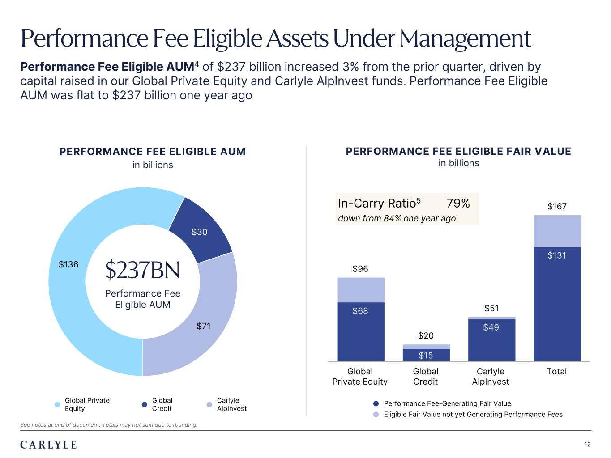
Plum R117 G45 B79 Dark Gray R101 G101 B101 Light Green R216 G240 B221 Pale Blue R221 G244 B255 Light Indigo R176 G188 B228 Indigo R49 G71 B143 Brown R96 G70 B60 Taupe R209 G199 B189 Light Gray R230 G230 B230 Dark Blue R22 G32 B64 Green R57 G108 B101 Champagne R251 G246 B237 Sky Blue R149 G218 B255 Salmon R240 G196 B188 12 $96 $20 $51 $167 $68 $15 $49 $131 Global Private Equity Global Credit Carlyle AlpInvest Total Performance Fee Eligible AUM4 of $237 billion increased 3% from the prior quarter, driven by capital raised in our Global Private Equity and Carlyle AlpInvest funds. Performance Fee Eligible AUM was flat to $237 billion one year ago Performance Fee Eligible Assets Under Management $136 $30 $71 $237BN Performance Fee Eligible AUM See notes at end of document. Totals may not sum due to rounding. PERFORMANCE FEE ELIGIBLE FAIR VALUE in billions PERFORMANCE FEE ELIGIBLE AUM in billions In-Carry Ratio5 79% down from 84% one year ago l Performance Fee-Generating Fair Value l Eligible Fair Value not yet Generating Performance Fees l Global Private Equity l Global Credit l Carlyle AlpInvest

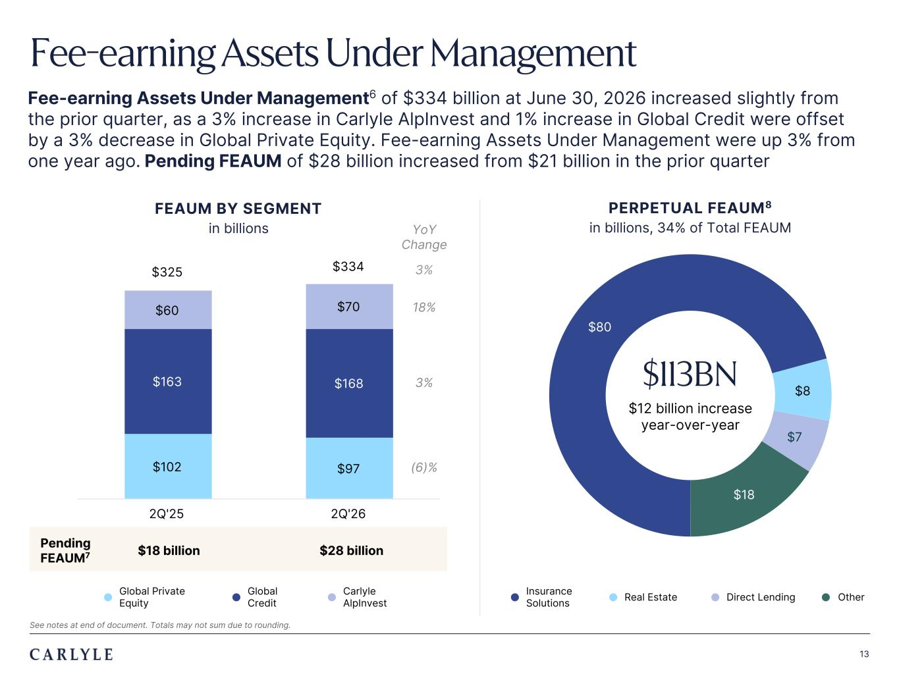
Plum R117 G45 B79 Dark Gray R101 G101 B101 Light Green R216 G240 B221 Pale Blue R221 G244 B255 Light Indigo R176 G188 B228 Indigo R49 G71 B143 Brown R96 G70 B60 Taupe R209 G199 B189 Light Gray R230 G230 B230 Dark Blue R22 G32 B64 Green R57 G108 B101 Champagne R251 G246 B237 Sky Blue R149 G218 B255 Salmon R240 G196 B188 13 $80 $8 $7 $18 $102 $97 $163 $168 $60 $70 $325 $334 2Q'25 2Q'26 Fee-earning Assets Under Management Fee-earning Assets Under Management6 of $334 billion at June 30, 2026 increased slightly from the prior quarter, as a 3% increase in Carlyle AlpInvest and 1% increase in Global Credit were offset by a 3% decrease in Global Private Equity. Fee-earning Assets Under Management were up 3% from one year ago. Pending FEAUM of $28 billion increased from $21 billion in the prior quarter Pending FEAUM7 $18 billion $28 billion FEAUM BY SEGMENT in billions PERPETUAL FEAUM8 in billions, 34% of Total FEAUMYoY Change 3% 18% 3% (6)% $113BN $12 billion increase year-over-year l Global Private Equity l Global Credit l Carlyle AlpInvest See notes at end of document. Totals may not sum due to rounding. l Insurance Solutions l Real Estate l Direct Lending l Other

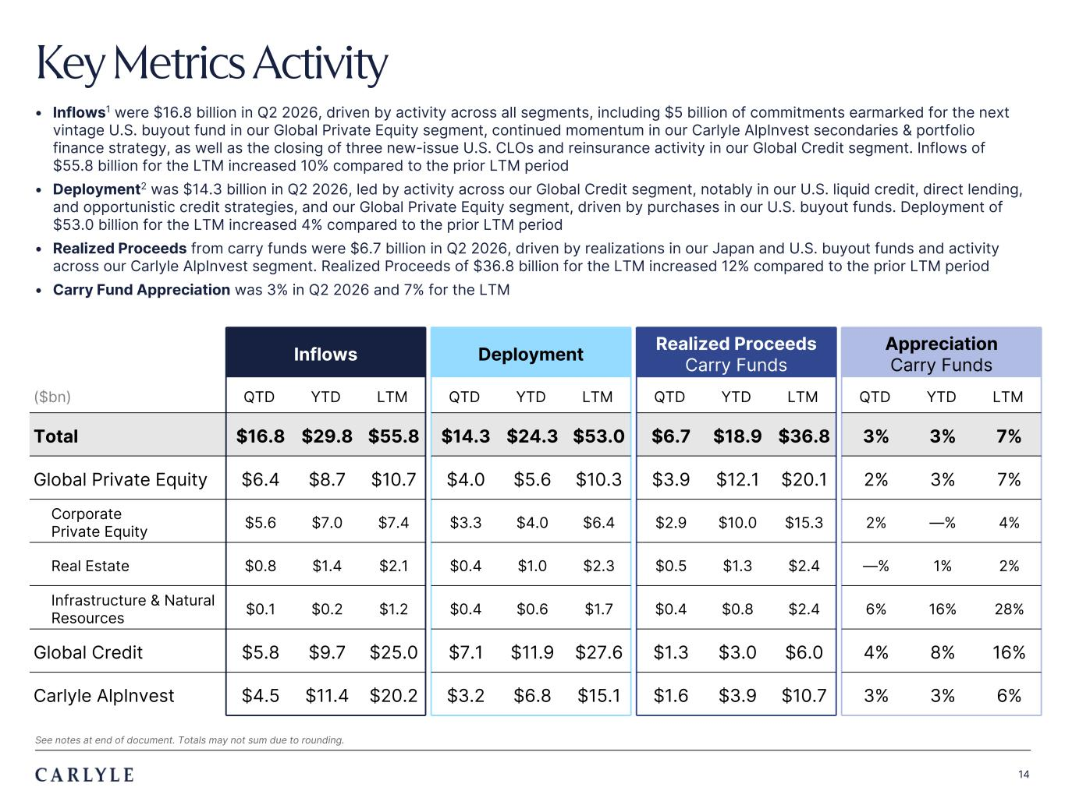
Plum R117 G45 B79 Dark Gray R101 G101 B101 Light Green R216 G240 B221 Pale Blue R221 G244 B255 Light Indigo R176 G188 B228 Indigo R49 G71 B143 Brown R96 G70 B60 Taupe R209 G199 B189 Light Gray R230 G230 B230 Dark Blue R22 G32 B64 Green R57 G108 B101 Champagne R251 G246 B237 Sky Blue R149 G218 B255 Salmon R240 G196 B188 14 Key Metrics Activity • Inflows1 were $16.8 billion in Q2 2026, driven by activity across all segments, including $5 billion of commitments earmarked for the next vintage U.S. buyout fund in our Global Private Equity segment, continued momentum in our Carlyle AlpInvest secondaries & portfolio finance strategy, as well as the closing of three new-issue U.S. CLOs and reinsurance activity in our Global Credit segment. Inflows of $55.8 billion for the LTM increased 10% compared to the prior LTM period • Deployment2 was $14.3 billion in Q2 2026, led by activity across our Global Credit segment, notably in our U.S. liquid credit, direct lending, and opportunistic credit strategies, and our Global Private Equity segment, driven by purchases in our U.S. buyout funds. Deployment of $53.0 billion for the LTM increased 4% compared to the prior LTM period • Realized Proceeds from carry funds were $6.7 billion in Q2 2026, driven by realizations in our Japan and U.S. buyout funds and activity across our Carlyle AlpInvest segment. Realized Proceeds of $36.8 billion for the LTM increased 12% compared to the prior LTM period • Carry Fund Appreciation was 3% in Q2 2026 and 7% for the LTM Inflows Deployment Realized Proceeds Carry Funds Appreciation Carry Funds ($bn) QTD YTD LTM QTD YTD LTM QTD YTD LTM QTD YTD LTM Total $16.8 $29.8 $55.8 $14.3 $24.3 $53.0 $6.7 $18.9 $36.8 3% 3% 7% Global Private Equity $6.4 $8.7 $10.7 $4.0 $5.6 $10.3 $3.9 $12.1 $20.1 2% 3% 7% Corporate Private Equity $5.6 $7.0 $7.4 $3.3 $4.0 $6.4 $2.9 $10.0 $15.3 2% —% 4% Real Estate $0.8 $1.4 $2.1 $0.4 $1.0 $2.3 $0.5 $1.3 $2.4 —% 1% 2% Infrastructure & Natural Resources $0.1 $0.2 $1.2 $0.4 $0.6 $1.7 $0.4 $0.8 $2.4 6% 16% 28% Global Credit $5.8 $9.7 $25.0 $7.1 $11.9 $27.6 $1.3 $3.0 $6.0 4% 8% 16% Carlyle AlpInvest $4.5 $11.4 $20.2 $3.2 $6.8 $15.1 $1.6 $3.9 $10.7 3% 3% 6% See notes at end of document. Totals may not sum due to rounding.

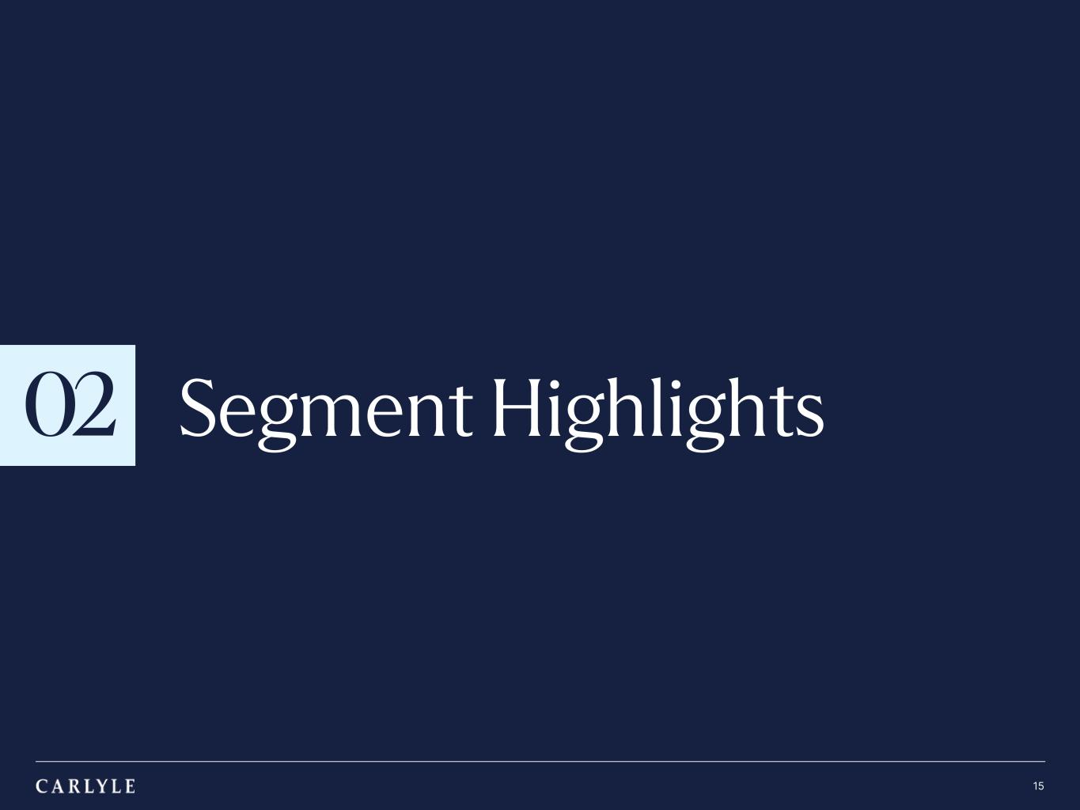
TRADE SECRET & STRICTLY CONFIDENTIAL 02 15 Segment Highlights

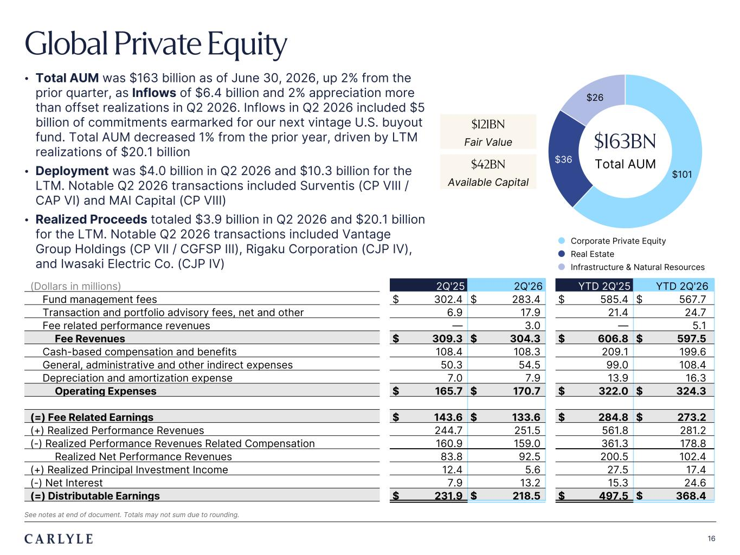
Plum R117 G45 B79 Dark Gray R101 G101 B101 Light Green R216 G240 B221 Pale Blue R221 G244 B255 Light Indigo R176 G188 B228 Indigo R49 G71 B143 Brown R96 G70 B60 Taupe R209 G199 B189 Light Gray R230 G230 B230 Dark Blue R22 G32 B64 Green R57 G108 B101 Champagne R251 G246 B237 Sky Blue R149 G218 B255 Salmon R240 G196 B188 16 Global Private Equity • Total AUM was $163 billion as of June 30, 2026, up 2% from the prior quarter, as Inflows of $6.4 billion and 2% appreciation more than offset realizations in Q2 2026. Inflows in Q2 2026 included $5 billion of commitments earmarked for our next vintage U.S. buyout fund. Total AUM decreased 1% from the prior year, driven by LTM realizations of $20.1 billion • Deployment was $4.0 billion in Q2 2026 and $10.3 billion for the LTM. Notable Q2 2026 transactions included Surventis (CP VIII / CAP VI) and MAI Capital (CP VIII) • Realized Proceeds totaled $3.9 billion in Q2 2026 and $20.1 billion for the LTM. Notable Q2 2026 transactions included Vantage Group Holdings (CP VII / CGFSP III), Rigaku Corporation (CJP IV), and Iwasaki Electric Co. (CJP IV) $101 $36 $26 $163BN Total AUM (Dollars in millions) 2Q'25 2Q'26 YTD 2Q'25 YTD 2Q'26 Fund management fees $ 302.4 $ 283.4 $ 585.4 $ 567.7 Transaction and portfolio advisory fees, net and other 6.9 17.9 21.4 24.7 Fee related performance revenues — 3.0 — 5.1 Fee Revenues $ 309.3 $ 304.3 $ 606.8 $ 597.5 Cash-based compensation and benefits 108.4 108.3 209.1 199.6 General, administrative and other indirect expenses 50.3 54.5 99.0 108.4 Depreciation and amortization expense 7.0 7.9 13.9 16.3 Operating Expenses $ 165.7 $ 170.7 $ 322.0 $ 324.3 (=) Fee Related Earnings $ 143.6 $ 133.6 $ 284.8 $ 273.2 (+) Realized Performance Revenues 244.7 251.5 561.8 281.2 (-) Realized Performance Revenues Related Compensation 160.9 159.0 361.3 178.8 Realized Net Performance Revenues 83.8 92.5 200.5 102.4 (+) Realized Principal Investment Income 12.4 5.6 27.5 17.4 (-) Net Interest 7.9 13.2 15.3 24.6 (=) Distributable Earnings $ 231.9 $ 218.5 $ 497.5 $ 368.4 $121BN Fair Value $42BN Available Capital See notes at end of document. Totals may not sum due to rounding. l Corporate Private Equity l Real Estate l Infrastructure & Natural Resources

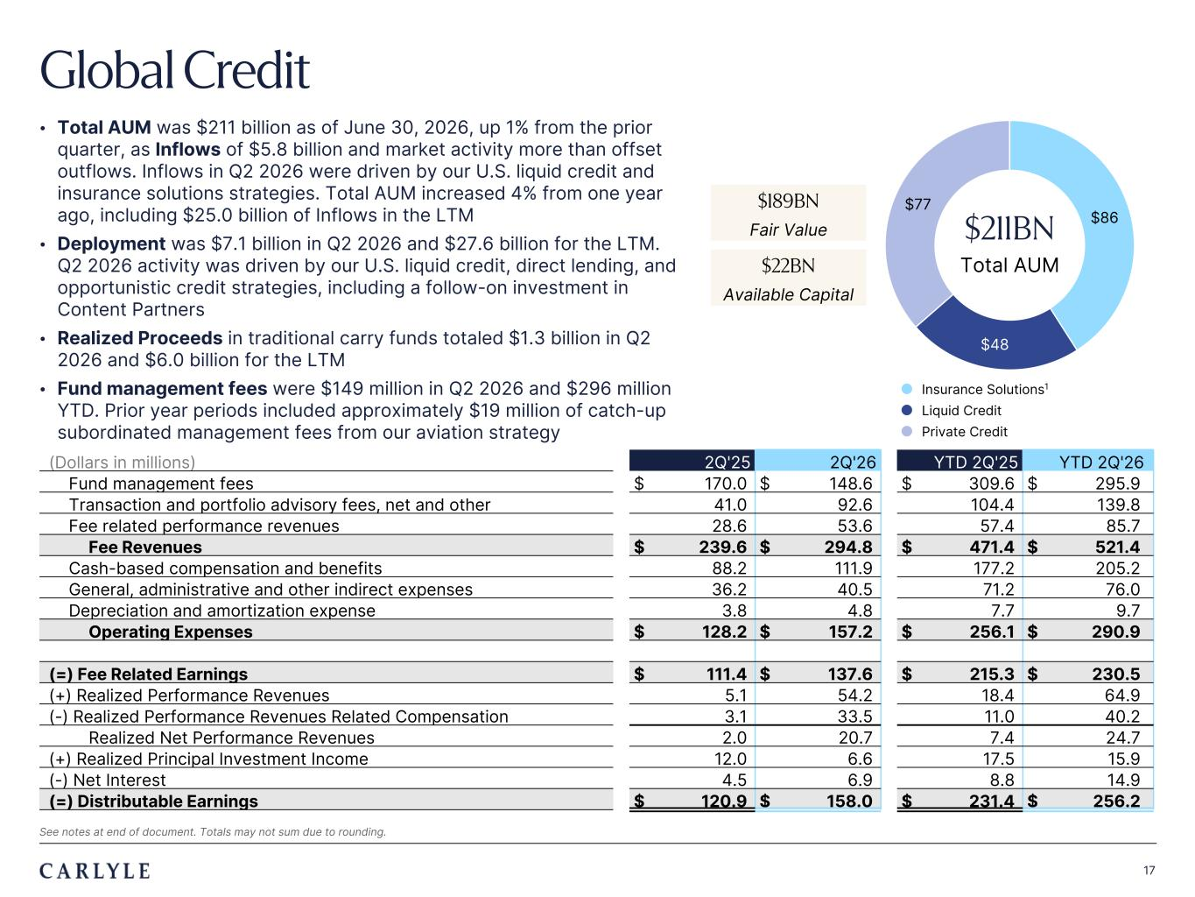
Plum R117 G45 B79 Dark Gray R101 G101 B101 Light Green R216 G240 B221 Pale Blue R221 G244 B255 Light Indigo R176 G188 B228 Indigo R49 G71 B143 Brown R96 G70 B60 Taupe R209 G199 B189 Light Gray R230 G230 B230 Dark Blue R22 G32 B64 Green R57 G108 B101 Champagne R251 G246 B237 Sky Blue R149 G218 B255 Salmon R240 G196 B188 17 Global Credit • Total AUM was $211 billion as of June 30, 2026, up 1% from the prior quarter, as Inflows of $5.8 billion and market activity more than offset outflows. Inflows in Q2 2026 were driven by our U.S. liquid credit and insurance solutions strategies. Total AUM increased 4% from one year ago, including $25.0 billion of Inflows in the LTM • Deployment was $7.1 billion in Q2 2026 and $27.6 billion for the LTM. Q2 2026 activity was driven by our U.S. liquid credit, direct lending, and opportunistic credit strategies, including a follow-on investment in Content Partners • Realized Proceeds in traditional carry funds totaled $1.3 billion in Q2 2026 and $6.0 billion for the LTM • Fund management fees were $149 million in Q2 2026 and $296 million YTD. Prior year periods included approximately $19 million of catch-up subordinated management fees from our aviation strategy (Dollars in millions) 2Q'25 2Q'26 YTD 2Q'25 YTD 2Q'26 Fund management fees $ 170.0 $ 148.6 $ 309.6 $ 295.9 Transaction and portfolio advisory fees, net and other 41.0 92.6 104.4 139.8 Fee related performance revenues 28.6 53.6 57.4 85.7 Fee Revenues $ 239.6 $ 294.8 $ 471.4 $ 521.4 Cash-based compensation and benefits 88.2 111.9 177.2 205.2 General, administrative and other indirect expenses 36.2 40.5 71.2 76.0 Depreciation and amortization expense 3.8 4.8 7.7 9.7 Operating Expenses $ 128.2 $ 157.2 $ 256.1 $ 290.9 (=) Fee Related Earnings $ 111.4 $ 137.6 $ 215.3 $ 230.5 (+) Realized Performance Revenues 5.1 54.2 18.4 64.9 (-) Realized Performance Revenues Related Compensation 3.1 33.5 11.0 40.2 Realized Net Performance Revenues 2.0 20.7 7.4 24.7 (+) Realized Principal Investment Income 12.0 6.6 17.5 15.9 (-) Net Interest 4.5 6.9 8.8 14.9 (=) Distributable Earnings $ 120.9 $ 158.0 $ 231.4 $ 256.2 $86 $48 $77 $211BN Total AUM $189BN Fair Value $22BN Available Capital l Insurance Solutions1 l Liquid Credit l Private Credit See notes at end of document. Totals may not sum due to rounding.

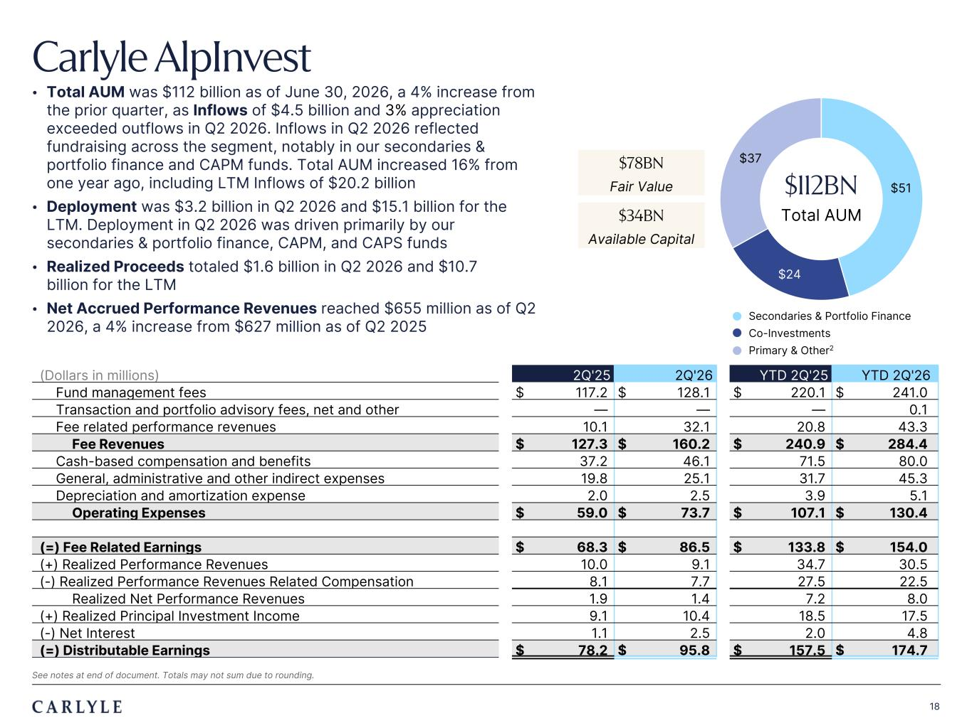
Plum R117 G45 B79 Dark Gray R101 G101 B101 Light Green R216 G240 B221 Pale Blue R221 G244 B255 Light Indigo R176 G188 B228 Indigo R49 G71 B143 Brown R96 G70 B60 Taupe R209 G199 B189 Light Gray R230 G230 B230 Dark Blue R22 G32 B64 Green R57 G108 B101 Champagne R251 G246 B237 Sky Blue R149 G218 B255 Salmon R240 G196 B188 18 Carlyle AlpInvest • Total AUM was $112 billion as of June 30, 2026, a 4% increase from the prior quarter, as Inflows of $4.5 billion and 3% appreciation exceeded outflows in Q2 2026. Inflows in Q2 2026 reflected fundraising across the segment, notably in our secondaries & portfolio finance and CAPM funds. Total AUM increased 16% from one year ago, including LTM Inflows of $20.2 billion • Deployment was $3.2 billion in Q2 2026 and $15.1 billion for the LTM. Deployment in Q2 2026 was driven primarily by our secondaries & portfolio finance, CAPM, and CAPS funds • Realized Proceeds totaled $1.6 billion in Q2 2026 and $10.7 billion for the LTM • Net Accrued Performance Revenues reached $655 million as of Q2 2026, a 4% increase from $627 million as of Q2 2025 (Dollars in millions) 2Q'25 2Q'26 YTD 2Q'25 YTD 2Q'26 Fund management fees $ 117.2 $ 128.1 $ 220.1 $ 241.0 Transaction and portfolio advisory fees, net and other — — — 0.1 Fee related performance revenues 10.1 32.1 20.8 43.3 Fee Revenues $ 127.3 $ 160.2 $ 240.9 $ 284.4 Cash-based compensation and benefits 37.2 46.1 71.5 80.0 General, administrative and other indirect expenses 19.8 25.1 31.7 45.3 Depreciation and amortization expense 2.0 2.5 3.9 5.1 Operating Expenses $ 59.0 $ 73.7 $ 107.1 $ 130.4 (=) Fee Related Earnings $ 68.3 $ 86.5 $ 133.8 $ 154.0 (+) Realized Performance Revenues 10.0 9.1 34.7 30.5 (-) Realized Performance Revenues Related Compensation 8.1 7.7 27.5 22.5 Realized Net Performance Revenues 1.9 1.4 7.2 8.0 (+) Realized Principal Investment Income 9.1 10.4 18.5 17.5 (-) Net Interest 1.1 2.5 2.0 4.8 (=) Distributable Earnings $ 78.2 $ 95.8 $ 157.5 $ 174.7 $51 $24 $37 $112BN Total AUM $78BN Fair Value $34BN Available Capital l Secondaries & Portfolio Finance l Co-Investments l Primary & Other2 See notes at end of document. Totals may not sum due to rounding.

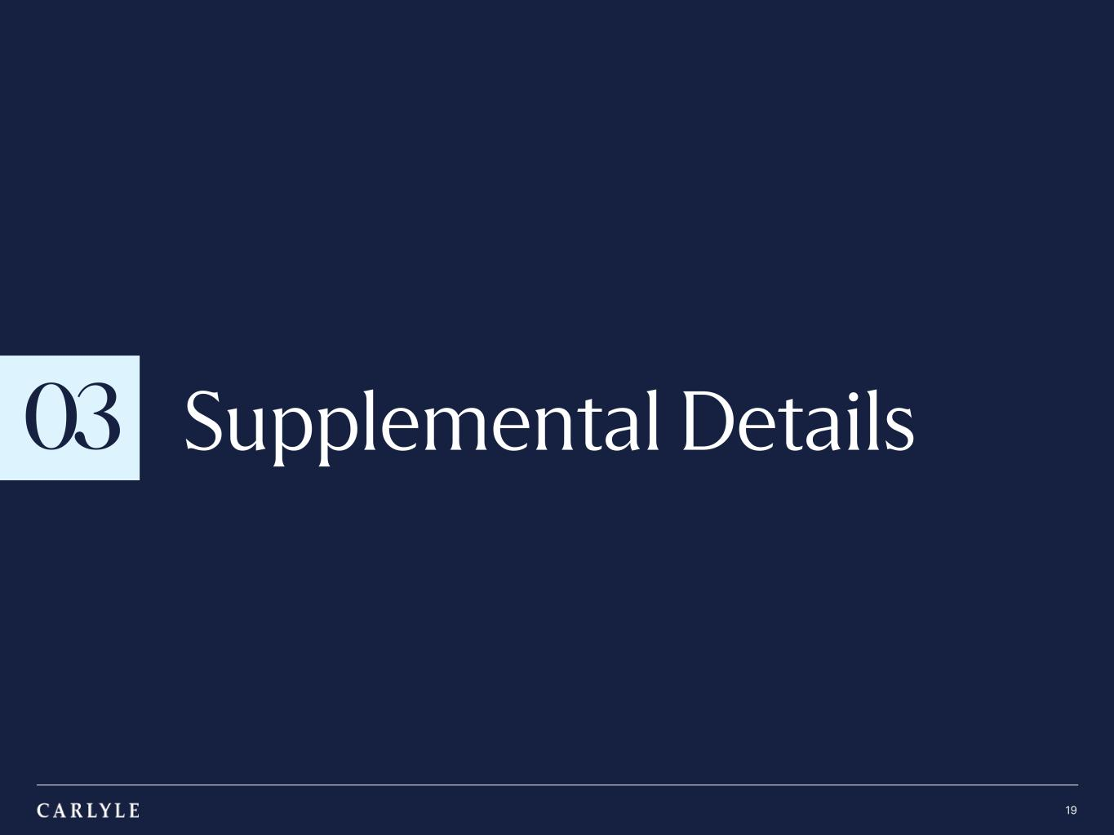
TRADE SECRET & STRICTLY CONFIDENTIAL 03 19 Supplemental Details

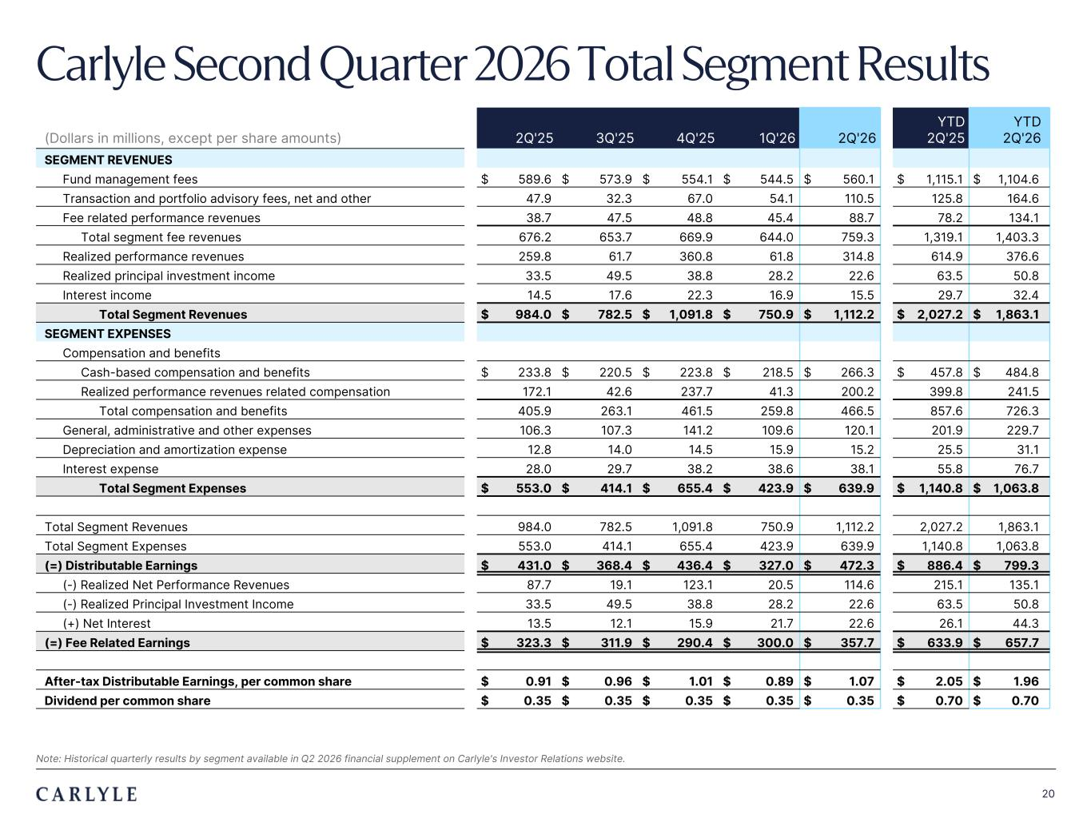
Plum R117 G45 B79 Dark Gray R101 G101 B101 Light Green R216 G240 B221 Pale Blue R221 G244 B255 Light Indigo R176 G188 B228 Indigo R49 G71 B143 Brown R96 G70 B60 Taupe R209 G199 B189 Light Gray R230 G230 B230 Dark Blue R22 G32 B64 Green R57 G108 B101 Champagne R251 G246 B237 Sky Blue R149 G218 B255 Salmon R240 G196 B188 20 Note: Historical quarterly results by segment available in Q2 2026 financial supplement on Carlyle's Investor Relations website. (Dollars in millions, except per share amounts) 2Q'25 3Q'25 4Q'25 1Q'26 2Q'26 YTD 2Q'25 YTD 2Q'26 SEGMENT REVENUES Fund management fees $ 589.6 $ 573.9 $ 554.1 $ 544.5 $ 560.1 $ 1,115.1 $ 1,104.6 Transaction and portfolio advisory fees, net and other 47.9 32.3 67.0 54.1 110.5 125.8 164.6 Fee related performance revenues 38.7 47.5 48.8 45.4 88.7 78.2 134.1 Total segment fee revenues 676.2 653.7 669.9 644.0 759.3 1,319.1 1,403.3 Realized performance revenues 259.8 61.7 360.8 61.8 314.8 614.9 376.6 Realized principal investment income 33.5 49.5 38.8 28.2 22.6 63.5 50.8 Interest income 14.5 17.6 22.3 16.9 15.5 29.7 32.4 Total Segment Revenues $ 984.0 $ 782.5 $ 1,091.8 $ 750.9 $ 1,112.2 $ 2,027.2 $ 1,863.1 SEGMENT EXPENSES Compensation and benefits Cash-based compensation and benefits $ 233.8 $ 220.5 $ 223.8 $ 218.5 $ 266.3 $ 457.8 $ 484.8 Realized performance revenues related compensation 172.1 42.6 237.7 41.3 200.2 399.8 241.5 Total compensation and benefits 405.9 263.1 461.5 259.8 466.5 857.6 726.3 General, administrative and other expenses 106.3 107.3 141.2 109.6 120.1 201.9 229.7 Depreciation and amortization expense 12.8 14.0 14.5 15.9 15.2 25.5 31.1 Interest expense 28.0 29.7 38.2 38.6 38.1 55.8 76.7 Total Segment Expenses $ 553.0 $ 414.1 $ 655.4 $ 423.9 $ 639.9 $ 1,140.8 $ 1,063.8 Total Segment Revenues 984.0 782.5 1,091.8 750.9 1,112.2 2,027.2 1,863.1 Total Segment Expenses 553.0 414.1 655.4 423.9 639.9 1,140.8 1,063.8 (=) Distributable Earnings $ 431.0 $ 368.4 $ 436.4 $ 327.0 $ 472.3 $ 886.4 $ 799.3 (-) Realized Net Performance Revenues 87.7 19.1 123.1 20.5 114.6 215.1 135.1 (-) Realized Principal Investment Income 33.5 49.5 38.8 28.2 22.6 63.5 50.8 (+) Net Interest 13.5 12.1 15.9 21.7 22.6 26.1 44.3 (=) Fee Related Earnings $ 323.3 $ 311.9 $ 290.4 $ 300.0 $ 357.7 $ 633.9 $ 657.7 After-tax Distributable Earnings, per common share $ 0.91 $ 0.96 $ 1.01 $ 0.89 $ 1.07 $ 2.05 $ 1.96 Dividend per common share $ 0.35 $ 0.35 $ 0.35 $ 0.35 $ 0.35 $ 0.70 $ 0.70 Carlyle Second Quarter 2026 Total Segment Results

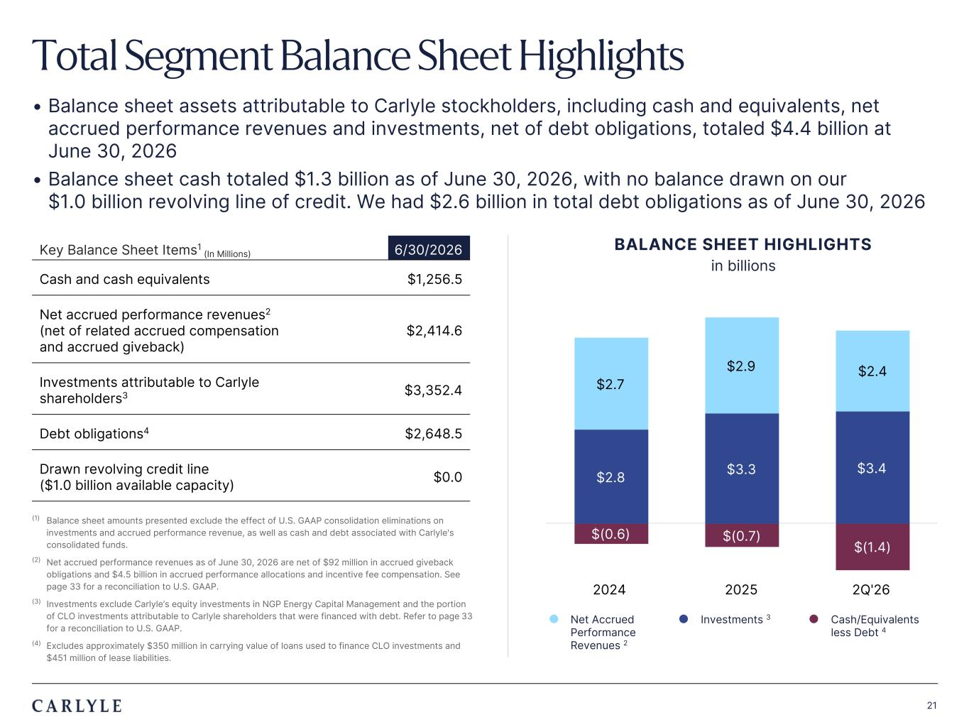
Plum R117 G45 B79 Dark Gray R101 G101 B101 Light Green R216 G240 B221 Pale Blue R221 G244 B255 Light Indigo R176 G188 B228 Indigo R49 G71 B143 Brown R96 G70 B60 Taupe R209 G199 B189 Light Gray R230 G230 B230 Dark Blue R22 G32 B64 Green R57 G108 B101 Champagne R251 G246 B237 Sky Blue R149 G218 B255 Salmon R240 G196 B188 21 Total Segment Balance Sheet Highlights • Balance sheet assets attributable to Carlyle stockholders, including cash and equivalents, net accrued performance revenues and investments, net of debt obligations, totaled $4.4 billion at June 30, 2026 • Balance sheet cash totaled $1.3 billion as of June 30, 2026, with no balance drawn on our $1.0 billion revolving line of credit. We had $2.6 billion in total debt obligations as of June 30, 2026 Key Balance Sheet Items1 (In Millions) 6/30/2026 Cash and cash equivalents $1,256.5 Net accrued performance revenues2 (net of related accrued compensation and accrued giveback) $2,414.6 Investments attributable to Carlyle shareholders3 $3,352.4 Debt obligations4 $2,648.5 Drawn revolving credit line ($1.0 billion available capacity) $0.0 (1) Balance sheet amounts presented exclude the effect of U.S. GAAP consolidation eliminations on investments and accrued performance revenue, as well as cash and debt associated with Carlyle's consolidated funds. (2) Net accrued performance revenues as of June 30, 2026 are net of $92 million in accrued giveback obligations and $4.5 billion in accrued performance allocations and incentive fee compensation. See page 33 for a reconciliation to U.S. GAAP. (3) Investments exclude Carlyle’s equity investments in NGP Energy Capital Management and the portion of CLO investments attributable to Carlyle shareholders that were financed with debt. Refer to page 33 for a reconciliation to U.S. GAAP. (4) Excludes approximately $350 million in carrying value of loans used to finance CLO investments and $451 million of lease liabilities. $(0.6) $(0.7) $(1.4) $2.8 $3.3 $3.4 $2.7 $2.9 $2.4 2024 2025 2Q'26 l Net Accrued Performance Revenues 2 l Investments 3 l Cash/Equivalents less Debt 4 BALANCE SHEET HIGHLIGHTS in billions

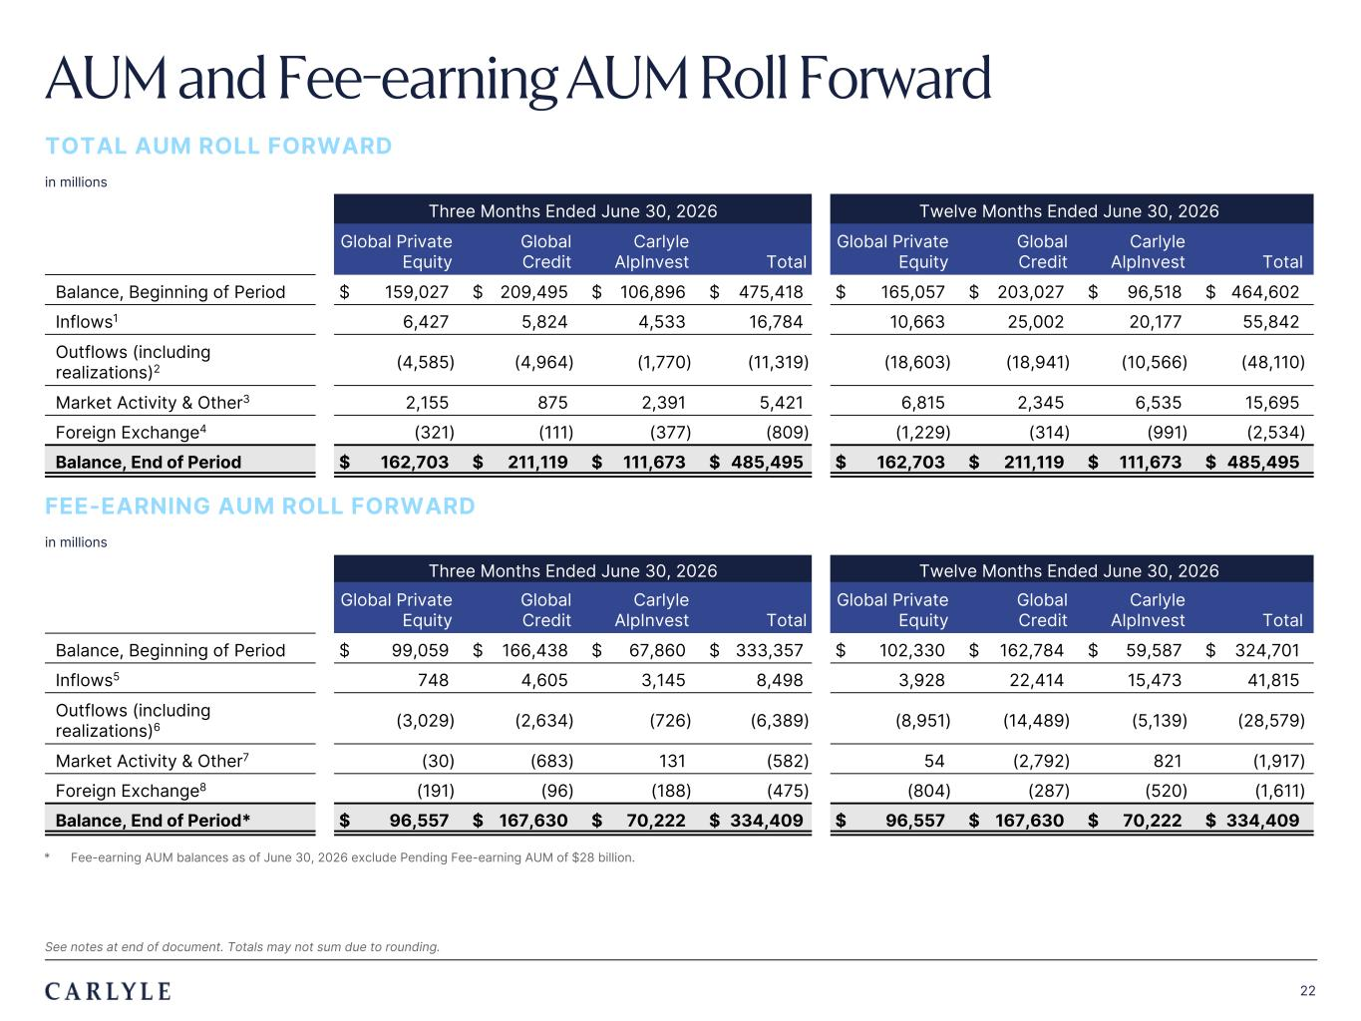
Plum R117 G45 B79 Dark Gray R101 G101 B101 Light Green R216 G240 B221 Pale Blue R221 G244 B255 Light Indigo R176 G188 B228 Indigo R49 G71 B143 Brown R96 G70 B60 Taupe R209 G199 B189 Light Gray R230 G230 B230 Dark Blue R22 G32 B64 Green R57 G108 B101 Champagne R251 G246 B237 Sky Blue R149 G218 B255 Salmon R240 G196 B188 22 Three Months Ended June 30, 2026 Twelve Months Ended June 30, 2026 Global Private Equity Global Credit Carlyle AlpInvest Total Global Private Equity Global Credit Carlyle AlpInvest Total Balance, Beginning of Period $ 159,027 $ 209,495 $ 106,896 $ 475,418 $ 165,057 $ 203,027 $ 96,518 $ 464,602 Inflows1 6,427 5,824 4,533 16,784 10,663 25,002 20,177 55,842 Outflows (including realizations)2 (4,585) (4,964) (1,770) (11,319) (18,603) (18,941) (10,566) (48,110) Market Activity & Other3 2,155 875 2,391 5,421 6,815 2,345 6,535 15,695 Foreign Exchange4 (321) (111) (377) (809) (1,229) (314) (991) (2,534) Balance, End of Period $ 162,703 $ 211,119 $ 111,673 $ 485,495 $ 162,703 $ 211,119 $ 111,673 $ 485,495 Three Months Ended June 30, 2026 Twelve Months Ended June 30, 2026 Global Private Equity Global Credit Carlyle AlpInvest Total Global Private Equity Global Credit Carlyle AlpInvest Total Balance, Beginning of Period $ 99,059 $ 166,438 $ 67,860 $ 333,357 $ 102,330 $ 162,784 $ 59,587 $ 324,701 Inflows5 748 4,605 3,145 8,498 3,928 22,414 15,473 41,815 Outflows (including realizations)6 (3,029) (2,634) (726) (6,389) (8,951) (14,489) (5,139) (28,579) Market Activity & Other7 (30) (683) 131 (582) 54 (2,792) 821 (1,917) Foreign Exchange8 (191) (96) (188) (475) (804) (287) (520) (1,611) Balance, End of Period* $ 96,557 $ 167,630 $ 70,222 $ 334,409 $ 96,557 $ 167,630 $ 70,222 $ 334,409 * Fee-earning AUM balances as of June 30, 2026 exclude Pending Fee-earning AUM of $28 billion. AUM and Fee-earning AUM Roll Forward TOTAL AUM ROLL FORWARD in millions FEE-EARNING AUM ROLL FORWARD in millions See notes at end of document. Totals may not sum due to rounding.

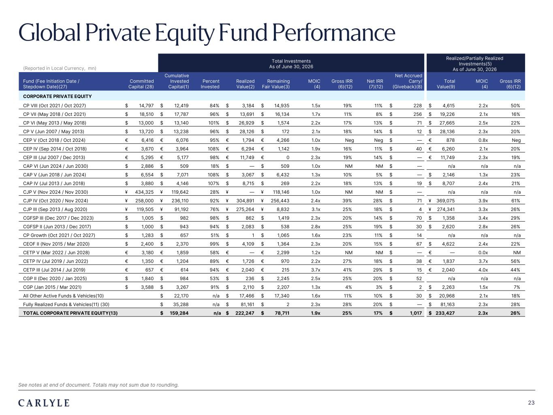
Plum R117 G45 B79 Dark Gray R101 G101 B101 Light Green R216 G240 B221 Pale Blue R221 G244 B255 Light Indigo R176 G188 B228 Indigo R49 G71 B143 Brown R96 G70 B60 Taupe R209 G199 B189 Light Gray R230 G230 B230 Dark Blue R22 G32 B64 Green R57 G108 B101 Champagne R251 G246 B237 Sky Blue R149 G218 B255 Salmon R240 G196 B188 23 Global Private Equity Fund Performance (Reported in Local Currency, mn) Total Investments As of June 30, 2026 Realized/Partially Realized Investments(5) As of June 30, 2026 Fund (Fee Initiation Date / Stepdown Date)(27) Committed Capital (28) Cumulative Invested Capital(1) Percent Invested Realized Value(2) Remaining Fair Value(3) MOIC (4) Gross IRR (6)(12) Net IRR (7)(12) Net Accrued Carry/ (Giveback)(8) Total Value(9) MOIC (4) Gross IRR (6)(12) CORPORATE PRIVATE EQUITY CP VIII (Oct 2021 / Oct 2027) $ 14,797 $ 12,419 84% $ 3,184 $ 14,935 1.5x 19% 11% $ 228 $ 4,615 2.2x 50% CP VII (May 2018 / Oct 2021) $ 18,510 $ 17,787 96% $ 13,691 $ 16,134 1.7x 11% 8% $ 256 $ 19,226 2.1x 16% CP VI (May 2013 / May 2018) $ 13,000 $ 13,140 101% $ 26,929 $ 1,574 2.2x 17% 13% $ 71 $ 27,665 2.5x 22% CP V (Jun 2007 / May 2013) $ 13,720 $ 13,238 96% $ 28,126 $ 172 2.1x 18% 14% $ 12 $ 28,136 2.3x 20% CEP V (Oct 2018 / Oct 2024) € 6,416 € 6,076 95% € 1,794 € 4,266 1.0x Neg Neg $ — € 878 0.8x Neg CEP IV (Sep 2014 / Oct 2018) € 3,670 € 3,964 108% € 6,294 € 1,142 1.9x 16% 11% $ 40 € 6,260 2.1x 20% CEP III (Jul 2007 / Dec 2013) € 5,295 € 5,177 98% € 11,749 € 0 2.3x 19% 14% $ — € 11,749 2.3x 19% CAP VI (Jun 2024 / Jun 2030) $ 2,886 $ 509 18% $ — $ 509 1.0x NM NM $ — n/a n/a n/a CAP V (Jun 2018 / Jun 2024) $ 6,554 $ 7,071 108% $ 3,067 $ 6,432 1.3x 10% 5% $ — $ 2,146 1.3x 23% CAP IV (Jul 2013 / Jun 2018) $ 3,880 $ 4,146 107% $ 8,715 $ 269 2.2x 18% 13% $ 19 $ 8,707 2.4x 21% CJP V (Nov 2024 / Nov 2030) ¥ 434,325 ¥ 119,642 28% ¥ — ¥ 118,146 1.0x NM NM $ — n/a n/a n/a CJP IV (Oct 2020 / Nov 2024) ¥ 258,000 ¥ 236,110 92% ¥ 304,891 ¥ 256,443 2.4x 39% 28% $ 71 ¥ 369,075 3.9x 61% CJP III (Sep 2013 / Aug 2020) ¥ 119,505 ¥ 91,192 76% ¥ 275,264 ¥ 8,832 3.1x 25% 18% $ 4 ¥ 274,341 3.3x 26% CGFSP III (Dec 2017 / Dec 2023) $ 1,005 $ 982 98% $ 862 $ 1,419 2.3x 20% 14% $ 70 $ 1,358 3.4x 29% CGFSP II (Jun 2013 / Dec 2017) $ 1,000 $ 943 94% $ 2,083 $ 538 2.8x 25% 19% $ 30 $ 2,620 2.8x 26% CP Growth (Oct 2021 / Oct 2027) $ 1,283 $ 657 51% $ 1 $ 1,065 1.6x 23% 11% $ 14 n/a n/a n/a CEOF II (Nov 2015 / Mar 2020) $ 2,400 $ 2,370 99% $ 4,109 $ 1,364 2.3x 20% 15% $ 67 $ 4,622 2.4x 22% CETP V (Mar 2022 / Jun 2028) € 3,180 € 1,859 58% € — € 2,299 1.2x NM NM $ — € — 0.0x NM CETP IV (Jul 2019 / Jun 2022) € 1,350 € 1,204 89% € 1,726 € 970 2.2x 27% 18% $ 38 € 1,837 3.7x 56% CETP III (Jul 2014 / Jul 2019) € 657 € 614 94% € 2,040 € 215 3.7x 41% 29% $ 15 € 2,040 4.0x 44% CGP II (Dec 2020 / Jan 2025) $ 1,840 $ 984 53% $ 236 $ 2,245 2.5x 25% 20% $ 52 n/a n/a n/a CGP (Jan 2015 / Mar 2021) $ 3,588 $ 3,267 91% $ 2,110 $ 2,207 1.3x 4% 3% $ 2 $ 2,263 1.5x 7% All Other Active Funds & Vehicles(10) $ 22,170 n/a $ 17,466 $ 17,340 1.6x 11% 10% $ 30 $ 20,968 2.1x 18% Fully Realized Funds & Vehicles(11) (30) $ 35,288 n/a $ 81,161 $ 2 2.3x 28% 20% $ — $ 81,163 2.3x 28% TOTAL CORPORATE PRIVATE EQUITY(13) $ 159,284 n/a $ 222,247 $ 78,711 1.9x 25% 17% $ 1,017 $ 233,427 2.3x 26% See notes at end of document. Totals may not sum due to rounding.

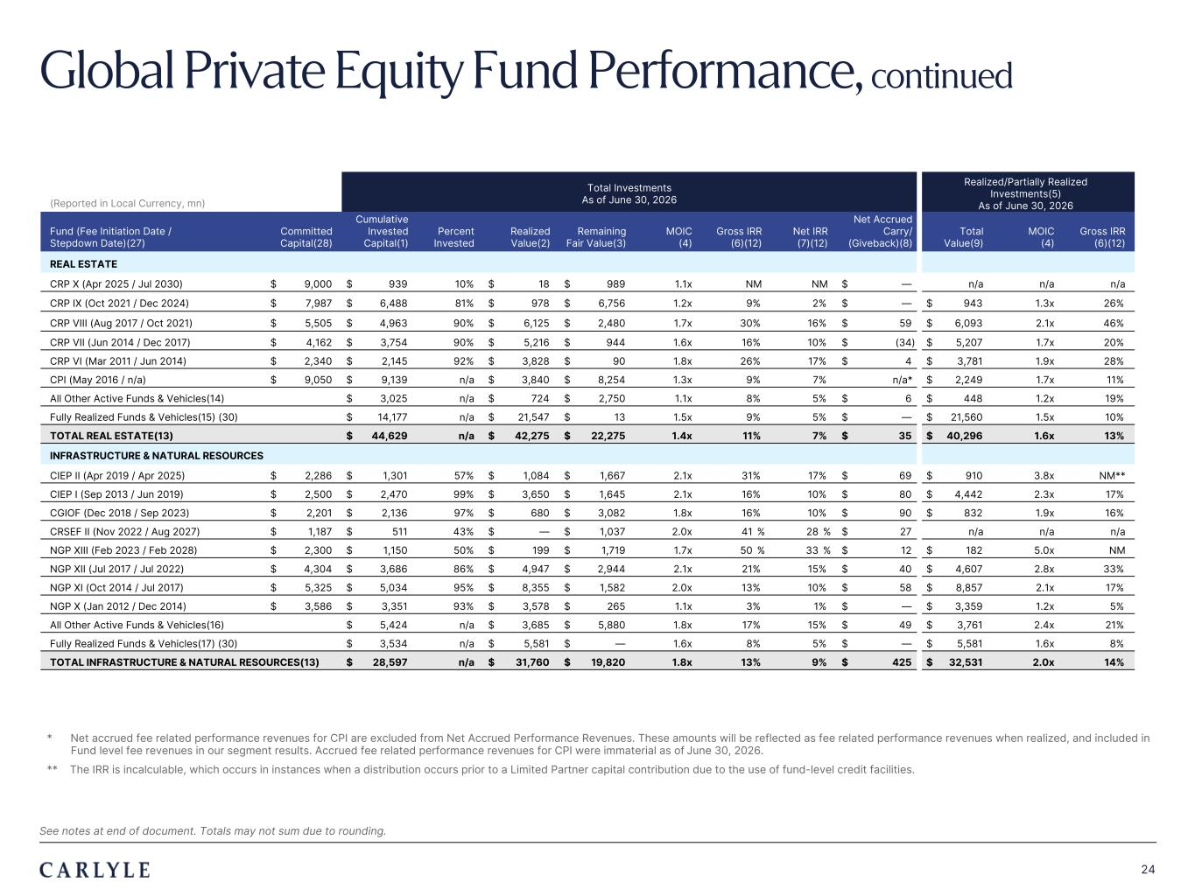
Plum R117 G45 B79 Dark Gray R101 G101 B101 Light Green R216 G240 B221 Pale Blue R221 G244 B255 Light Indigo R176 G188 B228 Indigo R49 G71 B143 Brown R96 G70 B60 Taupe R209 G199 B189 Light Gray R230 G230 B230 Dark Blue R22 G32 B64 Green R57 G108 B101 Champagne R251 G246 B237 Sky Blue R149 G218 B255 Salmon R240 G196 B188 24 Global Private Equity Fund Performance, continued (Reported in Local Currency, mn) Total Investments As of June 30, 2026 Realized/Partially Realized Investments(5) As of June 30, 2026 Fund (Fee Initiation Date / Stepdown Date)(27) Committed Capital(28) Cumulative Invested Capital(1) Percent Invested Realized Value(2) Remaining Fair Value(3) MOIC (4) Gross IRR (6)(12) Net IRR (7)(12) Net Accrued Carry/ (Giveback)(8) Total Value(9) MOIC (4) Gross IRR (6)(12) REAL ESTATE CRP X (Apr 2025 / Jul 2030) $ 9,000 $ 939 10% $ 18 $ 989 1.1x NM NM $ — n/a n/a n/a CRP IX (Oct 2021 / Dec 2024) $ 7,987 $ 6,488 81% $ 978 $ 6,756 1.2x 9% 2% $ — $ 943 1.3x 26% CRP VIII (Aug 2017 / Oct 2021) $ 5,505 $ 4,963 90% $ 6,125 $ 2,480 1.7x 30% 16% $ 59 $ 6,093 2.1x 46% CRP VII (Jun 2014 / Dec 2017) $ 4,162 $ 3,754 90% $ 5,216 $ 944 1.6x 16% 10% $ (34) $ 5,207 1.7x 20% CRP VI (Mar 2011 / Jun 2014) $ 2,340 $ 2,145 92% $ 3,828 $ 90 1.8x 26% 17% $ 4 $ 3,781 1.9x 28% CPI (May 2016 / n/a) $ 9,050 $ 9,139 n/a $ 3,840 $ 8,254 1.3x 9% 7% n/a* $ 2,249 1.7x 11% All Other Active Funds & Vehicles(14) $ 3,025 n/a $ 724 $ 2,750 1.1x 8% 5% $ 6 $ 448 1.2x 19% Fully Realized Funds & Vehicles(15) (30) $ 14,177 n/a $ 21,547 $ 13 1.5x 9% 5% $ — $ 21,560 1.5x 10% TOTAL REAL ESTATE(13) $ 44,629 n/a $ 42,275 $ 22,275 1.4x 11% 7% $ 35 $ 40,296 1.6x 13% & NINFRASTRUCTURE & NATURAL RESOURCES CIEP II (Apr 2019 / Apr 2025) $ 2,286 $ 1,301 57% $ 1,084 $ 1,667 2.1x 31% 17% $ 69 $ 910 3.8x NM** CIEP I (Sep 2013 / Jun 2019) $ 2,500 $ 2,470 99% $ 3,650 $ 1,645 2.1x 16% 10% $ 80 $ 4,442 2.3x 17% CGIOF (Dec 2018 / Sep 2023) $ 2,201 $ 2,136 97% $ 680 $ 3,082 1.8x 16% 10% $ 90 $ 832 1.9x 16% CRSEF II (Nov 2022 / Aug 2027) $ 1,187 $ 511 43% $ — $ 1,037 2.0x 41 % 28 % $ 27 n/a n/a n/a NGP XIII (Feb 2023 / Feb 2028) $ 2,300 $ 1,150 50% $ 199 $ 1,719 1.7x 50 % 33 % $ 12 $ 182 5.0x NM NGP XII (Jul 2017 / Jul 2022) $ 4,304 $ 3,686 86% $ 4,947 $ 2,944 2.1x 21% 15% $ 40 $ 4,607 2.8x 33% NGP XI (Oct 2014 / Jul 2017) $ 5,325 $ 5,034 95% $ 8,355 $ 1,582 2.0x 13% 10% $ 58 $ 8,857 2.1x 17% NGP X (Jan 2012 / Dec 2014) $ 3,586 $ 3,351 93% $ 3,578 $ 265 1.1x 3% 1% $ — $ 3,359 1.2x 5% All Other Active Funds & Vehicles(16) $ 5,424 n/a $ 3,685 $ 5,880 1.8x 17% 15% $ 49 $ 3,761 2.4x 21% Fully Realized Funds & Vehicles(17) (30) $ 3,534 n/a $ 5,581 $ — 1.6x 8% 5% $ — $ 5,581 1.6x 8% TOTAL INFRASTRUCTURE & NATURAL RESOURCES(13) $ 28,597 n/a $ 31,760 $ 19,820 1.8x 13% 9% $ 425 $ 32,531 2.0x 14% * Net accrued fee related performance revenues for CPI are excluded from Net Accrued Performance Revenues. These amounts will be reflected as fee related performance revenues when realized, and included in Fund level fee revenues in our segment results. Accrued fee related performance revenues for CPI were immaterial as of June 30, 2026. ** The IRR is incalculable, which occurs in instances when a distribution occurs prior to a Limited Partner capital contribution due to the use of fund-level credit facilities. See notes at end of document. Totals may not sum due to rounding.

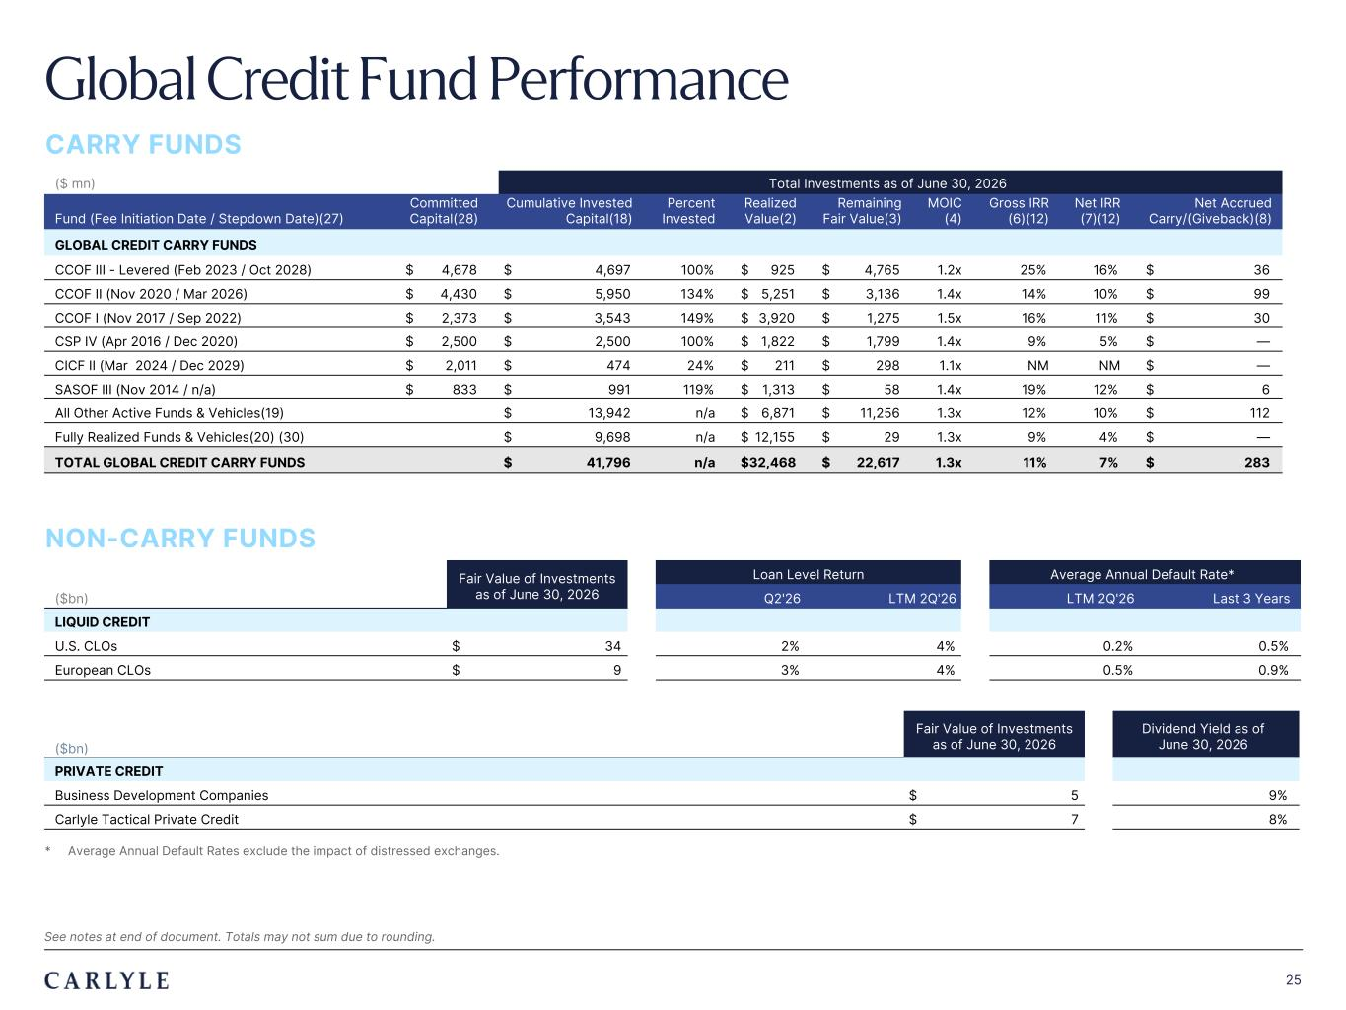
Plum R117 G45 B79 Dark Gray R101 G101 B101 Light Green R216 G240 B221 Pale Blue R221 G244 B255 Light Indigo R176 G188 B228 Indigo R49 G71 B143 Brown R96 G70 B60 Taupe R209 G199 B189 Light Gray R230 G230 B230 Dark Blue R22 G32 B64 Green R57 G108 B101 Champagne R251 G246 B237 Sky Blue R149 G218 B255 Salmon R240 G196 B188 25 Global Credit Fund Performance CARRY FUNDS ($ mn) Total Investments as of June 30, 2026 Fund (Fee Initiation Date / Stepdown Date)(27) Committed Capital(28) Cumulative Invested Capital(18) Percent Invested Realized Value(2) Remaining Fair Value(3) MOIC (4) Gross IRR (6)(12) Net IRR (7)(12) Net Accrued Carry/(Giveback)(8) GLOBAL CREDIT CARRY FUNDS CCOF III - Levered (Feb 2023 / Oct 2028) $ 4,678 $ 4,697 100% $ 925 $ 4,765 1.2x 25% 16% $ 36 CCOF II (Nov 2020 / Mar 2026) $ 4,430 $ 5,950 134% $ 5,251 $ 3,136 1.4x 14% 10% $ 99 CCOF I (Nov 2017 / Sep 2022) $ 2,373 $ 3,543 149% $ 3,920 $ 1,275 1.5x 16% 11% $ 30 CSP IV (Apr 2016 / Dec 2020) $ 2,500 $ 2,500 100% $ 1,822 $ 1,799 1.4x 9% 5% $ — CICF II (Mar 2024 / Dec 2029) $ 2,011 $ 474 24% $ 211 $ 298 1.1x NM NM $ — SASOF III (Nov 2014 / n/a) $ 833 $ 991 119% $ 1,313 $ 58 1.4x 19% 12% $ 6 All Other Active Funds & Vehicles(19) $ 13,942 n/a $ 6,871 $ 11,256 1.3x 12% 10% $ 112 Fully Realized Funds & Vehicles(20) (30) $ 9,698 n/a $ 12,155 $ 29 1.3x 9% 4% $ — TOTAL GLOBAL CREDIT CARRY FUNDS $ 41,796 n/a $ 32,468 $ 22,617 1.3x 11% 7% $ 283 NON-CARRY FUNDS Fair Value of Investments as of June 30, 2026 Loan Level Return Average Annual Default Rate* ($bn) Q2'26 LTM 2Q'26 LTM 2Q'26 Last 3 Years LIQUID CREDIT U.S. CLOs $ 34 2% 4% 0.2% 0.5% European CLOs $ 9 3% 4% 0.5% 0.9% * Average Annual Default Rates exclude the impact of distressed exchanges. See notes at end of document. Totals may not sum due to rounding. Fair Value of Investments as of June 30, 2026 Dividend Yield as of June 30, 2026($bn) PRIVATE CREDIT Business Development Companies $ 5 9% Carlyle Tactical Private Credit $ 7 8%

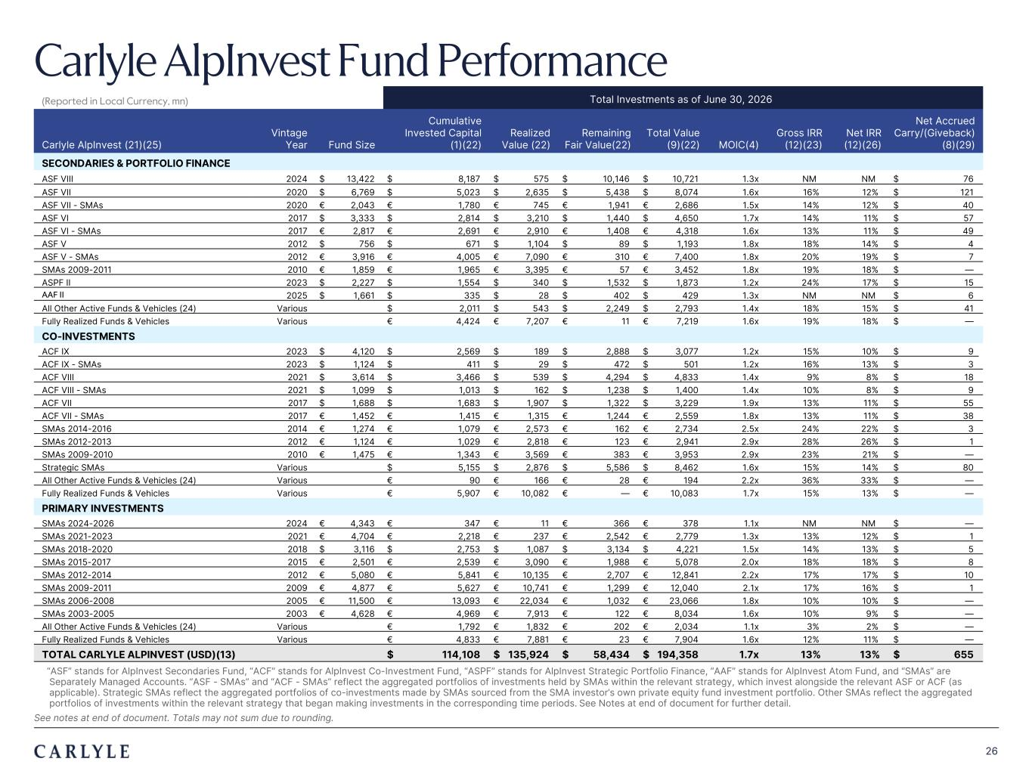
Plum R117 G45 B79 Dark Gray R101 G101 B101 Light Green R216 G240 B221 Pale Blue R221 G244 B255 Light Indigo R176 G188 B228 Indigo R49 G71 B143 Brown R96 G70 B60 Taupe R209 G199 B189 Light Gray R230 G230 B230 Dark Blue R22 G32 B64 Green R57 G108 B101 Champagne R251 G246 B237 Sky Blue R149 G218 B255 Salmon R240 G196 B188 26 Carlyle AlpInvest Fund Performance (Reported in Local Currency, mn) Total Investments as of June 30, 2026 Carlyle AlpInvest (21)(25) Vintage Year Fund Size Cumulative Invested Capital (1)(22) Realized Value (22) Remaining Fair Value(22) Total Value (9)(22) MOIC(4) Gross IRR (12)(23) Net IRR (12)(26) Net Accrued Carry/(Giveback) (8)(29) SECONDARIES & PORTFOLIO FINANCE ASF VIII 2024 $ 13,422 $ 8,187 $ 575 $ 10,146 $ 10,721 1.3x NM NM $ 76 ASF VII 2020 $ 6,769 $ 5,023 $ 2,635 $ 5,438 $ 8,074 1.6x 16% 12% $ 121 ASF VII - SMAs 2020 € 2,043 € 1,780 € 745 € 1,941 € 2,686 1.5x 14% 12% $ 40 ASF VI 2017 $ 3,333 $ 2,814 $ 3,210 $ 1,440 $ 4,650 1.7x 14% 11% $ 57 ASF VI - SMAs 2017 € 2,817 € 2,691 € 2,910 € 1,408 € 4,318 1.6x 13% 11% $ 49 ASF V 2012 $ 756 $ 671 $ 1,104 $ 89 $ 1,193 1.8x 18% 14% $ 4 ASF V - SMAs 2012 € 3,916 € 4,005 € 7,090 € 310 € 7,400 1.8x 20% 19% $ 7 SMAs 2009-2011 2010 € 1,859 € 1,965 € 3,395 € 57 € 3,452 1.8x 19% 18% $ — ASPF II 2023 $ 2,227 $ 1,554 $ 340 $ 1,532 $ 1,873 1.2x 24% 17% $ 15 AAF II 2025 $ 1,661 $ 335 $ 28 $ 402 $ 429 1.3x NM NM $ 6 All Other Active Funds & Vehicles (24) Various $ 2,011 $ 543 $ 2,249 $ 2,793 1.4x 18% 15% $ 41 Fully Realized Funds & Vehicles Various € 4,424 € 7,207 € 11 € 7,219 1.6x 19% 18% $ — CO-INVESTMENTS ACF IX 2023 $ 4,120 $ 2,569 $ 189 $ 2,888 $ 3,077 1.2x 15% 10% $ 9 ACF IX - SMAs 2023 $ 1,124 $ 411 $ 29 $ 472 $ 501 1.2x 16% 13% $ 3 ACF VIII 2021 $ 3,614 $ 3,466 $ 539 $ 4,294 $ 4,833 1.4x 9% 8% $ 18 ACF VIII - SMAs 2021 $ 1,099 $ 1,013 $ 162 $ 1,238 $ 1,400 1.4x 10% 8% $ 9 ACF VII 2017 $ 1,688 $ 1,683 $ 1,907 $ 1,322 $ 3,229 1.9x 13% 11% $ 55 ACF VII - SMAs 2017 € 1,452 € 1,415 € 1,315 € 1,244 € 2,559 1.8x 13% 11% $ 38 SMAs 2014-2016 2014 € 1,274 € 1,079 € 2,573 € 162 € 2,734 2.5x 24% 22% $ 3 SMAs 2012-2013 2012 € 1,124 € 1,029 € 2,818 € 123 € 2,941 2.9x 28% 26% $ 1 SMAs 2009-2010 2010 € 1,475 € 1,343 € 3,569 € 383 € 3,953 2.9x 23% 21% $ — Strategic SMAs Various $ 5,155 $ 2,876 $ 5,586 $ 8,462 1.6x 15% 14% $ 80 All Other Active Funds & Vehicles (24) Various € 90 € 166 € 28 € 194 2.2x 36% 33% $ — Fully Realized Funds & Vehicles Various € 5,907 € 10,082 € — € 10,083 1.7x 15% 13% $ — PRIMARY INVESTMENTS SMAs 2024-2026 2024 € 4,343 € 347 € 11 € 366 € 378 1.1x NM NM $ — SMAs 2021-2023 2021 € 4,704 € 2,218 € 237 € 2,542 € 2,779 1.3x 13% 12% $ 1 SMAs 2018-2020 2018 $ 3,116 $ 2,753 $ 1,087 $ 3,134 $ 4,221 1.5x 14% 13% $ 5 SMAs 2015-2017 2015 € 2,501 € 2,539 € 3,090 € 1,988 € 5,078 2.0x 18% 18% $ 8 SMAs 2012-2014 2012 € 5,080 € 5,841 € 10,135 € 2,707 € 12,841 2.2x 17% 17% $ 10 SMAs 2009-2011 2009 € 4,877 € 5,627 € 10,741 € 1,299 € 12,040 2.1x 17% 16% $ 1 SMAs 2006-2008 2005 € 11,500 € 13,093 € 22,034 € 1,032 € 23,066 1.8x 10% 10% $ — SMAs 2003-2005 2003 € 4,628 € 4,969 € 7,913 € 122 € 8,034 1.6x 10% 9% $ — All Other Active Funds & Vehicles (24) Various € 1,792 € 1,832 € 202 € 2,034 1.1x 3% 2% $ — Fully Realized Funds & Vehicles Various € 4,833 € 7,881 € 23 € 7,904 1.6x 12% 11% $ — TOTAL CARLYLE ALPINVEST (USD)(13) $ 114,108 $ 135,924 $ 58,434 $ 194,358 1.7x 13% 13% $ 655 “ASF” stands for AlpInvest Secondaries Fund, “ACF” stands for AlpInvest Co-Investment Fund, “ASPF” stands for AlpInvest Strategic Portfolio Finance, “AAF” stands for AlpInvest Atom Fund, and “SMAs” are Separately Managed Accounts. “ASF - SMAs” and “ACF - SMAs” reflect the aggregated portfolios of investments held by SMAs within the relevant strategy, which invest alongside the relevant ASF or ACF (as applicable). Strategic SMAs reflect the aggregated portfolios of co-investments made by SMAs sourced from the SMA investor’s own private equity fund investment portfolio. Other SMAs reflect the aggregated portfolios of investments within the relevant strategy that began making investments in the corresponding time periods. See Notes at end of document for further detail. See notes at end of document. Totals may not sum due to rounding.


TRADE SECRET & STRICTLY CONFIDENTIAL 04 27 Reconciliations & Disclosures

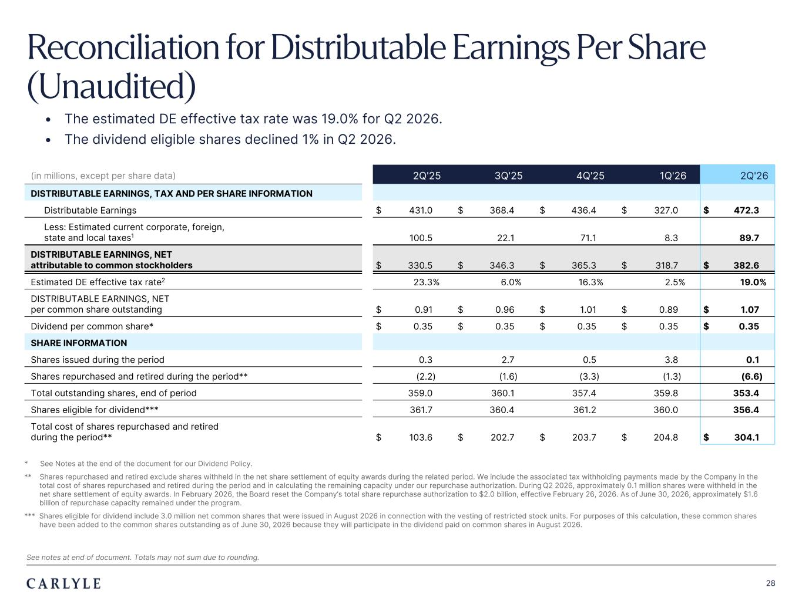
Plum R117 G45 B79 Dark Gray R101 G101 B101 Light Green R216 G240 B221 Pale Blue R221 G244 B255 Light Indigo R176 G188 B228 Indigo R49 G71 B143 Brown R96 G70 B60 Taupe R209 G199 B189 Light Gray R230 G230 B230 Dark Blue R22 G32 B64 Green R57 G108 B101 Champagne R251 G246 B237 Sky Blue R149 G218 B255 Salmon R240 G196 B188 28 Reconciliation for Distributable Earnings Per Share (Unaudited) * See Notes at the end of the document for our Dividend Policy. ** Shares repurchased and retired exclude shares withheld in the net share settlement of equity awards during the related period. We include the associated tax withholding payments made by the Company in the total cost of shares repurchased and retired during the period and in calculating the remaining capacity under our repurchase authorization. During Q2 2026, approximately 0.1 million shares were withheld in the net share settlement of equity awards. In February 2026, the Board reset the Company’s total share repurchase authorization to $2.0 billion, effective February 26, 2026. As of June 30, 2026, approximately $1.6 billion of repurchase capacity remained under the program. *** Shares eligible for dividend include 3.0 million net common shares that were issued in August 2026 in connection with the vesting of restricted stock units. For purposes of this calculation, these common shares have been added to the common shares outstanding as of June 30, 2026 because they will participate in the dividend paid on common shares in August 2026. (in millions, except per share data) 2Q'25 3Q'25 4Q'25 1Q'26 2Q'26 DISTRIBUTABLE EARNINGS, TAX AND PER SHARE INFORMATION Distributable Earnings $ 431.0 $ 368.4 $ 436.4 $ 327.0 $ 472.3 Less: Estimated current corporate, foreign, state and local taxes1 100.5 22.1 71.1 8.3 89.7 DISTRIBUTABLE EARNINGS, NET attributable to common stockholders $ 330.5 $ 346.3 $ 365.3 $ 318.7 $ 382.6 Estimated DE effective tax rate2 23.3% 6.0% 16.3% 2.5% 19.0% DISTRIBUTABLE EARNINGS, NET per common share outstanding $ 0.91 $ 0.96 $ 1.01 $ 0.89 $ 1.07 Dividend per common share* $ 0.35 $ 0.35 $ 0.35 $ 0.35 $ 0.35 SHARE INFORMATION Shares issued during the period 0.3 2.7 0.5 3.8 0.1 Shares repurchased and retired during the period** (2.2) (1.6) (3.3) (1.3) (6.6) Total outstanding shares, end of period 359.0 360.1 357.4 359.8 353.4 Shares eligible for dividend*** 361.7 360.4 361.2 360.0 356.4 Total cost of shares repurchased and retired during the period** $ 103.6 $ 202.7 $ 203.7 $ 204.8 $ 304.1 See notes at end of document. Totals may not sum due to rounding. • The estimated DE effective tax rate was 19.0% for Q2 2026. • The dividend eligible shares declined 1% in Q2 2026.

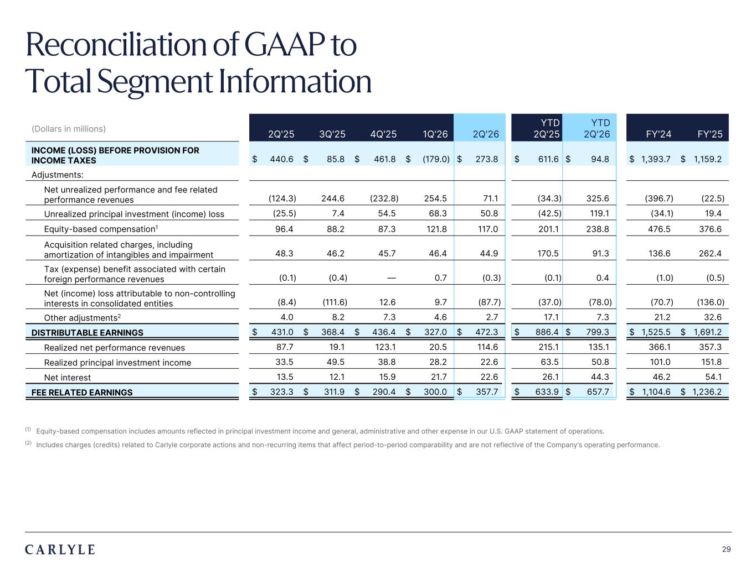
Plum R117 G45 B79 Dark Gray R101 G101 B101 Light Green R216 G240 B221 Pale Blue R221 G244 B255 Light Indigo R176 G188 B228 Indigo R49 G71 B143 Brown R96 G70 B60 Taupe R209 G199 B189 Light Gray R230 G230 B230 Dark Blue R22 G32 B64 Green R57 G108 B101 Champagne R251 G246 B237 Sky Blue R149 G218 B255 Salmon R240 G196 B188 29 (1) Equity-based compensation includes amounts reflected in principal investment income and general, administrative and other expense in our U.S. GAAP statement of operations. (2) Includes charges (credits) related to Carlyle corporate actions and non-recurring items that affect period-to-period comparability and are not reflective of the Company’s operating performance. (Dollars in millions) 2Q'25 3Q'25 4Q'25 1Q'26 2Q'26 YTD 2Q'25 YTD 2Q'26 FY'24 FY'25 INCOME (LOSS) BEFORE PROVISION FOR INCOME TAXES $ 440.6 $ 85.8 $ 461.8 $ (179.0) $ 273.8 $ 611.6 $ 94.8 $ 1,393.7 $ 1,159.2 Adjustments: Net unrealized performance and fee related performance revenues (124.3) 244.6 (232.8) 254.5 71.1 (34.3) 325.6 (396.7) (22.5) Unrealized principal investment (income) loss (25.5) 7.4 54.5 68.3 50.8 (42.5) 119.1 (34.1) 19.4 Equity-based compensation1 96.4 88.2 87.3 121.8 117.0 201.1 238.8 476.5 376.6 Acquisition related charges, including amortization of intangibles and impairment 48.3 46.2 45.7 46.4 44.9 170.5 91.3 136.6 262.4 Tax (expense) benefit associated with certain foreign performance revenues (0.1) (0.4) — 0.7 (0.3) (0.1) 0.4 (1.0) (0.5) Net (income) loss attributable to non-controlling interests in consolidated entities (8.4) (111.6) 12.6 9.7 (87.7) (37.0) (78.0) (70.7) (136.0) Other adjustments2 4.0 8.2 7.3 4.6 2.7 17.1 7.3 21.2 32.6 DISTRIBUTABLE EARNINGS $ 431.0 $ 368.4 $ 436.4 $ 327.0 $ 472.3 $ 886.4 $ 799.3 $ 1,525.5 $ 1,691.2 Realized net performance revenues 87.7 19.1 123.1 20.5 114.6 215.1 135.1 366.1 357.3 Realized principal investment income 33.5 49.5 38.8 28.2 22.6 63.5 50.8 101.0 151.8 Net interest 13.5 12.1 15.9 21.7 22.6 26.1 44.3 46.2 54.1 FEE RELATED EARNINGS $ 323.3 $ 311.9 $ 290.4 $ 300.0 $ 357.7 $ 633.9 $ 657.7 $ 1,104.6 $ 1,236.2 Reconciliation of GAAP to Total Segment Information

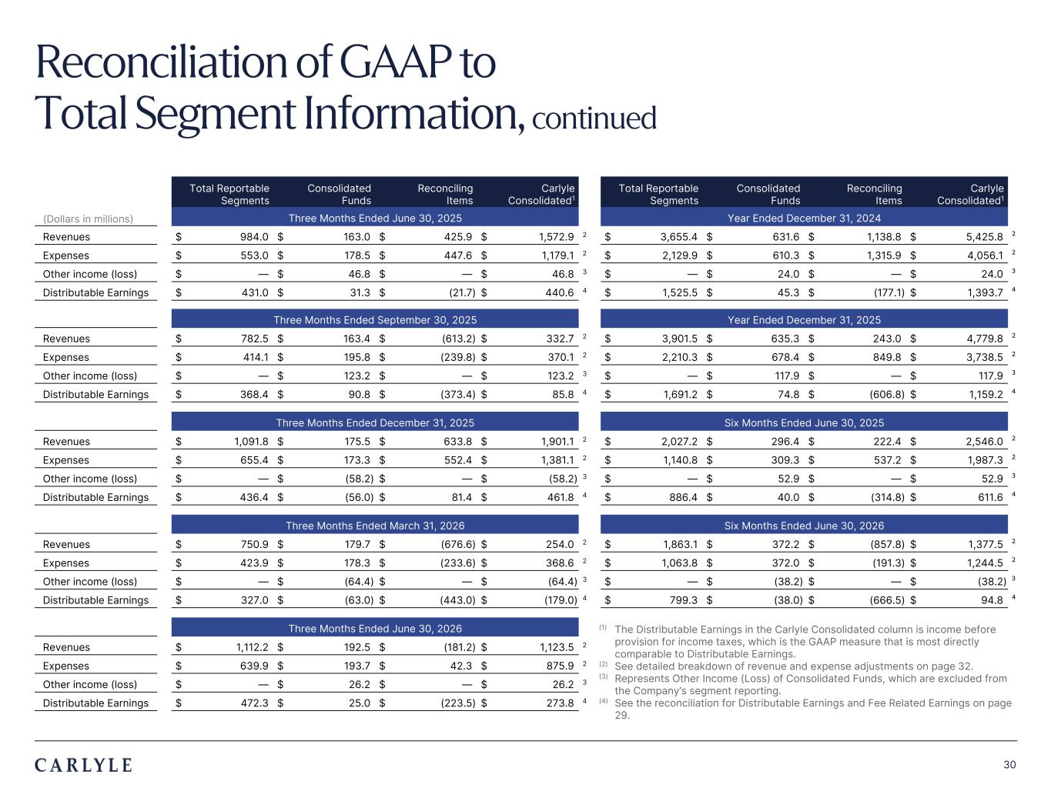
Plum R117 G45 B79 Dark Gray R101 G101 B101 Light Green R216 G240 B221 Pale Blue R221 G244 B255 Light Indigo R176 G188 B228 Indigo R49 G71 B143 Brown R96 G70 B60 Taupe R209 G199 B189 Light Gray R230 G230 B230 Dark Blue R22 G32 B64 Green R57 G108 B101 Champagne R251 G246 B237 Sky Blue R149 G218 B255 Salmon R240 G196 B188 30 Total Reportable Segments Consolidated Funds Reconciling Items Carlyle Consolidated1 Total Reportable Segments Consolidated Funds Reconciling Items Carlyle Consolidated1 (Dollars in millions) Three Months Ended June 30, 2025 Year Ended December 31, 2024 Revenues $ 984.0 $ 163.0 $ 425.9 $ 1,572.9 2 $ 3,655.4 $ 631.6 $ 1,138.8 $ 5,425.8 2 Expenses $ 553.0 $ 178.5 $ 447.6 $ 1,179.1 2 $ 2,129.9 $ 610.3 $ 1,315.9 $ 4,056.1 2 Other income (loss) $ — $ 46.8 $ — $ 46.8 3 $ — $ 24.0 $ — $ 24.0 3 Distributable Earnings $ 431.0 $ 31.3 $ (21.7) $ 440.6 4 $ 1,525.5 $ 45.3 $ (177.1) $ 1,393.7 4 Three Months Ended September 30, 2025 Year Ended December 31, 2025 Revenues $ 782.5 $ 163.4 $ (613.2) $ 332.7 2 $ 3,901.5 $ 635.3 $ 243.0 $ 4,779.8 2 Expenses $ 414.1 $ 195.8 $ (239.8) $ 370.1 2 $ 2,210.3 $ 678.4 $ 849.8 $ 3,738.5 2 Other income (loss) $ — $ 123.2 $ — $ 123.2 3 $ — $ 117.9 $ — $ 117.9 3 Distributable Earnings $ 368.4 $ 90.8 $ (373.4) $ 85.8 4 $ 1,691.2 $ 74.8 $ (606.8) $ 1,159.2 4 Three Months Ended December 31, 2025 Six Months Ended June 30, 2025 Revenues $ 1,091.8 $ 175.5 $ 633.8 $ 1,901.1 2 $ 2,027.2 $ 296.4 $ 222.4 $ 2,546.0 2 Expenses $ 655.4 $ 173.3 $ 552.4 $ 1,381.1 2 $ 1,140.8 $ 309.3 $ 537.2 $ 1,987.3 2 Other income (loss) $ — $ (58.2) $ — $ (58.2) 3 $ — $ 52.9 $ — $ 52.9 3 Distributable Earnings $ 436.4 $ (56.0) $ 81.4 $ 461.8 4 $ 886.4 $ 40.0 $ (314.8) $ 611.6 4 Three Months Ended March 31, 2026 Six Months Ended June 30, 2026 Revenues $ 750.9 $ 179.7 $ (676.6) $ 254.0 2 $ 1,863.1 $ 372.2 $ (857.8) $ 1,377.5 2 Expenses $ 423.9 $ 178.3 $ (233.6) $ 368.6 2 $ 1,063.8 $ 372.0 $ (191.3) $ 1,244.5 2 Other income (loss) $ — $ (64.4) $ — $ (64.4) 3 $ — $ (38.2) $ — $ (38.2) 3 Distributable Earnings $ 327.0 $ (63.0) $ (443.0) $ (179.0) 4 $ 799.3 $ (38.0) $ (666.5) $ 94.8 4 Three Months Ended June 30, 2026 Revenues $ 1,112.2 $ 192.5 $ (181.2) $ 1,123.5 2 Expenses $ 639.9 $ 193.7 $ 42.3 $ 875.9 2 Other income (loss) $ — $ 26.2 $ — $ 26.2 3 Distributable Earnings $ 472.3 $ 25.0 $ (223.5) $ 273.8 4 (1) The Distributable Earnings in the Carlyle Consolidated column is income before provision for income taxes, which is the GAAP measure that is most directly comparable to Distributable Earnings. (2) See detailed breakdown of revenue and expense adjustments on page 32. (3) Represents Other Income (Loss) of Consolidated Funds, which are excluded from the Company’s segment reporting. (4) See the reconciliation for Distributable Earnings and Fee Related Earnings on page 29. Reconciliation of GAAP to Total Segment Information, continued

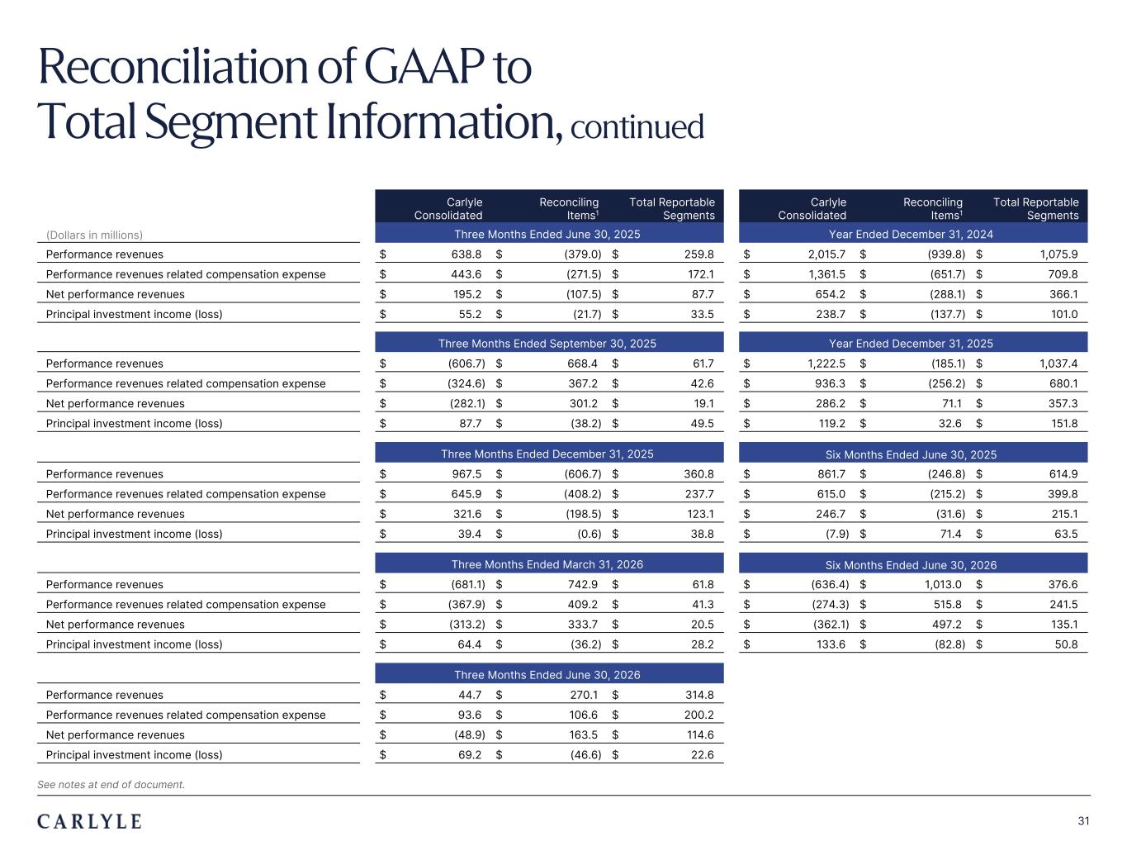
Plum R117 G45 B79 Dark Gray R101 G101 B101 Light Green R216 G240 B221 Pale Blue R221 G244 B255 Light Indigo R176 G188 B228 Indigo R49 G71 B143 Brown R96 G70 B60 Taupe R209 G199 B189 Light Gray R230 G230 B230 Dark Blue R22 G32 B64 Green R57 G108 B101 Champagne R251 G246 B237 Sky Blue R149 G218 B255 Salmon R240 G196 B188 31 Carlyle Consolidated Reconciling Items1 Total Reportable Segments Carlyle Consolidated Reconciling Items1 Total Reportable Segments (Dollars in millions) Three Months Ended June 30, 2025 Year Ended December 31, 2024 Performance revenues $ 638.8 $ (379.0) $ 259.8 $ 2,015.7 $ (939.8) $ 1,075.9 Performance revenues related compensation expense $ 443.6 $ (271.5) $ 172.1 $ 1,361.5 $ (651.7) $ 709.8 Net performance revenues $ 195.2 $ (107.5) $ 87.7 $ 654.2 $ (288.1) $ 366.1 Principal investment income (loss) $ 55.2 $ (21.7) $ 33.5 $ 238.7 $ (137.7) $ 101.0 Three Months Ended September 30, 2025 Year Ended December 31, 2025 Performance revenues $ (606.7) $ 668.4 $ 61.7 $ 1,222.5 $ (185.1) $ 1,037.4 Performance revenues related compensation expense $ (324.6) $ 367.2 $ 42.6 $ 936.3 $ (256.2) $ 680.1 Net performance revenues $ (282.1) $ 301.2 $ 19.1 $ 286.2 $ 71.1 $ 357.3 Principal investment income (loss) $ 87.7 $ (38.2) $ 49.5 $ 119.2 $ 32.6 $ 151.8 Three Months Ended December 31, 2025 Six Months Ended June 30, 2025 Performance revenues $ 967.5 $ (606.7) $ 360.8 $ 861.7 $ (246.8) $ 614.9 Performance revenues related compensation expense $ 645.9 $ (408.2) $ 237.7 $ 615.0 $ (215.2) $ 399.8 Net performance revenues $ 321.6 $ (198.5) $ 123.1 $ 246.7 $ (31.6) $ 215.1 Principal investment income (loss) $ 39.4 $ (0.6) $ 38.8 $ (7.9) $ 71.4 $ 63.5 Three Months Ended March 31, 2026 Six Months Ended June 30, 2026 Performance revenues $ (681.1) $ 742.9 $ 61.8 $ (636.4) $ 1,013.0 $ 376.6 Performance revenues related compensation expense $ (367.9) $ 409.2 $ 41.3 $ (274.3) $ 515.8 $ 241.5 Net performance revenues $ (313.2) $ 333.7 $ 20.5 $ (362.1) $ 497.2 $ 135.1 Principal investment income (loss) $ 64.4 $ (36.2) $ 28.2 $ 133.6 $ (82.8) $ 50.8 Three Months Ended June 30, 2026 Performance revenues $ 44.7 $ 270.1 $ 314.8 Performance revenues related compensation expense $ 93.6 $ 106.6 $ 200.2 Net performance revenues $ (48.9) $ 163.5 $ 114.6 Principal investment income (loss) $ 69.2 $ (46.6) $ 22.6 Reconciliation of GAAP to Total Segment Information, continued See notes at end of document.

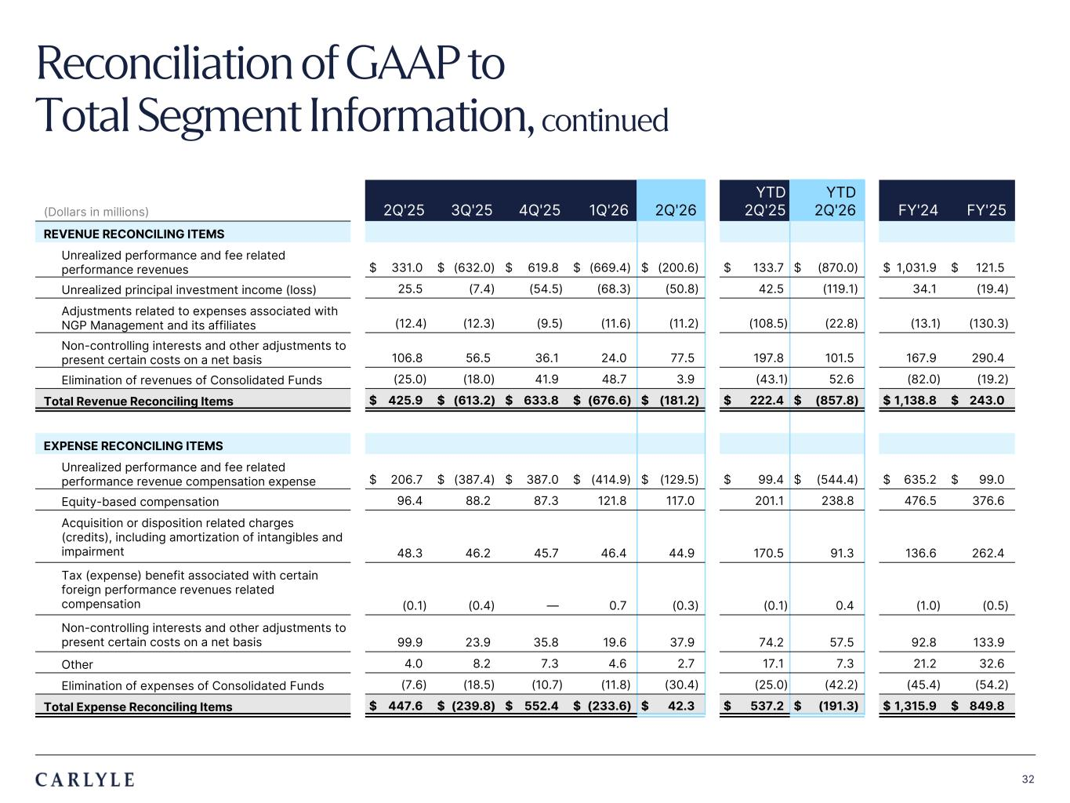
Plum R117 G45 B79 Dark Gray R101 G101 B101 Light Green R216 G240 B221 Pale Blue R221 G244 B255 Light Indigo R176 G188 B228 Indigo R49 G71 B143 Brown R96 G70 B60 Taupe R209 G199 B189 Light Gray R230 G230 B230 Dark Blue R22 G32 B64 Green R57 G108 B101 Champagne R251 G246 B237 Sky Blue R149 G218 B255 Salmon R240 G196 B188 32 (Dollars in millions) 2Q'25 3Q'25 4Q'25 1Q'26 2Q'26 YTD 2Q'25 YTD 2Q'26 FY'24 FY'25 REVENUE RECONCILING ITEMS Unrealized performance and fee related performance revenues $ 331.0 $ (632.0) $ 619.8 $ (669.4) $ (200.6) $ 133.7 $ (870.0) $ 1,031.9 $ 121.5 Unrealized principal investment income (loss) 25.5 (7.4) (54.5) (68.3) (50.8) 42.5 (119.1) 34.1 (19.4) Adjustments related to expenses associated with NGP Management and its affiliates (12.4) (12.3) (9.5) (11.6) (11.2) (108.5) (22.8) (13.1) (130.3) Non-controlling interests and other adjustments to present certain costs on a net basis 106.8 56.5 36.1 24.0 77.5 197.8 101.5 167.9 290.4 Elimination of revenues of Consolidated Funds (25.0) (18.0) 41.9 48.7 3.9 (43.1) 52.6 (82.0) (19.2) Total Revenue Reconciling Items $ 425.9 $ (613.2) $ 633.8 $ (676.6) $ (181.2) $ 222.4 $ (857.8) $ 1,138.8 $ 243.0 EXPENSE RECONCILING ITEMS Unrealized performance and fee related performance revenue compensation expense $ 206.7 $ (387.4) $ 387.0 $ (414.9) $ (129.5) $ 99.4 $ (544.4) $ 635.2 $ 99.0 Equity-based compensation 96.4 88.2 87.3 121.8 117.0 201.1 238.8 476.5 376.6 Acquisition or disposition related charges (credits), including amortization of intangibles and impairment 48.3 46.2 45.7 46.4 44.9 170.5 91.3 136.6 262.4 Tax (expense) benefit associated with certain foreign performance revenues related compensation (0.1) (0.4) — 0.7 (0.3) (0.1) 0.4 (1.0) (0.5) Non-controlling interests and other adjustments to present certain costs on a net basis 99.9 23.9 35.8 19.6 37.9 74.2 57.5 92.8 133.9 Other 4.0 8.2 7.3 4.6 2.7 17.1 7.3 21.2 32.6 Elimination of expenses of Consolidated Funds (7.6) (18.5) (10.7) (11.8) (30.4) (25.0) (42.2) (45.4) (54.2) Total Expense Reconciling Items $ 447.6 $ (239.8) $ 552.4 $ (233.6) $ 42.3 $ 537.2 $ (191.3) $ 1,315.9 $ 849.8 Reconciliation of GAAP to Total Segment Information, continued

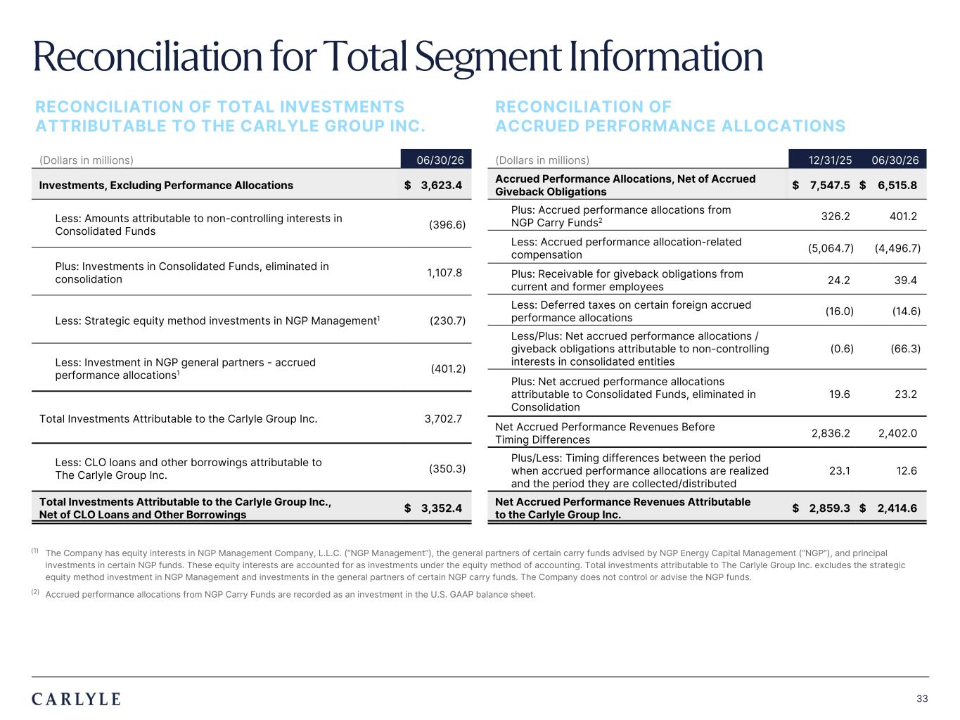
Plum R117 G45 B79 Dark Gray R101 G101 B101 Light Green R216 G240 B221 Pale Blue R221 G244 B255 Light Indigo R176 G188 B228 Indigo R49 G71 B143 Brown R96 G70 B60 Taupe R209 G199 B189 Light Gray R230 G230 B230 Dark Blue R22 G32 B64 Green R57 G108 B101 Champagne R251 G246 B237 Sky Blue R149 G218 B255 Salmon R240 G196 B188 33 Reconciliation for Total Segment Information (1) The Company has equity interests in NGP Management Company, L.L.C. (“NGP Management”), the general partners of certain carry funds advised by NGP Energy Capital Management (“NGP”), and principal investments in certain NGP funds. These equity interests are accounted for as investments under the equity method of accounting. Total investments attributable to The Carlyle Group Inc. excludes the strategic equity method investment in NGP Management and investments in the general partners of certain NGP carry funds. The Company does not control or advise the NGP funds. (2) Accrued performance allocations from NGP Carry Funds are recorded as an investment in the U.S. GAAP balance sheet. RECONCILIATION OF TOTAL INVESTMENTS ATTRIBUTABLE TO THE CARLYLE GROUP INC. (Dollars in millions) 06/30/26 Investments, Excluding Performance Allocations $ 3,623.4 Less: Amounts attributable to non-controlling interests in Consolidated Funds (396.6) Plus: Investments in Consolidated Funds, eliminated in consolidation 1,107.8 Less: Strategic equity method investments in NGP Management1 (230.7) Less: Investment in NGP general partners - accrued performance allocations1 (401.2) Total Investments Attributable to the Carlyle Group Inc. 3,702.7 Less: CLO loans and other borrowings attributable to The Carlyle Group Inc. (350.3) Total Investments Attributable to the Carlyle Group Inc., Net of CLO Loans and Other Borrowings $ 3,352.4 RECONCILIATION OF ACCRUED PERFORMANCE ALLOCATIONS (Dollars in millions) 12/31/25 06/30/26 Accrued Performance Allocations, Net of Accrued Giveback Obligations $ 7,547.5 $ 6,515.8 Plus: Accrued performance allocations from NGP Carry Funds2 326.2 401.2 Less: Accrued performance allocation-related compensation (5,064.7) (4,496.7) Plus: Receivable for giveback obligations from current and former employees 24.2 39.4 Less: Deferred taxes on certain foreign accrued performance allocations (16.0) (14.6) Less/Plus: Net accrued performance allocations / giveback obligations attributable to non-controlling interests in consolidated entities (0.6) (66.3) Plus: Net accrued performance allocations attributable to Consolidated Funds, eliminated in Consolidation 19.6 23.2 Net Accrued Performance Revenues Before Timing Differences 2,836.2 2,402.0 Plus/Less: Timing differences between the period when accrued performance allocations are realized and the period they are collected/distributed 23.1 12.6 Net Accrued Performance Revenues Attributable to the Carlyle Group Inc. $ 2,859.3 $ 2,414.6

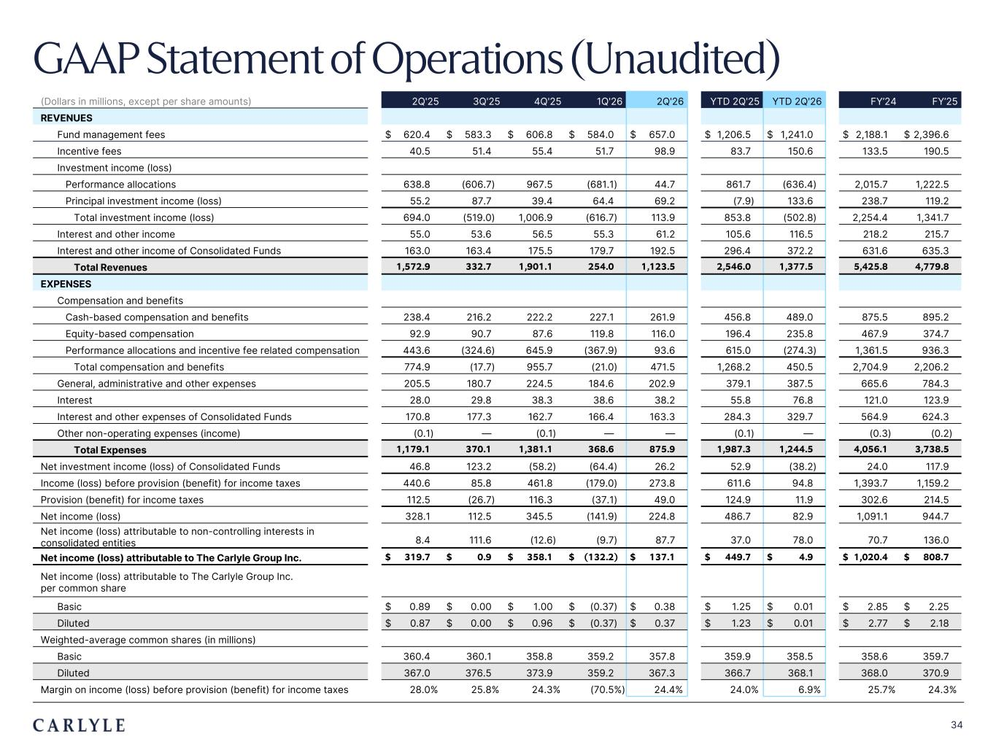
Plum R117 G45 B79 Dark Gray R101 G101 B101 Light Green R216 G240 B221 Pale Blue R221 G244 B255 Light Indigo R176 G188 B228 Indigo R49 G71 B143 Brown R96 G70 B60 Taupe R209 G199 B189 Light Gray R230 G230 B230 Dark Blue R22 G32 B64 Green R57 G108 B101 Champagne R251 G246 B237 Sky Blue R149 G218 B255 Salmon R240 G196 B188 34 GAAP Statement of Operations (Unaudited) (Dollars in millions, except per share amounts) 2Q'25 3Q'25 4Q'25 1Q'26 2Q'26 YTD 2Q'25 YTD 2Q'26 FY’24 FY’25 REVENUES Fund management fees $ 620.4 $ 583.3 $ 606.8 $ 584.0 $ 657.0 $ 1,206.5 $ 1,241.0 $ 2,188.1 $ 2,396.6 Incentive fees 40.5 51.4 55.4 51.7 98.9 83.7 150.6 133.5 190.5 Investment income (loss) Performance allocations 638.8 (606.7) 967.5 (681.1) 44.7 861.7 (636.4) 2,015.7 1,222.5 Principal investment income (loss) 55.2 87.7 39.4 64.4 69.2 (7.9) 133.6 238.7 119.2 Total investment income (loss) 694.0 (519.0) 1,006.9 (616.7) 113.9 853.8 (502.8) 2,254.4 1,341.7 Interest and other income 55.0 53.6 56.5 55.3 61.2 105.6 116.5 218.2 215.7 Interest and other income of Consolidated Funds 163.0 163.4 175.5 179.7 192.5 296.4 372.2 631.6 635.3 Total Revenues 1,572.9 332.7 1,901.1 254.0 1,123.5 2,546.0 1,377.5 5,425.8 4,779.8 EXPENSES Compensation and benefits Cash-based compensation and benefits 238.4 216.2 222.2 227.1 261.9 456.8 489.0 875.5 895.2 Equity-based compensation 92.9 90.7 87.6 119.8 116.0 196.4 235.8 467.9 374.7 Performance allocations and incentive fee related compensation 443.6 (324.6) 645.9 (367.9) 93.6 615.0 (274.3) 1,361.5 936.3 Total compensation and benefits 774.9 (17.7) 955.7 (21.0) 471.5 1,268.2 450.5 2,704.9 2,206.2 General, administrative and other expenses 205.5 180.7 224.5 184.6 202.9 379.1 387.5 665.6 784.3 Interest 28.0 29.8 38.3 38.6 38.2 55.8 76.8 121.0 123.9 Interest and other expenses of Consolidated Funds 170.8 177.3 162.7 166.4 163.3 284.3 329.7 564.9 624.3 Other non-operating expenses (income) (0.1) — (0.1) — — (0.1) — (0.3) (0.2) Total Expenses 1,179.1 370.1 1,381.1 368.6 875.9 1,987.3 1,244.5 4,056.1 3,738.5 Net investment income (loss) of Consolidated Funds 46.8 123.2 (58.2) (64.4) 26.2 52.9 (38.2) 24.0 117.9 Income (loss) before provision (benefit) for income taxes 440.6 85.8 461.8 (179.0) 273.8 611.6 94.8 1,393.7 1,159.2 Provision (benefit) for income taxes 112.5 (26.7) 116.3 (37.1) 49.0 124.9 11.9 302.6 214.5 Net income (loss) 328.1 112.5 345.5 (141.9) 224.8 486.7 82.9 1,091.1 944.7 Net income (loss) attributable to non-controlling interests in consolidated entities 8.4 111.6 (12.6) (9.7) 87.7 37.0 78.0 70.7 136.0 Net income (loss) attributable to The Carlyle Group Inc. $ 319.7 $ 0.9 $ 358.1 $ (132.2) $ 137.1 $ 449.7 $ 4.9 $ 1,020.4 $ 808.7 Net income (loss) attributable to The Carlyle Group Inc. per common share Basic $ 0.89 $ 0.00 $ 1.00 $ (0.37) $ 0.38 $ 1.25 $ 0.01 $ 2.85 $ 2.25 Diluted $ 0.87 $ 0.00 $ 0.96 $ (0.37) $ 0.37 $ 1.23 $ 0.01 $ 2.77 $ 2.18 Weighted-average common shares (in millions) Basic 360.4 360.1 358.8 359.2 357.8 359.9 358.5 358.6 359.7 Diluted 367.0 376.5 373.9 359.2 367.3 366.7 368.1 368.0 370.9 Margin on income (loss) before provision (benefit) for income taxes 28.0% 25.8% 24.3% (70.5%) 24.4% 24.0% 6.9% 25.7% 24.3%

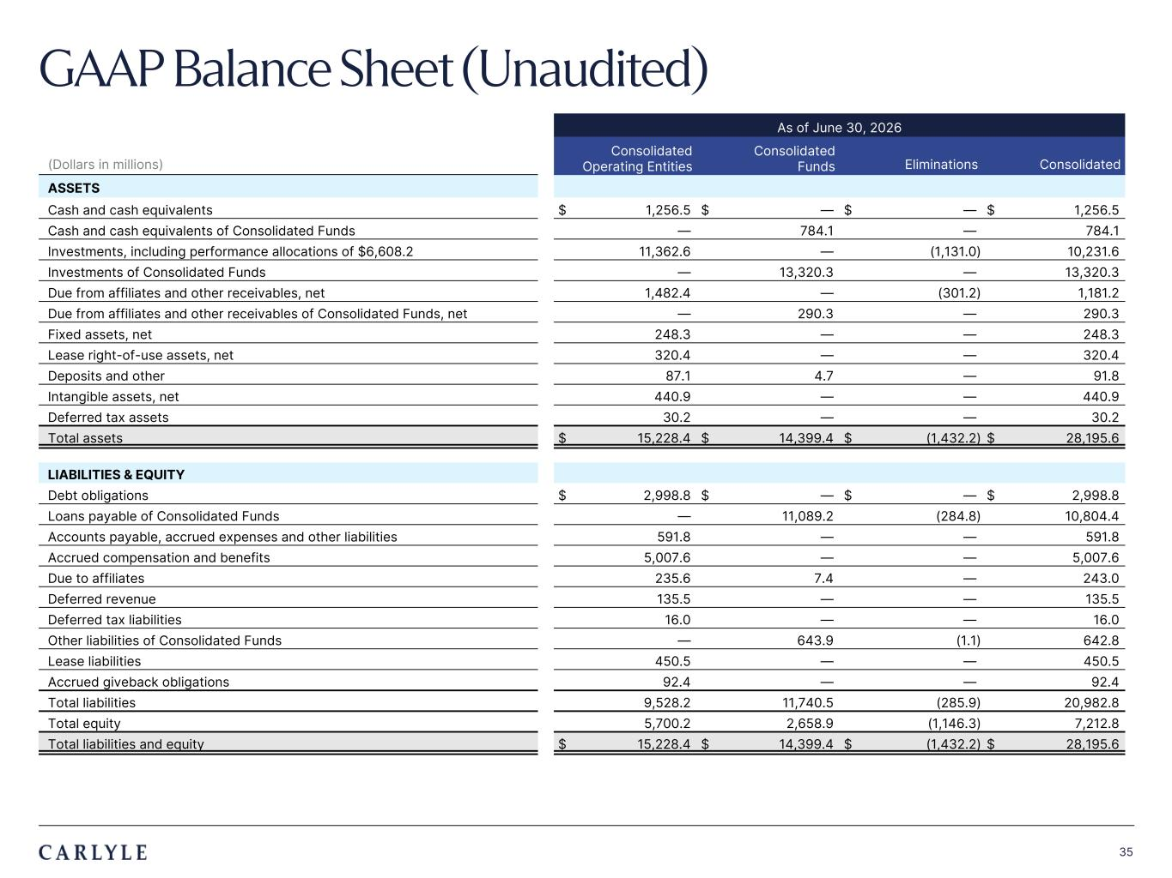
Plum R117 G45 B79 Dark Gray R101 G101 B101 Light Green R216 G240 B221 Pale Blue R221 G244 B255 Light Indigo R176 G188 B228 Indigo R49 G71 B143 Brown R96 G70 B60 Taupe R209 G199 B189 Light Gray R230 G230 B230 Dark Blue R22 G32 B64 Green R57 G108 B101 Champagne R251 G246 B237 Sky Blue R149 G218 B255 Salmon R240 G196 B188 35 As of June 30, 2026 (Dollars in millions) Consolidated Operating Entities Consolidated Funds Eliminations Consolidated ASSETS Cash and cash equivalents $ 1,256.5 $ — $ — $ 1,256.5 Cash and cash equivalents of Consolidated Funds — 784.1 — 784.1 Investments, including performance allocations of $6,608.2 11,362.6 — (1,131.0) 10,231.6 Investments of Consolidated Funds — 13,320.3 — 13,320.3 Due from affiliates and other receivables, net 1,482.4 — (301.2) 1,181.2 Due from affiliates and other receivables of Consolidated Funds, net — 290.3 — 290.3 Fixed assets, net 248.3 — — 248.3 Lease right-of-use assets, net 320.4 — — 320.4 Deposits and other 87.1 4.7 — 91.8 Intangible assets, net 440.9 — — 440.9 Deferred tax assets 30.2 — — 30.2 Total assets $ 15,228.4 $ 14,399.4 $ (1,432.2) $ 28,195.6 LIABILITIES & EQUITY Debt obligations $ 2,998.8 $ — $ — $ 2,998.8 Loans payable of Consolidated Funds — 11,089.2 (284.8) 10,804.4 Accounts payable, accrued expenses and other liabilities 591.8 — — 591.8 Accrued compensation and benefits 5,007.6 — — 5,007.6 Due to affiliates 235.6 7.4 — 243.0 Deferred revenue 135.5 — — 135.5 Deferred tax liabilities 16.0 — — 16.0 Other liabilities of Consolidated Funds — 643.9 (1.1) 642.8 Lease liabilities 450.5 — — 450.5 Accrued giveback obligations 92.4 — — 92.4 Total liabilities 9,528.2 11,740.5 (285.9) 20,982.8 Total equity 5,700.2 2,658.9 (1,146.3) 7,212.8 Total liabilities and equity $ 15,228.4 $ 14,399.4 $ (1,432.2) $ 28,195.6 GAAP Balance Sheet (Unaudited)

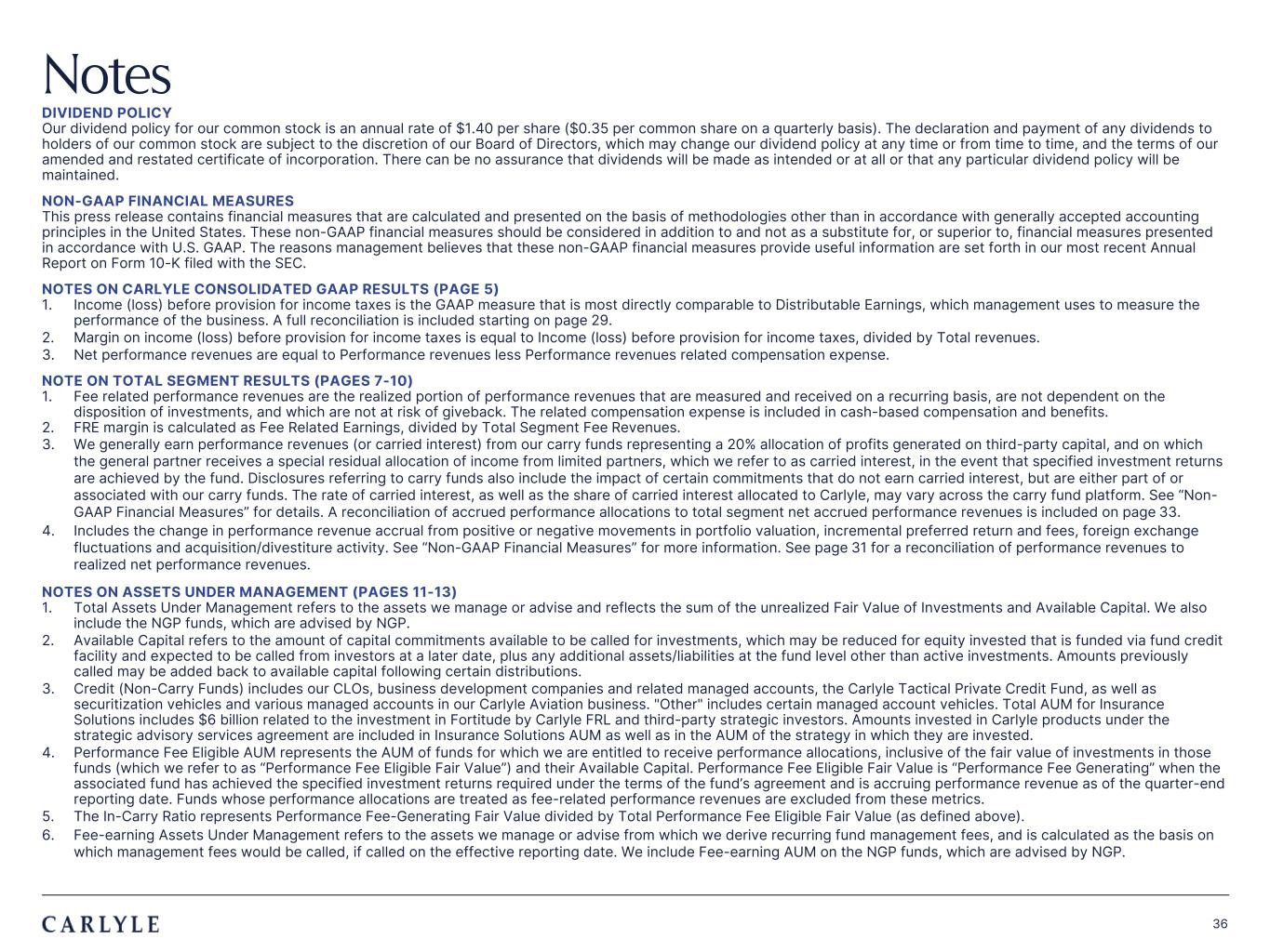
Plum R117 G45 B79 Dark Gray R101 G101 B101 Light Green R216 G240 B221 Pale Blue R221 G244 B255 Light Indigo R176 G188 B228 Indigo R49 G71 B143 Brown R96 G70 B60 Taupe R209 G199 B189 Light Gray R230 G230 B230 Dark Blue R22 G32 B64 Green R57 G108 B101 Champagne R251 G246 B237 Sky Blue R149 G218 B255 Salmon R240 G196 B188 36 Notes DIVIDEND POLICY Our dividend policy for our common stock is an annual rate of $1.40 per share ($0.35 per common share on a quarterly basis). The declaration and payment of any dividends to holders of our common stock are subject to the discretion of our Board of Directors, which may change our dividend policy at any time or from time to time, and the terms of our amended and restated certificate of incorporation. There can be no assurance that dividends will be made as intended or at all or that any particular dividend policy will be maintained. NON-GAAP FINANCIAL MEASURES This press release contains financial measures that are calculated and presented on the basis of methodologies other than in accordance with generally accepted accounting principles in the United States. These non-GAAP financial measures should be considered in addition to and not as a substitute for, or superior to, financial measures presented in accordance with U.S. GAAP. The reasons management believes that these non-GAAP financial measures provide useful information are set forth in our most recent Annual Report on Form 10-K filed with the SEC. NOTES ON CARLYLE CONSOLIDATED GAAP RESULTS (PAGE 5) 1. Income (loss) before provision for income taxes is the GAAP measure that is most directly comparable to Distributable Earnings, which management uses to measure the performance of the business. A full reconciliation is included starting on page 29. 2. Margin on income (loss) before provision for income taxes is equal to Income (loss) before provision for income taxes, divided by Total revenues. 3. Net performance revenues are equal to Performance revenues less Performance revenues related compensation expense. NOTE ON TOTAL SEGMENT RESULTS (PAGES 7-10) 1. Fee related performance revenues are the realized portion of performance revenues that are measured and received on a recurring basis, are not dependent on the disposition of investments, and which are not at risk of giveback. The related compensation expense is included in cash-based compensation and benefits. 2. FRE margin is calculated as Fee Related Earnings, divided by Total Segment Fee Revenues. 3. We generally earn performance revenues (or carried interest) from our carry funds representing a 20% allocation of profits generated on third-party capital, and on which the general partner receives a special residual allocation of income from limited partners, which we refer to as carried interest, in the event that specified investment returns are achieved by the fund. Disclosures referring to carry funds also include the impact of certain commitments that do not earn carried interest, but are either part of or associated with our carry funds. The rate of carried interest, as well as the share of carried interest allocated to Carlyle, may vary across the carry fund platform. See “Non- GAAP Financial Measures” for details. A reconciliation of accrued performance allocations to total segment net accrued performance revenues is included on page 33. 4. Includes the change in performance revenue accrual from positive or negative movements in portfolio valuation, incremental preferred return and fees, foreign exchange fluctuations and acquisition/divestiture activity. See “Non-GAAP Financial Measures” for more information. See page 31 for a reconciliation of performance revenues to realized net performance revenues. NOTES ON ASSETS UNDER MANAGEMENT (PAGES 11-13) 1. Total Assets Under Management refers to the assets we manage or advise and reflects the sum of the unrealized Fair Value of Investments and Available Capital. We also include the NGP funds, which are advised by NGP. 2. Available Capital refers to the amount of capital commitments available to be called for investments, which may be reduced for equity invested that is funded via fund credit facility and expected to be called from investors at a later date, plus any additional assets/liabilities at the fund level other than active investments. Amounts previously called may be added back to available capital following certain distributions. 3. Credit (Non-Carry Funds) includes our CLOs, business development companies and related managed accounts, the Carlyle Tactical Private Credit Fund, as well as securitization vehicles and various managed accounts in our Carlyle Aviation business. "Other" includes certain managed account vehicles. Total AUM for Insurance Solutions includes $6 billion related to the investment in Fortitude by Carlyle FRL and third-party strategic investors. Amounts invested in Carlyle products under the strategic advisory services agreement are included in Insurance Solutions AUM as well as in the AUM of the strategy in which they are invested. 4. Performance Fee Eligible AUM represents the AUM of funds for which we are entitled to receive performance allocations, inclusive of the fair value of investments in those funds (which we refer to as “Performance Fee Eligible Fair Value”) and their Available Capital. Performance Fee Eligible Fair Value is “Performance Fee Generating” when the associated fund has achieved the specified investment returns required under the terms of the fund’s agreement and is accruing performance revenue as of the quarter-end reporting date. Funds whose performance allocations are treated as fee-related performance revenues are excluded from these metrics. 5. The In-Carry Ratio represents Performance Fee-Generating Fair Value divided by Total Performance Fee Eligible Fair Value (as defined above). 6. Fee-earning Assets Under Management refers to the assets we manage or advise from which we derive recurring fund management fees, and is calculated as the basis on which management fees would be called, if called on the effective reporting date. We include Fee-earning AUM on the NGP funds, which are advised by NGP.

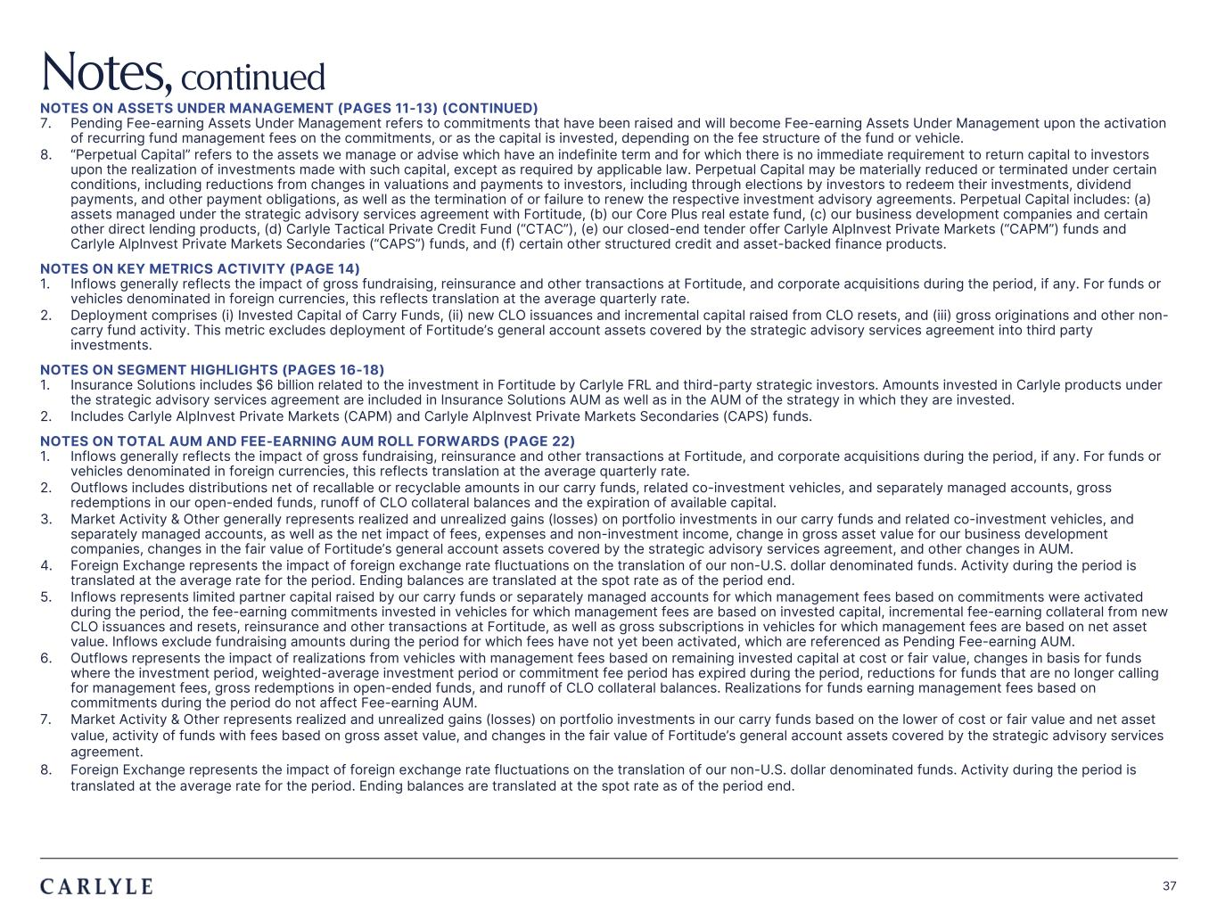
Plum R117 G45 B79 Dark Gray R101 G101 B101 Light Green R216 G240 B221 Pale Blue R221 G244 B255 Light Indigo R176 G188 B228 Indigo R49 G71 B143 Brown R96 G70 B60 Taupe R209 G199 B189 Light Gray R230 G230 B230 Dark Blue R22 G32 B64 Green R57 G108 B101 Champagne R251 G246 B237 Sky Blue R149 G218 B255 Salmon R240 G196 B188 37 Notes, continued NOTES ON ASSETS UNDER MANAGEMENT (PAGES 11-13) (CONTINUED) 7. Pending Fee-earning Assets Under Management refers to commitments that have been raised and will become Fee-earning Assets Under Management upon the activation of recurring fund management fees on the commitments, or as the capital is invested, depending on the fee structure of the fund or vehicle. 8. “Perpetual Capital” refers to the assets we manage or advise which have an indefinite term and for which there is no immediate requirement to return capital to investors upon the realization of investments made with such capital, except as required by applicable law. Perpetual Capital may be materially reduced or terminated under certain conditions, including reductions from changes in valuations and payments to investors, including through elections by investors to redeem their investments, dividend payments, and other payment obligations, as well as the termination of or failure to renew the respective investment advisory agreements. Perpetual Capital includes: (a) assets managed under the strategic advisory services agreement with Fortitude, (b) our Core Plus real estate fund, (c) our business development companies and certain other direct lending products, (d) Carlyle Tactical Private Credit Fund (“CTAC”), (e) our closed-end tender offer Carlyle AlpInvest Private Markets (“CAPM”) funds and Carlyle AlpInvest Private Markets Secondaries (“CAPS”) funds, and (f) certain other structured credit and asset-backed finance products. NOTES ON KEY METRICS ACTIVITY (PAGE 14) 1. Inflows generally reflects the impact of gross fundraising, reinsurance and other transactions at Fortitude, and corporate acquisitions during the period, if any. For funds or vehicles denominated in foreign currencies, this reflects translation at the average quarterly rate. 2. Deployment comprises (i) Invested Capital of Carry Funds, (ii) new CLO issuances and incremental capital raised from CLO resets, and (iii) gross originations and other non- carry fund activity. This metric excludes deployment of Fortitude’s general account assets covered by the strategic advisory services agreement into third party investments. NOTES ON SEGMENT HIGHLIGHTS (PAGES 16-18) 1. Insurance Solutions includes $6 billion related to the investment in Fortitude by Carlyle FRL and third-party strategic investors. Amounts invested in Carlyle products under the strategic advisory services agreement are included in Insurance Solutions AUM as well as in the AUM of the strategy in which they are invested. 2. Includes Carlyle AlpInvest Private Markets (CAPM) and Carlyle AlpInvest Private Markets Secondaries (CAPS) funds. NOTES ON TOTAL AUM AND FEE-EARNING AUM ROLL FORWARDS (PAGE 22) 1. Inflows generally reflects the impact of gross fundraising, reinsurance and other transactions at Fortitude, and corporate acquisitions during the period, if any. For funds or vehicles denominated in foreign currencies, this reflects translation at the average quarterly rate. 2. Outflows includes distributions net of recallable or recyclable amounts in our carry funds, related co-investment vehicles, and separately managed accounts, gross redemptions in our open-ended funds, runoff of CLO collateral balances and the expiration of available capital. 3. Market Activity & Other generally represents realized and unrealized gains (losses) on portfolio investments in our carry funds and related co-investment vehicles, and separately managed accounts, as well as the net impact of fees, expenses and non-investment income, change in gross asset value for our business development companies, changes in the fair value of Fortitude’s general account assets covered by the strategic advisory services agreement, and other changes in AUM. 4. Foreign Exchange represents the impact of foreign exchange rate fluctuations on the translation of our non-U.S. dollar denominated funds. Activity during the period is translated at the average rate for the period. Ending balances are translated at the spot rate as of the period end. 5. Inflows represents limited partner capital raised by our carry funds or separately managed accounts for which management fees based on commitments were activated during the period, the fee-earning commitments invested in vehicles for which management fees are based on invested capital, incremental fee-earning collateral from new CLO issuances and resets, reinsurance and other transactions at Fortitude, as well as gross subscriptions in vehicles for which management fees are based on net asset value. Inflows exclude fundraising amounts during the period for which fees have not yet been activated, which are referenced as Pending Fee-earning AUM. 6. Outflows represents the impact of realizations from vehicles with management fees based on remaining invested capital at cost or fair value, changes in basis for funds where the investment period, weighted-average investment period or commitment fee period has expired during the period, reductions for funds that are no longer calling for management fees, gross redemptions in open-ended funds, and runoff of CLO collateral balances. Realizations for funds earning management fees based on commitments during the period do not affect Fee-earning AUM. 7. Market Activity & Other represents realized and unrealized gains (losses) on portfolio investments in our carry funds based on the lower of cost or fair value and net asset value, activity of funds with fees based on gross asset value, and changes in the fair value of Fortitude’s general account assets covered by the strategic advisory services agreement. 8. Foreign Exchange represents the impact of foreign exchange rate fluctuations on the translation of our non-U.S. dollar denominated funds. Activity during the period is translated at the average rate for the period. Ending balances are translated at the spot rate as of the period end.

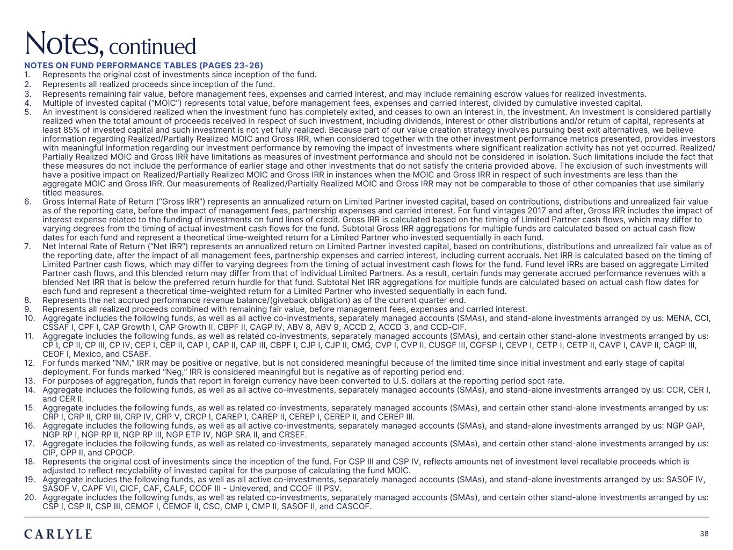
Plum R117 G45 B79 Dark Gray R101 G101 B101 Light Green R216 G240 B221 Pale Blue R221 G244 B255 Light Indigo R176 G188 B228 Indigo R49 G71 B143 Brown R96 G70 B60 Taupe R209 G199 B189 Light Gray R230 G230 B230 Dark Blue R22 G32 B64 Green R57 G108 B101 Champagne R251 G246 B237 Sky Blue R149 G218 B255 Salmon R240 G196 B188 38 NOTES ON FUND PERFORMANCE TABLES (PAGES 23-26) 1. Represents the original cost of investments since inception of the fund. 2. Represents all realized proceeds since inception of the fund. 3. Represents remaining fair value, before management fees, expenses and carried interest, and may include remaining escrow values for realized investments. 4. Multiple of invested capital (“MOIC”) represents total value, before management fees, expenses and carried interest, divided by cumulative invested capital. 5. An investment is considered realized when the investment fund has completely exited, and ceases to own an interest in, the investment. An investment is considered partially realized when the total amount of proceeds received in respect of such investment, including dividends, interest or other distributions and/or return of capital, represents at least 85% of invested capital and such investment is not yet fully realized. Because part of our value creation strategy involves pursuing best exit alternatives, we believe information regarding Realized/Partially Realized MOIC and Gross IRR, when considered together with the other investment performance metrics presented, provides investors with meaningful information regarding our investment performance by removing the impact of investments where significant realization activity has not yet occurred. Realized/ Partially Realized MOIC and Gross IRR have limitations as measures of investment performance and should not be considered in isolation. Such limitations include the fact that these measures do not include the performance of earlier stage and other investments that do not satisfy the criteria provided above. The exclusion of such investments will have a positive impact on Realized/Partially Realized MOIC and Gross IRR in instances when the MOIC and Gross IRR in respect of such investments are less than the aggregate MOIC and Gross IRR. Our measurements of Realized/Partially Realized MOIC and Gross IRR may not be comparable to those of other companies that use similarly titled measures. 6. Gross Internal Rate of Return (“Gross IRR”) represents an annualized return on Limited Partner invested capital, based on contributions, distributions and unrealized fair value as of the reporting date, before the impact of management fees, partnership expenses and carried interest. For fund vintages 2017 and after, Gross IRR includes the impact of interest expense related to the funding of investments on fund lines of credit. Gross IRR is calculated based on the timing of Limited Partner cash flows, which may differ to varying degrees from the timing of actual investment cash flows for the fund. Subtotal Gross IRR aggregations for multiple funds are calculated based on actual cash flow dates for each fund and represent a theoretical time-weighted return for a Limited Partner who invested sequentially in each fund. 7. Net Internal Rate of Return (“Net IRR”) represents an annualized return on Limited Partner invested capital, based on contributions, distributions and unrealized fair value as of the reporting date, after the impact of all management fees, partnership expenses and carried interest, including current accruals. Net IRR is calculated based on the timing of Limited Partner cash flows, which may differ to varying degrees from the timing of actual investment cash flows for the fund. Fund level IRRs are based on aggregate Limited Partner cash flows, and this blended return may differ from that of individual Limited Partners. As a result, certain funds may generate accrued performance revenues with a blended Net IRR that is below the preferred return hurdle for that fund. Subtotal Net IRR aggregations for multiple funds are calculated based on actual cash flow dates for each fund and represent a theoretical time-weighted return for a Limited Partner who invested sequentially in each fund. 8. Represents the net accrued performance revenue balance/(giveback obligation) as of the current quarter end. 9. Represents all realized proceeds combined with remaining fair value, before management fees, expenses and carried interest. 10. Aggregate includes the following funds, as well as all active co-investments, separately managed accounts (SMAs), and stand-alone investments arranged by us: MENA, CCI, CSSAF I, CPF I, CAP Growth I, CAP Growth II, CBPF II, CAGP IV, ABV 8, ABV 9, ACCD 2, ACCD 3, and CCD-CIF. 11. Aggregate includes the following funds, as well as related co-investments, separately managed accounts (SMAs), and certain other stand-alone investments arranged by us: CP I, CP II, CP III, CP IV, CEP I, CEP II, CAP I, CAP II, CAP III, CBPF I, CJP I, CJP II, CMG, CVP I, CVP II, CUSGF III, CGFSP I, CEVP I, CETP I, CETP II, CAVP I, CAVP II, CAGP III, CEOF I, Mexico, and CSABF. 12. For funds marked “NM,” IRR may be positive or negative, but is not considered meaningful because of the limited time since initial investment and early stage of capital deployment. For funds marked “Neg,” IRR is considered meaningful but is negative as of reporting period end. 13. For purposes of aggregation, funds that report in foreign currency have been converted to U.S. dollars at the reporting period spot rate. 14. Aggregate includes the following funds, as well as all active co-investments, separately managed accounts (SMAs), and stand-alone investments arranged by us: CCR, CER I, and CER II. 15. Aggregate includes the following funds, as well as related co-investments, separately managed accounts (SMAs), and certain other stand-alone investments arranged by us: CRP I, CRP II, CRP III, CRP IV, CRP V, CRCP I, CAREP I, CAREP II, CEREP I, CEREP II, and CEREP III. 16. Aggregate includes the following funds, as well as all active co-investments, separately managed accounts (SMAs), and stand-alone investments arranged by us: NGP GAP, NGP RP I, NGP RP II, NGP RP III, NGP ETP IV, NGP SRA II, and CRSEF. 17. Aggregate includes the following funds, as well as related co-investments, separately managed accounts (SMAs), and certain other stand-alone investments arranged by us: CIP, CPP II, and CPOCP. 18. Represents the original cost of investments since the inception of the fund. For CSP III and CSP IV, reflects amounts net of investment level recallable proceeds which is adjusted to reflect recyclability of invested capital for the purpose of calculating the fund MOIC. 19. Aggregate includes the following funds, as well as all active co-investments, separately managed accounts (SMAs), and stand-alone investments arranged by us: SASOF IV, SASOF V, CAPF VII, CICF, CAF, CALF, CCOF III - Unlevered, and CCOF III PSV. 20. Aggregate includes the following funds, as well as related co-investments, separately managed accounts (SMAs), and certain other stand-alone investments arranged by us: CSP I, CSP II, CSP III, CEMOF I, CEMOF II, CSC, CMP I, CMP II, SASOF II, and CASCOF. Notes, continued

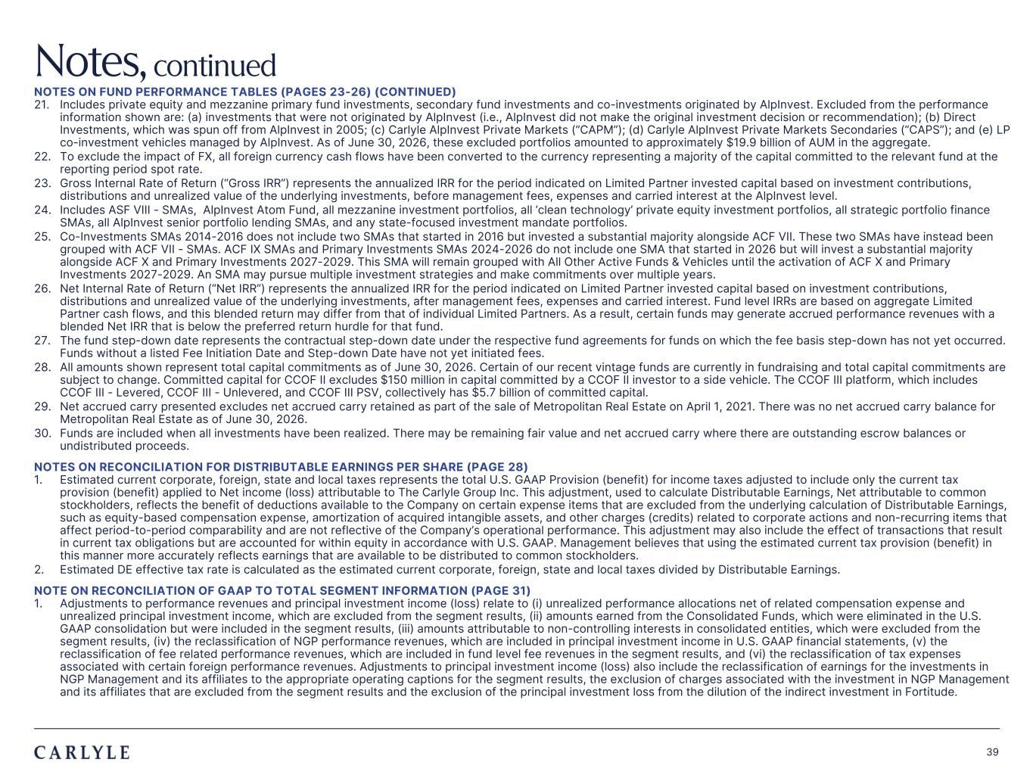
Plum R117 G45 B79 Dark Gray R101 G101 B101 Light Green R216 G240 B221 Pale Blue R221 G244 B255 Light Indigo R176 G188 B228 Indigo R49 G71 B143 Brown R96 G70 B60 Taupe R209 G199 B189 Light Gray R230 G230 B230 Dark Blue R22 G32 B64 Green R57 G108 B101 Champagne R251 G246 B237 Sky Blue R149 G218 B255 Salmon R240 G196 B188 39 NOTES ON FUND PERFORMANCE TABLES (PAGES 23-26) (CONTINUED) 21. Includes private equity and mezzanine primary fund investments, secondary fund investments and co-investments originated by AlpInvest. Excluded from the performance information shown are: (a) investments that were not originated by AlpInvest (i.e., AlpInvest did not make the original investment decision or recommendation); (b) Direct Investments, which was spun off from AlpInvest in 2005; (c) Carlyle AlpInvest Private Markets (“CAPM”); (d) Carlyle AlpInvest Private Markets Secondaries (“CAPS”); and (e) LP co-investment vehicles managed by AlpInvest. As of June 30, 2026, these excluded portfolios amounted to approximately $19.9 billion of AUM in the aggregate. 22. To exclude the impact of FX, all foreign currency cash flows have been converted to the currency representing a majority of the capital committed to the relevant fund at the reporting period spot rate. 23. Gross Internal Rate of Return (“Gross IRR”) represents the annualized IRR for the period indicated on Limited Partner invested capital based on investment contributions, distributions and unrealized value of the underlying investments, before management fees, expenses and carried interest at the AlpInvest level. 24. Includes ASF VIII - SMAs, AlpInvest Atom Fund, all mezzanine investment portfolios, all ‘clean technology’ private equity investment portfolios, all strategic portfolio finance SMAs, all AlpInvest senior portfolio lending SMAs, and any state-focused investment mandate portfolios. 25. Co-Investments SMAs 2014-2016 does not include two SMAs that started in 2016 but invested a substantial majority alongside ACF VII. These two SMAs have instead been grouped with ACF VII - SMAs. ACF IX SMAs and Primary Investments SMAs 2024-2026 do not include one SMA that started in 2026 but will invest a substantial majority alongside ACF X and Primary Investments 2027-2029. This SMA will remain grouped with All Other Active Funds & Vehicles until the activation of ACF X and Primary Investments 2027-2029. An SMA may pursue multiple investment strategies and make commitments over multiple years. 26. Net Internal Rate of Return (“Net IRR”) represents the annualized IRR for the period indicated on Limited Partner invested capital based on investment contributions, distributions and unrealized value of the underlying investments, after management fees, expenses and carried interest. Fund level IRRs are based on aggregate Limited Partner cash flows, and this blended return may differ from that of individual Limited Partners. As a result, certain funds may generate accrued performance revenues with a blended Net IRR that is below the preferred return hurdle for that fund. 27. The fund step-down date represents the contractual step-down date under the respective fund agreements for funds on which the fee basis step-down has not yet occurred. Funds without a listed Fee Initiation Date and Step-down Date have not yet initiated fees. 28. All amounts shown represent total capital commitments as of June 30, 2026. Certain of our recent vintage funds are currently in fundraising and total capital commitments are subject to change. Committed capital for CCOF II excludes $150 million in capital committed by a CCOF II investor to a side vehicle. The CCOF III platform, which includes CCOF III - Levered, CCOF III - Unlevered, and CCOF III PSV, collectively has $5.7 billion of committed capital. 29. Net accrued carry presented excludes net accrued carry retained as part of the sale of Metropolitan Real Estate on April 1, 2021. There was no net accrued carry balance for Metropolitan Real Estate as of June 30, 2026. 30. Funds are included when all investments have been realized. There may be remaining fair value and net accrued carry where there are outstanding escrow balances or undistributed proceeds. NOTES ON RECONCILIATION FOR DISTRIBUTABLE EARNINGS PER SHARE (PAGE 28) 1. Estimated current corporate, foreign, state and local taxes represents the total U.S. GAAP Provision (benefit) for income taxes adjusted to include only the current tax provision (benefit) applied to Net income (loss) attributable to The Carlyle Group Inc. This adjustment, used to calculate Distributable Earnings, Net attributable to common stockholders, reflects the benefit of deductions available to the Company on certain expense items that are excluded from the underlying calculation of Distributable Earnings, such as equity-based compensation expense, amortization of acquired intangible assets, and other charges (credits) related to corporate actions and non-recurring items that affect period-to-period comparability and are not reflective of the Company’s operational performance. This adjustment may also include the effect of transactions that result in current tax obligations but are accounted for within equity in accordance with U.S. GAAP. Management believes that using the estimated current tax provision (benefit) in this manner more accurately reflects earnings that are available to be distributed to common stockholders. 2. Estimated DE effective tax rate is calculated as the estimated current corporate, foreign, state and local taxes divided by Distributable Earnings. NOTE ON RECONCILIATION OF GAAP TO TOTAL SEGMENT INFORMATION (PAGE 31) 1. Adjustments to performance revenues and principal investment income (loss) relate to (i) unrealized performance allocations net of related compensation expense and unrealized principal investment income, which are excluded from the segment results, (ii) amounts earned from the Consolidated Funds, which were eliminated in the U.S. GAAP consolidation but were included in the segment results, (iii) amounts attributable to non-controlling interests in consolidated entities, which were excluded from the segment results, (iv) the reclassification of NGP performance revenues, which are included in principal investment income in U.S. GAAP financial statements, (v) the reclassification of fee related performance revenues, which are included in fund level fee revenues in the segment results, and (vi) the reclassification of tax expenses associated with certain foreign performance revenues. Adjustments to principal investment income (loss) also include the reclassification of earnings for the investments in NGP Management and its affiliates to the appropriate operating captions for the segment results, the exclusion of charges associated with the investment in NGP Management and its affiliates that are excluded from the segment results and the exclusion of the principal investment loss from the dilution of the indirect investment in Fortitude. Notes, continued

